SCS – Sopra Crypto Solutions
Reference guide
<?xml version="1.0"?><DocumentFile xmlns:xsi="http://www.w3.org/2001/XMLSchema-instance" xmlns:xsd="http://www.w3.org/2001/XMLSchema"> <GraphicCharterDefinitionId>0</GraphicCharterDefinitionId> <TemplateBaseTypeId>0</TemplateBaseTypeId> <CompanyId>1</CompanyId> <ConfidentialId>1</ConfidentialId> <ConfidentialDescription>Confidentiel</ConfidentialDescription> <CountryId>0</CountryId> <PageSizeId>1</PageSizeId> <PageOrientationId>1</PageOrientationId> <PrePrintedStationary>false</PrePrintedStationary> <Project /> <Reference>20230419-160420-LM</Reference> <TemplateType>3</TemplateType> <CultureId>fr-FR</CultureId> <LanguageId>2</LanguageId> <Customer /> <DocumentDate>2023-04-19T16:14:04.7209695+02:00</DocumentDate> <Saved>false</Saved> <IsValid>true</IsValid> <FirstPageCover>false</FirstPageCover> <IsNew>true</IsNew> <CurrentVersion>1.00</CurrentVersion> <DocumentType>Dossier</DocumentType> <DocumentTypeId>1</DocumentTypeId> <Entity /> <HasDistributionList>true</HasDistributionList> <HasForeword>false</HasForeword> <Recipient>XXXX
XXXX
XXXX</Recipient> <Title>DOSSIER</Title> <Status>1</Status> <StatusDescription>Travail</StatusDescription> <SetEdition>false</SetEdition> <SetVersion>false</SetVersion></DocumentFile>

Version 1.00
May 19, 2026
Ref.: 20230419-160420-LM
Status: In progress

Recipient (s)
XXXX  XXXX | XXXX

History
Version | Date | Origin of the update | Written by | Validated by
V01 | 13/05/25 | Ch 2 update (diagrams, HL archi), Avg price, API consumption | O Orban
V02 | 19/05/25 | Status evolution + Customer PL evaluation | O Orban
V03 | 26/05/25 | Limit checks in operation mgt | O Orban
V04 | 16/06/25 | Travel Rule mgt | O Orban
V05 | 25/06/25 | Digital asset config (increments) + Wyden exec reports + Regulation impacts and mgt of ‘agreed price’ in case of market order | O Orban
V06 | 11/07/25 | Direct interaction with Chainalysis | O Orban
V07 | 14/07/25 | Technical architecture | S Verma | O Orban
V08 | 23/07/25 | Minor updates in fee management related to liquidity management study.  Added GuardDuty in Target Architecture & Infrastructure Security.  Precision Realized PL in case of convert  Updated Security, added Observability & Monitoring  Updated Regulatory Compliance | O Orban & S Verma
V09 | 23/07/25 | Introduction of the “integration module” for order and price management, in order to work with Wyden and Aplo | O Orban
V10 | 28/07/25 | Adding Business map, simplification of the chapter 2, introduction of sequence diagrams | O Orban
V11 | 28/07/25 | Management of limit update request + split trade limit <> withdrawal limit | O Orban
V12 | 01/09/25 | Update of aplo integration | O Orban
V13 | 15/09/25 | Update of capability map, profitability computation, API design, limit management, and various minor changes | O Orban
V14 | 19/09/25 | Tax report and statement report (new chapter 3.16 & 3.17). | O Orban
V15 | 24/09/25 | Structure of the solution and deployment (from BfB answers) | O Orban
V16 | 10/10/25 | Update of profitability computation for convert order + bank fee computation + precision in amount | O Orban
V17 | 28/10/25 | Bank position management and bank user dashboards + margin management | O Orban
V18 | 07/11/25 | Recurring orders | O Orban
V19 | 27/11/25 | Update of tax report computation to do it on-line | O Orban
V20 | 27/11/25 | Updates on task management | O Orban
V21 | 12/12/25 | Update APLO integration to use new market/limit API, update in bank position management | O Orban
V22 | 19/12/25 | Introduction to DAC8 Reporting, Fireblocks webhook v2, bank position configuration update, min/max for withdrawal, id in logs | O Orban
V23 | 24/02/26 | Bank fee configuration, Bank position creation update, Remove agreed price, Management of cash order, Introduction of asset segration and impact on account schema. Change of internal endpoint for bank position. | O Orban
V24 | 10/04/26 | Update of authorization-reference header for non-repudiation in API. Update of API endpoint managing bank positions, update of order execution to review bank fee mgt, API Versioning, NL tax, persona / role update, digital asset configuration | O Orban
V25 | 24/04/26 | Minor update on amount on exchange bank position computation (§ 3.5.2). Minor update on sell cash order example (§ 2.3.1.c). Minor updates on RBAC and functional access control. | O Orban
V26 |  | Info on the x- extension in API doc

Contents
1. Introduction 10
2. General description 11
2.1. Overview 11
2.2. Business capabilities 12
2.2.1. Customer Products & Services 13
2.2.2. Operation & Execution 13
2.2.3. Enterprise Management 16
2.2.4. Data 16
2.2.5. Foundation 17
2.3. Concepts 18
2.3.1. Subledger 18
2.3.2. Orchestration & Operation 28
2.3.3. Custodian 29
2.3.4. Order Management System 29
2.3.5. Compliance 29
2.4. Application architecture 29
2.4.1. SCS Core 29
2.4.2. Deployment 30
2.5. Current limitations 31
3. Functioning 33
3.1. Introduction to the sequence diagrams 33
3.2. Customer requests to open a digital asset account 33
3.3. Customer accesses a digital asset dashboard 35
3.4. Customer logs in 37
3.5. Customer request to buy digital asset 38
3.5.1. Initiation of the buying order 39
3.5.2. Execution of the buying order 41
3.6. Customer requests to sell digital asset 47
3.6.1. Initiation of the selling order 47
3.6.2. Execution of the selling order 48
3.7. Customer initiates a deposit 51
3.7.1. Deposit address creation 51
3.7.2. Deposit receipt 53
3.7.3. Deposit sweeping 56
3.8. Customer requests to withdraw digital asset 56
3.8.1. Whitelisting of address 56
3.8.2. Customer requests withdrawal 59
3.8.3. Withdrawal execution 61
3.9. Customer requests to cancel an order 69
3.10. Continuous monitoring 71
3.11. Travel Rule completion 71
3.12. KYT task management 73
3.13. Price management 75
3.14. Order integration module 77
3.15. Limit update request 82
3.16. Tax Report 84
3.16.1. Tax-related data computation 85
3.16.2. Gain / Loss computation 85
3.16.3. Tax report retrieval 89
3.17. Statement reports 90
3.18. Bank position configuration 91
3.19. Document upload for KYT issue 93
3.20. Recurring Orders 93
3.21. Fee management 94
3.22. Customer position in subledger 95
3.23. Persona 97
3.24. Event & Statistics management 98
3.25. FIX connection 99
3.26. Limit management 99
3.27. Order and Transaction statuses 100
3.27.1. Buy/Sell order 101
3.27.2. Withdrawal 104
3.27.3. Deposit 105
3.28. Task management 105
3.28.1. Operation pending KYT 106
3.28.2. Document request 106
3.28.3. Travel Rule 107
3.28.4. Limit update 107
3.28.5. Deposit value 107
3.28.6. KYT – Continuous monitoring 108
3.29. Regulatory Compliance 108
3.29.1. MICA 108
3.29.2. TFR 109
3.29.3. DAC8 / CARF 109
3.29.4. GDPR 110
3.29.5. DORA 110
3.30. Operational dashboards 110
3.30.1. Bank revenues 111
3.30.2. Account statistics 111
3.30.3. Operation statistics 111
3.30.4. Bank positions 111
3.31. Alert management 112
3.32. Unrealized P&L 113
3.33. Bank fee computation 113
3.34. Digital asset configuration 113
4. Technical architecture 114
4.1. Architecture Principles 114
4.1.1. Microservices 114
4.1.2. Security by design 115
4.1.3. API-First 115
4.1.4. CI-CD Adoption 115
4.1.5. Logging and Monitoring 115
4.1.6. Code quality 115
4.1.7. Documentation 115
4.2. Technical Stack & Logical Architecture 115
4.2.1. Third-Party Tools 116
4.2.2. SCS Core services 117
4.2.3. SCS Core UI Layer 117
4.3. Infrastructure Architecture 117
4.3.1. Existing Architecture 117
4.3.2. Target Architecture 119
4.3.3. Infrastructure Scaling 119
4.4. Security 120
4.4.1. Infrastructure & Network Security 120
4.4.2. Identity, Access Management and Service Security 121
4.4.3. Application Security 122
4.4.4. Data Protection & Encryption 124
4.4.5. DevSecOps 125
4.5. Observability & Monitoring 125
4.5.1. Threat Detection & Logging 125
4.5.2. Centralized Monitoring 126
4.5.3. Automated Remediation 126
4.6. API 126
4.6.1. Design 126
4.6.2. API Versioning 127
4.6.3. Non-repudiation 128
4.6.4. Error management in API 128
4.6.5. Idempotency 129
4.6.6. API consumption 129
5. User interfaces 131
5.1. UI general principles 131
5.1.1. Amount formatting 131
5.2. UI for customers 131
5.3. UI for bank users 131
6. Glossary 132

- Introduction
The documentation of the SCS – Sopra Crypto Solutions is structured in 4 documents:
- The reference guide that describes what the solution is doing and how it’s doing it. It describes the available services, the managed objects, the processes, etc. They are described in business terms in order to be understandable by non-IT people.
- The integration guide that describes how to configure and personalize the solution according to bank’s needs. It also describes how to integrate the solution into the bank’s information system.
- The operation guide that describes how to configure and run the periodic processes of the solution and to follow-up production processes and potential incidents.
- The installation guide that describes how to deploy the solution in a bank context and the required prerequisites.
This document is the first one: the reference guide.

- General description
  - Overview
The SCS – Sopra Crypto Solutions is a solution that aims at completing a Core Banking System with services related to the management of digital assets for bank’s customers. The main services are:
- Management of customer digital asset account
- Management of digital asset transactions (deposit & withdrawal) and orders (buy, sell, convert)

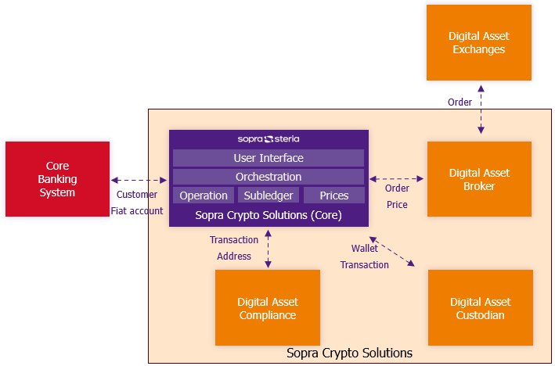
Figure 1 - Overview of the solution

The solution is built to work in close integration with the bank existing system and a digital asset ecosystem. The entities included in Sopra Crypto Solutions are:
- Sopra Crypto Solutions (Core): the core of the solution, which orchestrates the other entities, which is built by Sopra Steria, and which is the main focus of this documentation.
- Custodian: responsible of the interaction with blockchain networks for the execution of transactions (deposits & withdrawals). A default integration with Fireblocks is foreseen, but the solution could be integrated with an other custodian on bank request.
- Order Management System (OMS): responsible for the interactions with Exchange Venues for the execution of orders (buy & sell). A default integration with Wyden and Aplo is foreseen, allowing to work with one or the other, but the solution could be integrated with an other OMS on bank request.
- Compliance engine: responsible to control the transactions regarding compliance rules, as anti-money laundering, criminal activities, etc. A default integration with Chainalysis is foreseen, but the solution could be integrated with an other compliance engine on bank request.
The solution is interacting with entities outside of the scope of SCS:
- Exchange Venues: responsible for the execution of orders (buy & sell). The solution is integrated with Exchange Venues via Custodian and OMS.
- Banking System: responsible of managing customer data and fiat accounts, but also providing transverse features like customer notification, user task assignation, fee computation, etc. The solution is integrated with the Banking System through the SCS Core.

The SCS Core is a front-to-back solution, with 3 main layers:
- A User Interface (UI) layer, for customers and for bank users, where they can initiate requests and manage accounts, transactions, etc. This layer is optional and can be replaced by the bank own UI layer, relying on the SCS API endpoints.
- An orchestration layer, which deals with the requests submitted by users and orchestrates their execution by interacting with the ecosystem and the SCS Core functions
- A function layer, which includes the SCS Core functions related to operation execution, account management (aka the subledger, that maintains the bank and customer accounts, positions and history of entries) and price management

  - Business capabilities
The solution aims to cover an exhaustive set of business capabilities in order to fulfil all requirements related to crypto-asset management. These capabilities are illustrated in the here under capability map.
A capability map has the objective to structure the capabilities which are supported by the solution in collaboration with the Crypto ecosystem and the bank IT landscape.
A Capability is defined as (from ArchiMate):
A capability represents an ability that an active structure element, such as an organization, person, or system, possesses.
This approach is driven by the BIAN approach, in order to propose a map similar to the BIAN Service Landscape. The proposed map is not exhaustive for the whole bank products and activities, but limited to the scope of crypto activities, in line with the SCS target scope.
The map is completed with a view of the Business Products and related Services which are supported. These concepts are defined as (from ArchiMate):
A product represents a coherent collection of services and/or passive structure elements, accompanied by a contract, which is offered as a whole to (internal or external) customers.

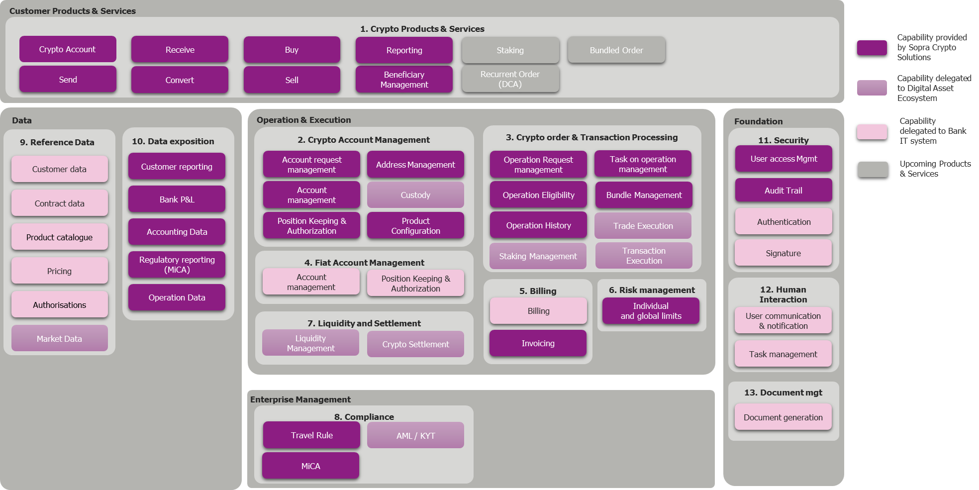
Figure 2 - Capability map
Many of these capabilities are provided by the solution, but some are delegated to the bank system or to the crypto-asset specialized partners.
The following paragraph gives a brief description of each capability. In case the capability is delegated, its description is limited to the features which are required by the solution.
    - Customer Products & Services
This area groups the Business Products & Business Services the solution is supporting. The focus is on crypto-related business products and services.
      - Crypto Products & Services (1)
Crypto Account
The business product which manages crypto positions and transactions history, with possibility of real-time portfolio valuation and performance tracking. It gives access to the services which are detailed here under.
Buy
The business service which allows purchasing crypto assets using funds from the customer’s linked bank fiat (euros) account.
Sell
The business service which allows trading crypto assets directly for fiat currency (euros) and have the funds deposited into the customer’s bank account.
Convert
The business service which allows exchanging one crypto asset for another (e.g., Bitcoin to Ethereum) without involving fiat currency.
Beneficiary Management
The business service which allows pre-registering and verifying any external crypto wallet addresses to which the customer intends to send funds.
Send
The business service which allows transferring from the customer’s crypto account to a pre-approved internal/external wallet or other trusted platform.
Receive
The business service which allows transferring from external wallets or other crypto platforms directly into the customer’s crypto account by generating an individual deposit address.
Reporting
The business service which allows reporting on crypto account activities, either to build dashboards, to produce account statements or fiscal reports.
Staking
The business service which allows locking some crypto assets and in return earning passive income in the form of crypto rewards.
This service is not yet available.
Recurrent Order (DCA)
The business service which allows managing recurrent orders that will trigger on periodical basis a buy order to invest a given amount of fiat into a crypto asset. Also known as DCA – Dollar Cost Averaging – strategy.
This service is not yet available.
Bundled Order
The business service which allows creating bundle of asset, on which the customer can create one order that will trigger as many orders as assets in the bundle, taking into account bundle distribution ratio.
This service is not yet available.

    - Operation & Execution
This area groups the capabilities which are required to support the execution of the business products and services.
      - Crypto account management (2)
This domain groups the capabilities which allow operating a crypto account.

Account Request management
This capability supports the logic to capture, validate, and orchestrate the user request related to account management, as for example account opening request, address creation request. It checks that the request is acceptable and orchestrate the execution of the request. It manages the customer positions and the bank positions.

Account management
This capability supports the crypto account lifecycle, i.e.:
- Crypto account creation
- Crypto account suspension when suspicious activities need to be investigated
- Crypto account closing

Position Keeping and Authorisation
This capability supports the management of the crypto account positions and related entries, including:
- Record-keeping of individual customer crypto holdings, as well as entry history.
- Reservation to temporarily hold funds for pending operations, preventing issues like overdrafts.
- Freeze of funds in case of illicit activities
- Booking for permanent recording of completed operations
- Authorization of request, ensuring the available balance remains positive.
- Record-keeping of bank positions, to mirror positions at exchanges (or broker) and at custody, including the management of profit & loss (realized and unrealized).

Address Management (whitelisting & deposit)
This capability supports the management of the crypto addresses, as well deposit addresses and whitelisted address (used for withdrawal)

Product configuration
This capability supports the configuration the crypto account product and related services (e.g. setting default limits).

Custody
This capability supports the management of crypto assets, on the blockchain, in a secure way.
This capability is provided by a partner (currently Fireblocks)

      - Crypto Order & Transaction processing (3)
This domain groups the capabilities which allow processing order (buy/sell/convert) and transaction (deposit/withdrawal) on crypto accounts.

Operation request management
This capability supports the logic to capture, validate, and orchestrate user order / transaction requests, and ensure their execution.

Eligibility
This capability supports the logic to ensure the user (customer or bank employee) at the origin of the request is eligible to do it.

Operation history
This capability manages the history of all order / transaction requests and operations.

Task on Operation Management
This capability manages manual tasks related to operation execution, as solving KYT issue or missing Travel Rule information.

Trade execution
This capability supports the execution of trade on exchanges.
This capability is provided by a partner (currently Wyden or Aplo)

Transaction execution
This capability supports the execution of deposit / withdrawal on blockchain.
This capability is provided by a partner (currently Fireblocks)

Bundle Management
This capability manages the bundle of digital assets that a customer can buy in bundle order, by defining the ponderation of each assets.
This capability is not yet available.

Staking Management
This capability manages the staking of digital assets.
This capability is provided by a partner (currently Aplo)

      - Fiat account management (4)
This domain groups the capabilities which allow managing fiat account

Account management
This capability supports the fiat account lifecycle, i.e.:
- Fiat account creation
- Fiat account closing
This capability must be provided by the bank IT system

Position Keeping and Authorisation
This capability supports the management of the fiat account positions and related entries, including:
- Record-keeping of individual customer fiat holdings, as well as entry history.
- Reservation to temporarily hold funds for pending operations, preventing issues like overdrafts.
- Booking for permanent recording of completed operations
- Authorization of request, ensuring the available balance remains positive.
This capability must be provided by the bank IT system
      - Billing (5)
This domain groups the capabilities which allow computing and booking bank fees

Billing
This capability supports the computation of the bank fees to be applied on order and transactions.
This capability must be provided by the bank IT system

Invoicing
This capability supports the booking of the bank fees on customer positions
      - Risk management (6)
This domain groups the capabilities related to risk management.

Individual and global limits
This capability supports the management and control of operation limits and position limits, at individual (customer limits) and at global (bank) level.
      - Liquidity & settlement (7)
This domain groups the capabilities related to risk management.

Liquidity management
This capability monitors bank liquidity at exchanges and at custodian, and manages alerts in case of liquidity issues
This capability is provided by a partner (currently Fireblocks, Wyden or Aplo)

Crypto settlement
This capability automates crypto settlement between exchanges and wallet, based on liquidity management rules.
This capability is provided by a partner (currently Fireblocks, Wyden or Aplo)

    - Enterprise Management
This area groups the capabilities which are required to support the enterprise (i.e. the bank) responsibilities.
      - Compliance (8)
This domain groups the capabilities which allow to ensure the compliance with crypto-related regulations.

MiCA Compliance
This capability manages the
- Blocking of risky transactions based on a set of rules (AML)
- Freezing of customers’ accounts in case of risky activity
- Segregation of involved assets on dedicated vaults
- MiCA Compliance with fairness, best execution and asset segregation

Travel Rule
This capability supports the capture and storage of required originator and beneficiary information for crypto transfers.

AML / KYT
This capability supports the analysis of transactions to identify potential fraudulent activities
This capability is provided by a partner (currently Chainalysis)

    - Data
This area groups the capabilities which are required to manage transverse data and leverage existing data.
      - Reference data (9)
This domain groups the capabilities which allow to manage reference data, which are data shared by multiple domains.

Customer Data
This capability centralises detailed information on customers.
This capability must be provided by the bank IT system

Contract Data
This capability centralises detailed information on customer contracts.
This capability must be provided by the bank IT system

Product catalogue
This capability centralises definitions of all bank products, which includes a copy of the crypto products.
This capability must be provided by the bank IT system

Pricing
This capability centralises rules to determine applicable fees (e.g., transfer fees, trading commissions).
This capability must be provided by the bank IT system

Authorisation
This capability centralises rules to determine access rights (for customer and bank users)
This capability must be provided by the bank IT system

Market Data
This capability provides crypto-asset data, including available trading pairs and related prices
This capability is provided by a partner (currently Wyden or Aplo)
      - Data exposition (10)
This domain groups the capabilities which allow to expose and share the data which are managed by the solution.

Customer Reporting
This capability provides detailed information on customer position and operations, including P&L (i.e. precise computation of capital gains or losses for each disposition, using the average cost basis method) , which can be used to generate statements, fiscal reports, etc.

Bank P&L
This capability provides detailed information on bank profits & loss which can be used to monitor bank profitability

Accounting data
This capability provides detailed information on accounting-related activities which can be used to feed an general accounting engine

Regulatory reporting (MiCA)
This capability provides detailed information related to operation processing, travel rules, KYT which can be used to provide regulatory reporting related to crypto activities

Operation Data
This capability provides detailed information on operations, incidents, alerts, etc which can be used to build operating reports.
    - Foundation
This area groups the capabilities which are providing the technical or transverse functions supporting the other capabilities.
      - Security (11)
This domain groups the capabilities which allow to ensure the system is secured.

User access management
This capability controls the access rights of each user (customer or bank user)

Audit trail
This capability manages technical log of any activities (user driven or automated), including errors

Authentication
This capability manages the authentication of users.
This capability must be provided by the bank IT system

Signature
This capability manages the signature of user requests (including management of signature rules)
This capability must be provided by the bank IT system

      - Human interactions (12)
This domain groups the capabilities which supports human interactions.

User communication & notification
This capability manages communication with user (customer or bank user) as notification on events, via user selected channels.
This capability must be provided by the bank IT system

Task Management
This capability assign task to the right user, based on assignation rules
This capability must be provided by the bank IT system

Document generation
This capability generates document based on raw data and templates
This capability must be provided by the bank IT system

  - Concepts
    - Subledger
The subledger service is at the core of the solution: it maintains the bank positions, mirroring the situation at exchanges (or broker) and at custody, and the detailed customer positions. The customer positions are actually detailing the bank positions at custody, as the bank is the holder of the assets on the blockchain.
This chapter explains first the structure of the customer accounts and secondly describes the structure of the bank positions. Then it illustrates how these positions are managed by the solution in order to maintain them according to some accounting principles, for the different types of operation the solution is supporting.
      - Customer accounts
The subledger manages the position related to customer activities. It’s structured in a hierarchical structure with 3 levels:
- Account: represents the portfolio of the customer, in which all the positions are managed. A customer account is open once the bank accepts the request of the customer to have digital assets activities. It can be viewed as an operational object which refers to the contractual relation between the bank and the customer in the scope of these digital asset activities.
- Position: represents the situation for a given digital asset (e.g. BTC or ETH) in the account. The situation means basically the available amount of digital asset.
- Entry: justifies the position by logging all activities as debit (decrease of the position) or credit (increase of the position), triggered by the execution of orders or transactions. Let’s notice that some entries may be ‘reserved’ (blocked temporarily during the time of execution of an order or transaction) or ‘frozen’ (blocked for a longer period of time in the case waiting for a manual decision, usually linked to suspicious activity).
Let’s notice that next to the digital asset positions there is always a fiat account linked to a (digital asset) account. This fiat account is automatically opened in the Core Banking System and is only used in the scope of digital asset activities. It’s the responsibility of the customer to fund this account with fiat currency. All orders (buy & sell) will use the fiat account as counterparty for the fiat side of the order.

Attached to a Position there are some addresses that can be linked:
- Deposit address: when a customer wants to receive funds on his/her account, he/she must first create a deposit address, that he/she will be used as beneficiary address in the system that will trigger the deposit (actually a withdrawal from the point of view of this system). This is mandatory in order to be able to identify the customer which is the beneficiary of the deposit. Such address is a blockchain address.
- Whitelisted address: when a customer wants to withdrawal funds from his/her account, he/she can first register the beneficiary address as a whitelisted address for future usage. Such address is a blockchain address. Remark: whitelisting is not about AML control, but about having a specific action to register address prior withdrawal (and for multiple uses) in order to reduce potential mistake when creating the withdrawal transaction.
Remark: these addresses are linked to a position as they are only valid for a given digital asset.

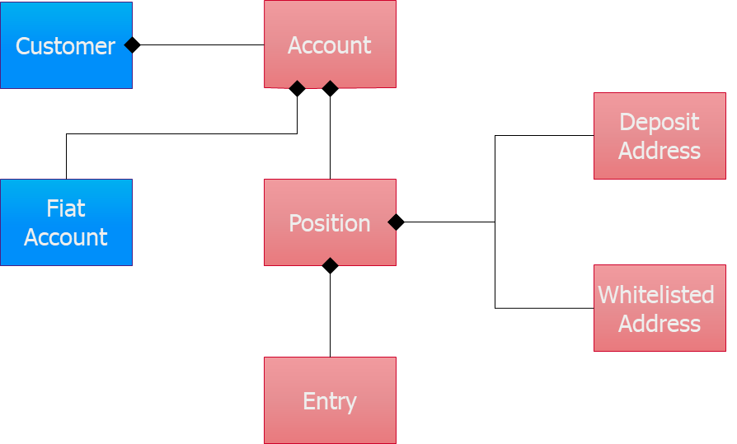
Figure 3 - Subledger concepts
      - Bank positions
Bank positions manage precisely an image of the bank positions at exchanges (in case of Wyden), broker (in case of Aplo) and under custody. The positions are used to build the dashboards for operational monitoring and to support alert generation related to liquidity management. Cf. § 3.27 and 3.28 for more details.
The positions in SCS are mirroring the situations at exchanges (via Wyden), broker (Aplo) or on the blockchain (via Fireblocks). These funds belong to the bank (potentially in the name of its customers): they are bank assets.
As in classical accounting, the customer funds are identified as liabilities: they are a debt the bank has regarding its customer. The customer funds are managed at two levels in the SCS subledger: a global customer position managed as a bank position (which corresponds to the omnibus wallet at custody) and the detailed customer position (cf. previous §) which are sub-positions of the first level.
Bank’s profit and loss (P&L) are also managed in SCS bank positions. P&L which are mirroring the bank positions at exchange / broker or under custody are ‘unrealized’, until they are settled back to bank (converted in fiat). In the meantime, there are ‘just’ liquidity, as they are part of the bank positions at exchange / broker or custody level. This is also true for P&L at exchange which are in fiat.
The realization of unrealized P&L is a complex process as it should be synchronized with the transfer of funds from the exchange / broker or custodian back to the bank fiat accounts. This is described later on in a dedicated chapter (cf. § 3.30).
The bank has to maintain in its own subledger an image of the position in fiat it has at exchange or broker. In the case of exchanges (via Wyden), the bank should manage ‘nostro mirror’ accounts that reflect the position at the exchanges. In the case of a broker (Aplo), the bank should manage a ‘loro’ account that is used to transfer funds with the broker. From SCS point of view, even if those two types of accounts (nostro mirror and loro) are different in the bank subledger, there are managed the same way (cf. infra in examples) in order to have a unique approach for both cases.

The concepts introduced in the previous paragraph for customer accounts remain applicable for bank account with some clarifications:
- Several types of positions are required to maintain accurately the bank positions, i.e. to distinct positions in exchanges, broker and under custody (and per wallet) and to identify P&L. This requires to be able to categorize positions.
- Fiat accounts must be linked, which correspond to nostro or loro accounts, related to the bank fiat positions at exchanges or broker, and which are used by these last ones to fund the order execution. The link with the nostro / loro account must be managed manually, and the related positions created before being able to execute trade (cf. § 3.18)
- Positions in fiat, which are on the linked fiat accounts, are also mirrored in the subledger to simplify the management of dashboards (i.e. the objective is to rely on direct access to the subledger positions instead of multiple API call to the bank CBS, but also to easier identify unrealized P&L).
      - Accounting principles
These “accounting principles” defines how to maintain the customer and bank positions in SCS subledger. The management of a general ledger (GL) and its related accounting principles are not in the scope of the SCS. It’s up to the bank to maintain its GL based on financial events which are published by the SCS Core (cf. § 3.21). Nevertheless the SCS subledger follows usual general accounting principles in order to offer a solid basis for reporting and justifications.

The main principles are:
- Bank positions that maintain bank assets (e.g. position at exchange, asset under custody) are managed as asset account on the balance sheet. Credit on an asset account decreases its economic value (even if its balance increases).
- Bank positions that maintain customer debt are managed as liabilities account on the balance sheet. Credit on a liability account increases its economic value (and increases its balance). These accounts are detailed with sub-positions (analytical split) per customer, cf. the customer positions.
- Bank positions that maintain profit & loss (P&L) are not asset nor liabilities. Credit on a P&L account represents a profit, debit a loss.
- Usual accounting principles must be respected: sum of credit must equal sum of debit, per currency.
- Some transitory bank accounts exist to respect the accounting principles, especially when a business transactions is spread over distinct events.

Conceptually the processing of an operation (order or transaction) can be seen as made of following steps:
- A pre-operation step, which is the reservation (blocking) of the customer assets to guarantee the funds will be available when the operation will be executed.
- The execution of the operation at exchange / broker level or by the custodian, which impacts the bank positions at exchange / broker level or under custody
- A post-execution step, which is the impacts of the operation on the customer assets in the bank (both SCS and CBS), based on the notification of the exchange, broker or custodian.
- The transfer on-chain of customer funds from the bank portfolio / wallet (at exchange / broker or at custody) to the omnibus wallet of the bank, in order to respect MiCA requirement on asset segregation (cf. 3.29.1).
- A post-transfer step, which is the impacts of the transfer on the bank positions in SCS, based on the notification of the custodian.
Remark: the steps 4 & 5 are currently not implemented in the solution. This will be done in following releases.

Let’s illustrate this mechanism for the different types of operation.

Buy order (expressed in base currency)

Case of Wyden
A customer buys 1 ETH at 2 000 €, which is the customer price which includes bank margin of 10 € (configured at Wyden side). There is 15 € of bank fees. The bank is paying 3 € of fees at the exchange.

- Pre-trade at Bank / SCS  Reserve customer fiat 2 015 €  - Execution at exchange level  Db Bank EUR position 1 993 € (1 990 + 3)  Cr Bank ETH position 1 ETH  - Post-trade at Bank / SCS  Db Bank Exchange 1 ETH  Cr Customer Transitory 1 ETH (+ customer position update)  Db Customer fiat 2 015 € (and unreserve funds)  Cr Exchange (Nostro mirror) 1 993 €  Cr P&L 25 € (bank fees + margin)  Db Unrealized P&L 3 € (exchange fees)  - Transfer between Exchange and Custody for the customer funds  Db Bank ETH Exchange 1 ETH  Cr Omnibus ETH Custody 1 ETH  - Post-transfer in SCS  DB Customer Transitory 1 ETH  Cr Customer ETH (Omnibus – Customer side) 1 ETH  Db Omnibus ETH (Omnibus – bank side) 1 ETH  Cr Bank ETH Exchange 1 ETH | 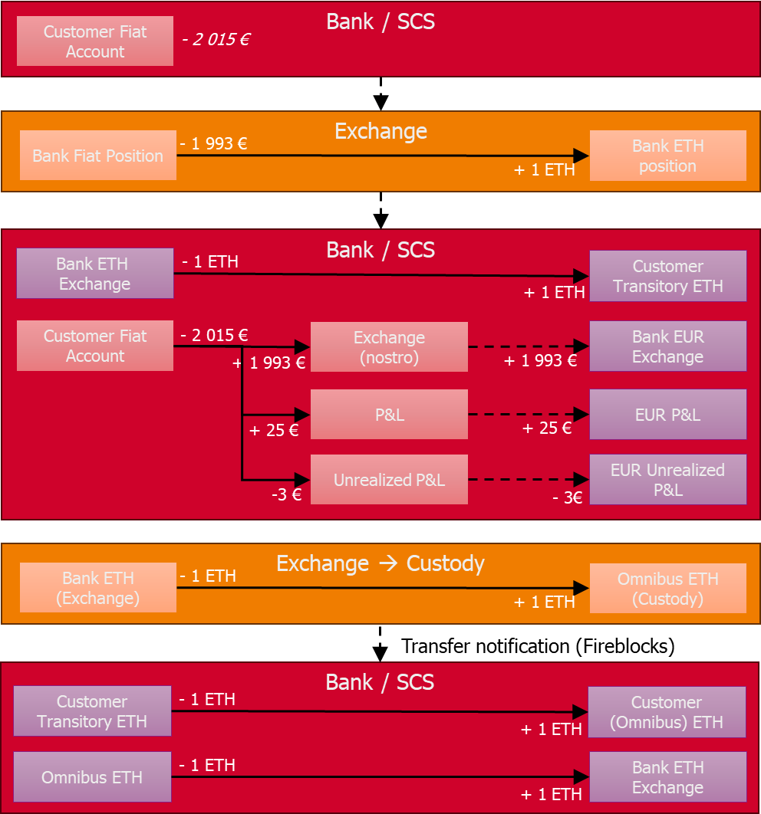
In the above picture (and following ones), each box is a position, which is managed either:
- At the level of the CBS subledger (or ledger), in red
- At the level of the SCS subledger (bank positions), in grey blue
- At the level of the exchange / broker / custody, in orange.
As explained earlier, all the bank fiat positions in the CBS are also mirrored in the SCS subledger to optimize future usages for dashboards.
In this example, the bank fiat position at the exchange is supposed to be sufficient to realize the trade. That’s the objective of the liquidity management to monitor this position and to manage fund transfers if needed. These fund transfers will themselves impact these positions and will be detailed in the liquidity management chapter.
The booking of the P&L is split in two parts, as one (the 25 €) is realized P&L (the bank fees and the margin are realized in euro in bank books) and the other one (the 3 €) is considered as unrealized P&L as these exchange fees are (at that time) just impacting the liquidity at the exchange. The way P&L (realized or unrealized) are booked at CBS level is a responsibility of the CBS: SCS will only provide a financial event that has to be interpreted by the bank general ledger. While the booking on the nostro (or loro in case of Wyden) are triggered by explicit API call (cf. illustration in the different use case in chapter 3).
The step 4 (transfer of customer funds from exchange to custody) is illustrated as an individual transfer following the trade, but practically it should be done periodically, aggregating the customer funds, in order to reduce gas fee.
Two omnibus accounts are illustrated: one at ‘asset side’, which corresponds to the fact the bank owns some asset on the blockchain, one at ‘liability side’, which corresponds to the fact that the assets are a debt to the customers.
There is a transitory account for the omnibus account on the liability side as at the time of the step 3, the funds are not yet on that omnibus account. Another transitory account could be inserted between the transfer from the exchange account and the custody account as this transfer is not instantaneous. But as this delay should be short, we don’t think it’s mandatory.
The customer position is updated directly at step 3, while the omnibus is only updated at step 5, to improve user experience, and in line with similar processes in classical securities trading. Similarly, the fiat settlement is done directly at the time of the execution (step 3) and not at the same time as the crypto settlement. This is also in line with similar processes in classical securities trading.
In reality the price of ETH is evolving between the step 1 (the reservation of the funds at the time of the triggering of the order) and its execution (step 2), which impacts the fiat amount. Except if a quote mechanism is used (currently not available). This evolution of the price is not illustrated on this example as it doesn’t change the schema and the pattern. Practically the solution manages a margin on the reserved amount to cover the price evolution, as explained in the detailed description of this use case (cf. § 3.5) and illustrated later on in this chapter in the case of a sale order expressed in quote currency.

Case of Aplo
A customer buys 1 ETH at 2 000 €, which is the customer price which includes bank margin of 10 € (configured at SCS side). There is 15 € of bank fees. There is no exchange fees; the Aplo fees are invoiced periodically and not taken into account at the level of each operation.

- Pre-trade at Bank / SCS  Reserve customer fiat 2 015 €  - Execution at broker level  Db Bank EUR position 1 990 €  Cr Bank ETH position 1 ETH  - Post-trade at Bank / SCS  Db Bank Broker 1 ETH  Cr Customer Transitory 1 ETH (+ customer position update)  Db Customer fiat 2 015 € (and unreserve funds)  Cr Broker (Loro) 1 990 €  Cr P&L 25 € (15 + 10)  - Transfer between Broker and Custody for the customer funds  Db Bank ETH Broker 1 ETH  Cr Omnibus ETH Custody 1 ETH  - Post-transfer in SCS  DB Customer Transitory 1 ETH  Cr Customer ETH (Omnibus – Customer side) 1 ETH  Db Omnibus ETH (Omnibus – bank side) 1 ETH  Cr Bank ETH Broker 1 ETH | 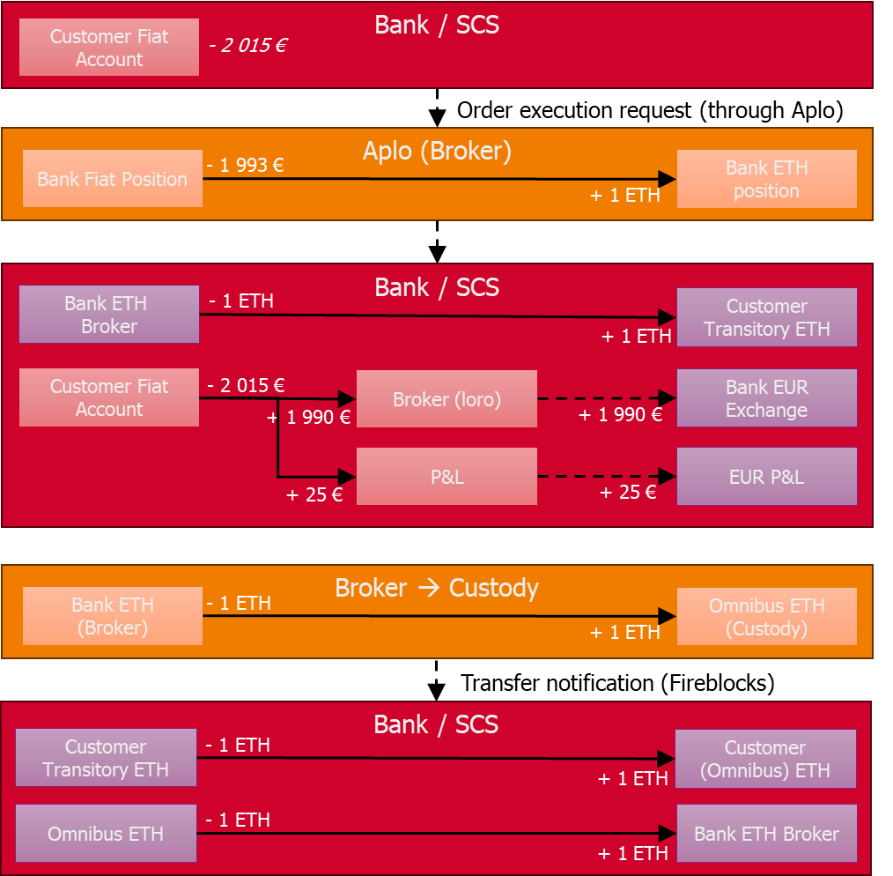

Funds on the Broker (Loro) account must be transferred periodically to Aplo. In the meantime, Aplo can execute the order based on some ‘credit line’ or some available funds. It’s also the responsibility of the liquidity management feature to monitor these positions and possibly trigger the fund transfers.
The transfers inside Aplo between funding and trading sub-accounts are not illustrated.
An alternative with Aplo is to transfer the customer funds to the Omnibus via Aplo, using the custody features of Aplo (which are also relying on an embedded Fireblocks implementation). Such alternative is not in scope for now, in order to keep a behaviour similar to Wyden.

Buy order (expressed in quote currency)

Case of Wyden
A customer buys for 500 € of ETH, at the time of the order validation the price is 2500 EUR, on which the bank takes 0.5 % margin, leading to a customer price of 2512.5 €. Based on this price, the customer expects to get 0.19900 ETH. Plus 7.5 € of fees (1.5 % on customer cost). Bank submits an order for 0.19900 ETH, and it’s executed at 2520 EUR, which means customer price at execution time is 2532.6 € and he should get 0.19743 ETH for his 500 EUR. There is 5 € of exchange fee.

- Pre-trade at Bank / SCS  Reserve customer fiat 507.5 €  - Execution at broker level (request to buy 0.199 ETH)  Db Bank EUR position 506.49 € (501.49 + 5)  Cr Bank ETH position 0.199 ETH  - Post-trade at Bank / SCS  Db Bank Exchange 0.199 ETH  Cr Customer Transitory 0.19743 ETH (+ customer position update)  Cr Bank P&L (custody) 0.00157 ETH - unrealized  Db Customer fiat 507.5 € (and unreserve funds)  Cr Exchange (Nostro mirror) 506.49€  Cr P&L 6.01 € (bank fees + margin), margin is negative: -1.49 €.  Db Unrealized P&L 5 € (exchange fees)  - Transfer between Exchange and Custody for the customer funds  Db Bank ETH Exchange 0.199 ETH  Cr Omnibus ETH Custody 0.19743 ETH  Cr Bank ETH 0.00157 ETH  - Post-transfer in SCS  DB Customer Transitory 0.19743 ETH  Cr Customer ETH (Omnibus – Customer side) 0.19743 ETH  Db Omnibus ETH (Omnibus – bank side) 0.19743 ETH  Db Bank ETH Asset 0.00157 ETH  Cr Bank ETH Exchange 0.199 ETH | 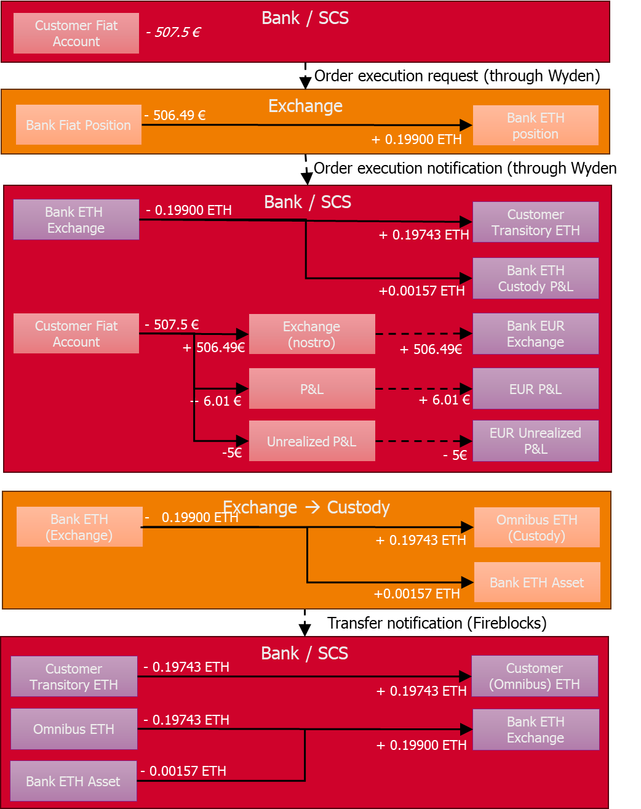
In this example we take into account the evolution of the price between the initiation of the order and its execution as it impacts the schema. It requires to manage the difference between the acquired funds and the ones delivered to the customer. This difference becomes a revenue (new asset) for the bank, which compensates the negative margin. These assets are added to an asset account which represents bank owns assets.
The negative margin is computed based on the difference of price between the initiation and the execution, considering the volume (i.e. (2512.5 - 2520) * 0.19743).

Case of Aplo
TO COMPLETE

Sell order

Case of Wyden

A customer sells 1 ETH at 3 000 €, which is the customer price which includes bank margin of 15 €. There is 20 € of bank fees. The bank has 5 € of exchange fees

- Pre-trade at Bank / SCS  Reserve Customer 1 ETH  - Execution at exchange level  Db Bank ETH position 1 ETH  Cr Bank EUR position 3 010 € (1 x 3 015 – 5)  - Post-trade at Bank / SCS  Db Customer Transitory 1 ETH (and unreserve)  Cr Bank ETH exchange 1 ETH  Db Exchange (nostro) 3 010 €  Cr Customer 2 980 € (1 x 3 000 – 20)  Cr Bank P&L (exchange, unrealized) 30 € (20 + 15 – 5)  - Transfer between Custody and Exchange for the customer funds  Db Omnibus ETH Custody 1 ETH  Cr Bank ETH exchange 1 ETH  - Post-transfer in SCS  DB Customer ETH (Omnibus – Customer side) 1 ETH  Cr Customer Transitory 1 ETH  Db Bank ETH exchange 1 ETH  Cr Omnibus ETH (Omnibus – bank side) 1 ETH | 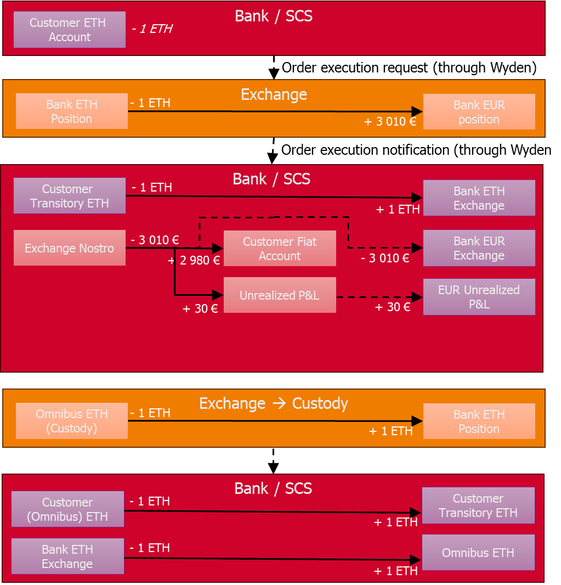
Case of Aplo

A customer sells 1 ETH at 3 000 €, which is the customer price which includes bank margin of 15 €. There is 20 € of bank fees.

- Pre-trade at Bank / SCS  Reserve Customer 1 ETH  - Execution at broker level  Db Bank ETH position 1 ETH  Cr Bank EUR position 3 015 €  - Post-trade at Bank / SCS  Db Customer Transitory 1 ETH (and unreserve)  Cr Bank ETH broker 1 ETH  Db Broker (loro) 3 015 €  Cr Customer 2 980 € (1 x 3 000 – 20)  Cr Bank P&L (exchange, unrealized) 35 € (20 + 15)  - Transfer between Custody and Broker for the customer funds  Db Omnibus ETH Custody 1 ETH  Cr Bank ETH broker 1 ETH  - Post-transfer in SCS  DB Customer ETH (Omnibus – Customer side) 1 ETH  Cr Customer Transitory 1 ETH  Db Bank ETH broker 1 ETH  Cr Omnibus ETH (Omnibus – bank side) 1 ETH | 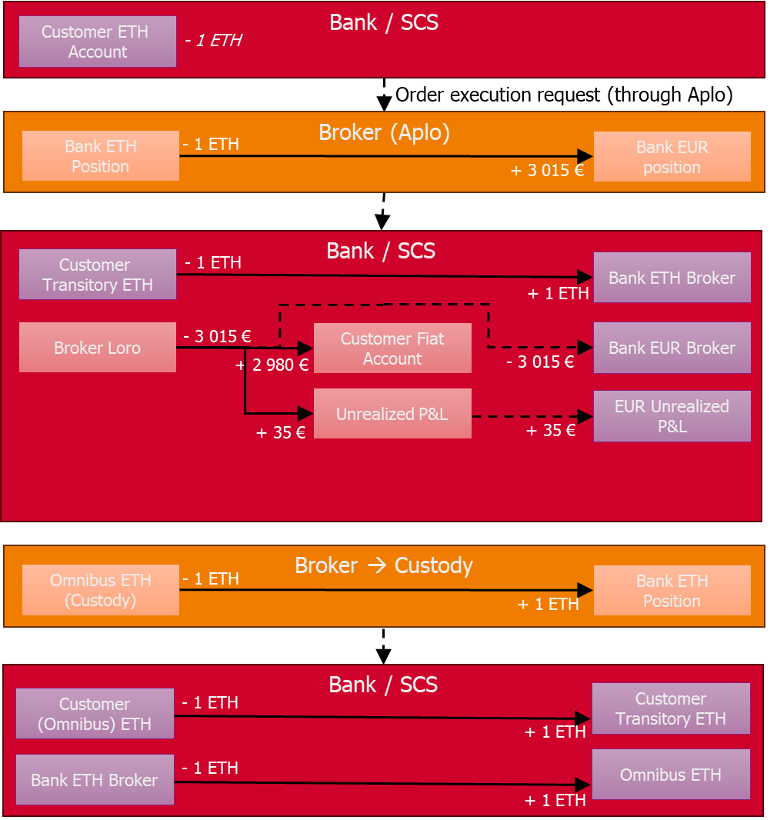

Sell order (expressed in quote currency)

Case of Wyden
A customer sells for 1000 € of ETH, at the time of the order validation the price is 2500 EUR, but the bank takes 0.5 % margin, so showing 2487.5 €, expecting to sell 0.402010 ETH. Plus 15 € of fees (1.5 % on customer cost) – he’ll get only 985 €. Order is executed at 2470 EUR. There is 5 € of exchange fees. At 2470 €, execution price shown to the customer is 2457.65 €, so for 1000 €, he should sell 0.406893 ETH.
To manage the fact that the ETH amount to sell is higher than initially foreseen, we need to take a margin on the reserved amount, if we want to guarantee the customer gets 1000 €. In this example let’s take 1 % margin on the ETH which are reserved, it makes: 0.406030 ETH to block. Which is not enough to cover the target amount, to reach 1000 € at target customer price. In order to cap the amount to the reserved amount, we need to compute a customer price that allows to reach this reserved amount, with a specific price margin (lower than initially foreseen). To get 1000 €, it means a customer price of 2462.87 €, and thus a margin of 0.29 % (based on the difference this customer price and the execution price, i.e. 1 – (2462.87 / 2470)) instead of 0.5 %.

- Pre-trade at Bank / SCS  Reserve Customer 0.406030 ETH  - Execution at exchange level (bank sells 0.402010 ETH at 2470 € + 5 € of fees)  Db Bank ETH position 0.402010 ETH  Cr Bank EUR position 987.96 € (992.96 – 5)  - Post-trade at Bank / SCS  Db Customer Transitory 0.406030 ETH (and unreserve)  Cr Bank ETH exchange 0.402010 ETH  Cr Bank ETH asset – Transitory 0.004020 ETH  Db Exchange (nostro) 987.96 €  Cr Customer 985 €  Cr Bank P&L (exchange, unrealized) 2.96 € (15 (bank fee) – 5 (exchange fee) – 7.04 (margin))  - Transfer between Custody and Exchange for the customer funds  Db Omnibus ETH Custody 0.406030 ETH  Cr Bank ETH exchange 0.402010 ETH  Cr Bank ETH Asset 0.004020 ETH  - Post-transfer in SCS  DB Customer ETH (Omnibus – Customer side) 0.406030 ETH  Cr Customer Transitory 0.046030 ETH  Db Bank ETH exchange 0.402010 ETH  Db Bank ETH Asset – Transitory 0.004020 ETH  Cr Omnibus ETH (Omnibus – bank side) 0.406030 ETH | 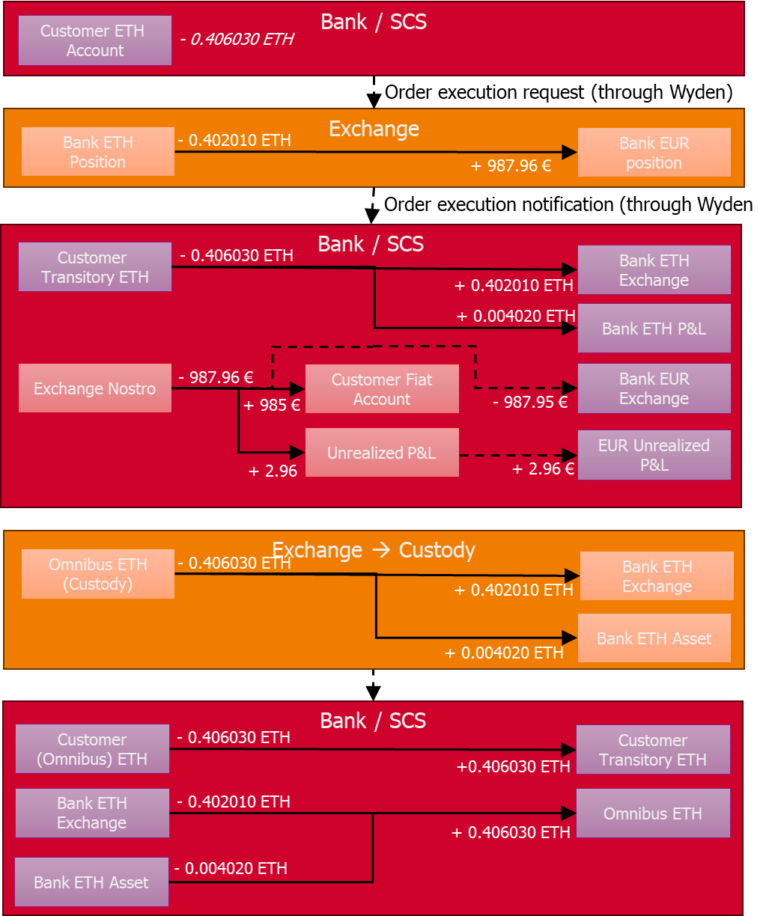

The margin of -7.04 is the result between the initial customer price (2487.5) and the execution price (2470). But the price shown to the customer will be 2462.87, which lead to an extra PL, which are the ETH the bank is owning.

Case of Aplo
TO COMPLETE

Convert order

Case of Wyden
A Customer converts 0,05 BTC into 1 ETH, at a price of 20 ETH, which is the customer price, which includes bank margin of 0,1 ETH (bank price is thus 20.1 ETH). There is 0.0075 ETH of bank fees. The bank has 0.0015 ETH of exchange fees.

- Pre-trade at Bank / SCS  Reserve Customer 0,05 BTC  - Execution at exchange level  Db Bank BTC position 0,05 BTC  Cr Bank ETH position 1,0035 ETH (0.05 * 20.1 = 1,005 – 0,0015)  - Post-trade at Bank / SCS  Db Customer Transitory 0,05 BTC  Cr Bank BTC exchange 0,05 BTC  Db Bank ETH exchange 1,0035 ETH  Cr Customer 0,9925 ETH  Cr Bank P&L (exchange, unrealized) 0.011 ETH (= 0,005 (price margin) + 0.0075 (bank fees) – 0.0015 (exchange fee))  - Transfer between Exchange and Custody for the customer funds  Db Bank ETH Exchange 0.9925 ETH  Cr Omnibus ETH Custody 0.9925 ETH  Db Omnibus BTC Custody 0.05 BTC  Cr Bank BTC Exchange 0.05 BTC  - Post-transfer in Bank / SCS  Db Customer Transitory 0.9925 ETH  Cr Customer ETH (Omnibus – Customer side) 0.9925 ETH  Db Omnibus ETH (Omnibus – bank side) 0.9925 ETH  Cr Bank ETH Exchange 0.9925  Db Customer BTC (Omnibus – Customer side) 0.05 BTC  Cr Customer Transitory 0.05 BTC  Db Bank BTC Exchange 0.05 BTC  Cr Omnibus BTC (Omnibus – bank side) 0.05 BTC | 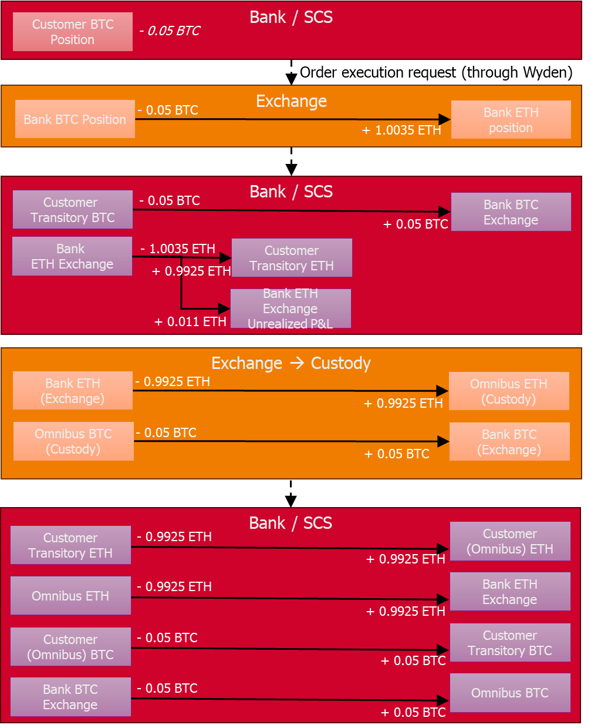
Case of Aplo
A Customer converts 0,05 BTC into 1 ETH, at a price of 20 ETH, which is the customer price, which includes bank margin of 0,1 ETH. There is 0.0075 ETH of bank fees.

- Pre-trade at Bank / SCS  Reserve Customer 0,05 BTC  - Execution at broker level  Db Bank BTC position 0,05 BTC  Cr Bank ETH position 1,005 ETH (0.05 BTC * 20.1)  - Post-trade at Bank / SCS  Db Customer Transitory 0,05 BTC (and unreserve)  Cr Bank BTC broker 0,05 BTC  Db Bank ETH broker 1,005 ETH  Cr Customer 0,9925 ETH  Cr Bank P&L (broker, unrealized) 0.0125 ETH (= 0.0075 + 0.005)  - Transfer between Broker and Custody for the customer funds  Db Bank ETH Broker 0.9925 ETH  Cr Omnibus ETH Custody 0.9925 ETH  Db Omnibus BTC Custody 0.05 BTC  Cr Bank BTC Broker 0.05 BTC  - Post-transfer in Bank / SCS  Db Customer Transitory 0.9925 ETH  Cr Customer ETH (Omnibus – Customer side) 0.9925 ETH  Db Omnibus ETH (Omnibus – bank side) 0.9925 ETH  Cr Bank ETH Broker 0.9925  Db Customer BTC (Omnibus – Customer side) 0.05 BTC  Cr Customer Transitory 0.05 BTC  Db Bank BTC Broker 0.05 BTC  Cr Omnibus BTC (Omnibus – bank side) 0.05 BTC | 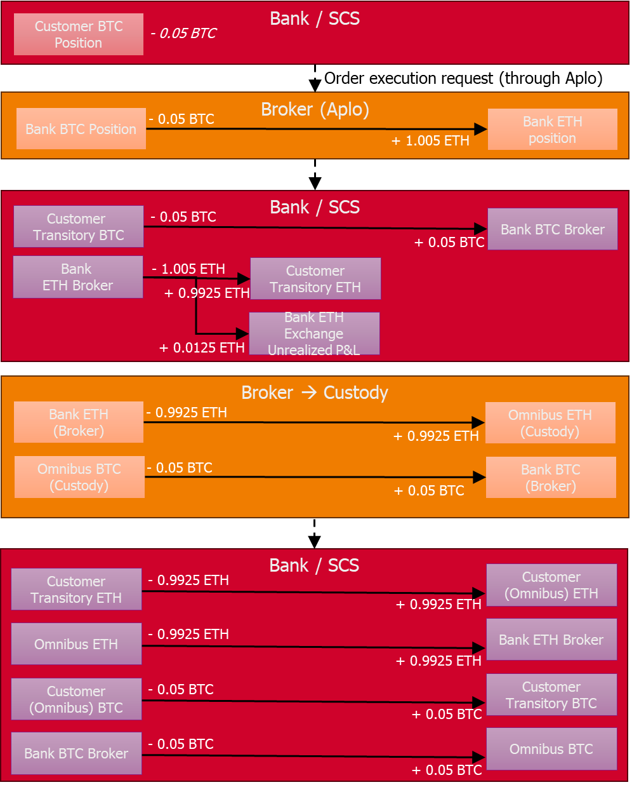

Convert order (expressed in quote currency)

Case of Wyden
A customer converts BTC into ETH for a target amount of 10 ETH, at the time of the order validation the price is 20 ETH (1 BTC = 20 ETH), but the bank takes 0.5 % margin, so showing 19.9 ETH, expecting to convert 0.502513 BTC. Plus 0.15 ETH of fees (1.5 % on customer cost) – he’ll get only 9.85 ETH. Order is executed at 19.7 ETH (for 1 BTC). There is 0.001 ETH of exchange fee, bank gets 0.502513 * 19.7 – 0.001 = 9.898506 ETH. At 19.7 ETH, execution price shown to the customer is 19.6015 ETH, so for 10 ETH, he should convert 0.510165 BTC.
As for the sale order in quote currency, we need to take a margin on the reserved amount, if we want to guarantee the customer gets 10 ETH. In this example let’s take 1 % margin on the BTC which are reserved, it makes: 0.507538 BTC to block. Which is not enough to cover the target amount, to reach 10 ETH at target customer price. In order to cap the amount to the reserved amount, we need to compute a customer price that allows to reach this reserved amount, with a specific price margin (lower than initially foreseen). To get 10 ETH, it means a customer price of 19.702958 ETH, and thus a negative margin of 0.015 %.

- Pre-trade at Bank / SCS  Reserve Customer 0.507538 BTC  - Execution at exchange level (bank sells 0.502513 BTC at 19.7 ETH + 0.001 ETH of fees)  Db Bank BTC position 0.502513 BTC  Cr Bank ETH position 9.898506 ETH (9.899506 – 0.001)  - Post-trade at Bank / SCS  Db Customer Transitory 0.507538 BTC (and unreserve)  Cr Bank BTC exchange 0.502513 BTC  Cr Bank BTC asset – Transitory 0.005025 BTC  Db Bank ETH exchange 9.898506 ETH  Cr Customer 9.85 ETH  Cr Bank P&L (exchange, unrealized) 0.048506 ETH (0.15 (bank fee) – 0.001 (exchange fee) – 0.100494 (margin))  - Transfer between Custody and Exchange for the customer funds  Db Bank ETH Exchange 9.898506 ETH  Cr Omnibus ETH Custody 9.85 ETH  Cr Bank ETH Asset 0.048506  Db Omnibus BTC Custody 0.507538 BTC  Cr Bank BTC Exchange 0.502513 BTC  Cr Bank BTC Asset 0.005025 BTC  - Post-transfer in SCS  Db Customer Transitory 9.85 ETH  Cr Customer ETH (Omnibus – Customer side) 9.85 ETH  Db Omnibus ETH (Omnibus – bank side) 9.85 ETH  Db Bank ETH Asset 0.048506  Cr Bank ETH Exchange 9.898506 ETH  Db Customer BTC (Omnibus – Customer side) 0.507538 BTC  Cr Customer Transitory 0.507538 BTC  Db Bank BTC Exchange 0.502513 BTC  Db Bank BTC Asset 0.005025 BTC  Cr Omnibus BTC (Omnibus – bank side) 0.507538 BTC | 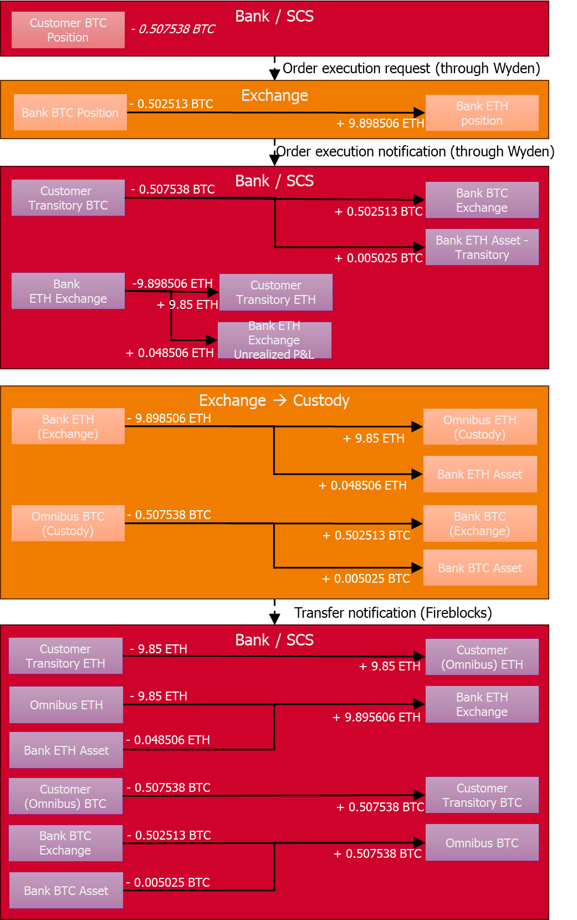

Case of Aplo
TO DO

Withdrawal
A customer transfers 0.5 ETH towards another address. There is 0.01 ETH of bank fees. There is 0.001 ETH of network fees

- Pre-trade at Bank / SCS  Reserve Customer 0.51 ETH  - Execution at custody level  Db Bank ETH withdrawal wallet 0.501 ETH  - Post-trade at Bank / SCS  Db Customer Transitory ETH 0.51 ETH  Cr Bank custody Withdrawal Wallet 0.501 ETH  Cr Bank P&L (custody) 0.009 ETH - unrealized  - Transfer between Custody Omnibus and Withdrawal wallet for customer funds  Db Omnibus ETH Custody 0.51 ETH  Cr Bank ETH Withdrawal wallet 0.501 ETH  Cr Bank ETH Asset 0.009 ETH  - Post-transfer in Bank / SCS  DB Customer ETH (Omnibus – Customer side) 1 ETH  Cr Customer Transitory 1 ETH  DB Bank custody Withdrawal Wallet 0.501 ETH  Db Bank ETH Asset 0.009 ETH  Cr Omnibus ETH (Omnibus – bank side) 0.51 ETH | 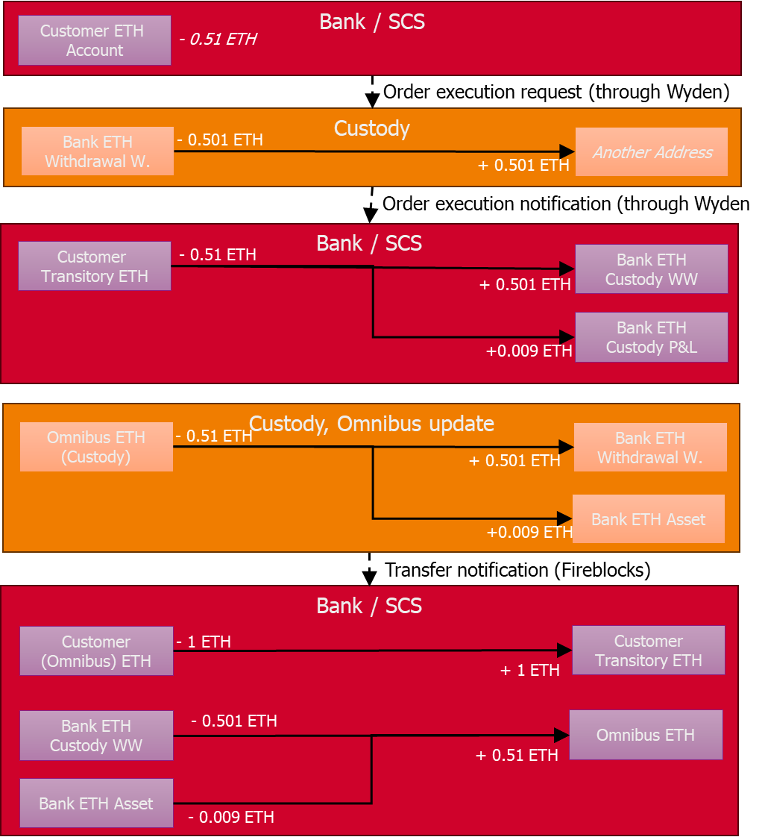
The ‘Bank ETH Asset’ is a new asset account which registers the bank own assets. The 0.009 are the ETH the bank now owns, coming from the Omnibus. They can’t stay on the omnibus, as there are not customer assets anymore.

Deposit
A customer receives 2 ETH

- Pre-trade at Bank / SCS  NA  - Execution at custody level  Cr Customer deposit address 2 ETH  - Post-trade at Bank / SCS  Db Bank custody (customer deposit address) 2 ETH  Cr Customer Transitory 2 ETH  - Transfer between Deposit Address and Omnibus  Db Customer deposit address 2 ETH  Cr Bank ETH Omnibus 2 ETH  - Post-transfer in SCS  Db Customer Transitory 2 ETH  Cr Customer ETH (Omnibus – Customer side) 2 ETH  Db Omnibus ETH (Omnibus – bank side) 2 ETH  Cr Bank custody (customer deposit address) 2 ETH | 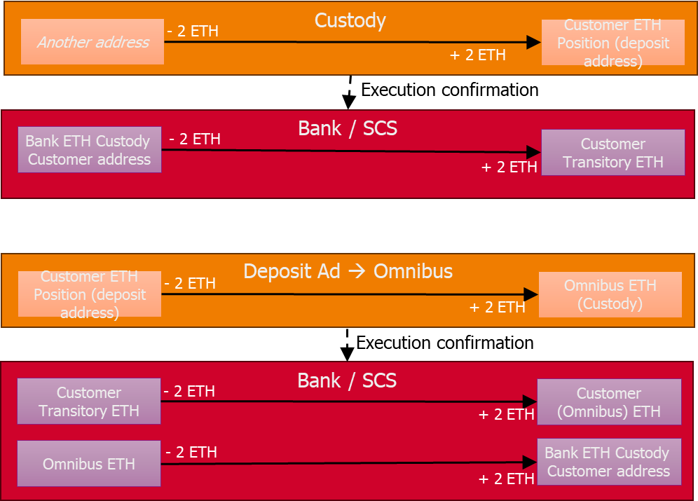
Moreover periodically there is a move of the funds from the customer deposit address to the bank omnibus wallet at Custody level. This doesn’t impact the SCS subledger [TO CONFIRM].
    - Orchestration & Operation
The orchestration layer manages request. A request represents any action triggered by the user via the UI layer. For example when the user is in a screen to initiate a withdrawal, the system generates a withdrawal request. This concept is extended to simple consultation of information: if the user wants to access his/her dashboard it’s also a request. A request has its own lifecycle: the system first controls that a request is acceptable and then submits it for execution. These controls are related to functional security and eligibility. They allow controlling that the action which is in the scope of the request is acceptable. For example if the user requests to withdrawal funds from a given account, the system will control that he/she has some rights (ownership, mandate) regarding this account, that the requested amount is available on the customer position, that the amount is under the limits, etc.
Once the request is accepted, it’s executed by the underlying services. When the request is related to a transaction (deposit & withdrawal) or an order (buy & sell) it leads to the creation of an operation which represents this execution and the related lifecycle. If the request is related to an account or an address, there is no operation as the account or the address are directly created (i.e. no need to support a complex lifecycle). Some operations are not triggered based on a request, as automatic operation (e.g. batching of withdrawal) or operations triggered by the ecosystem (e.g. a deposit is an operation which is triggered by the reception of funds which is communicated by the Custodian).
    - Custodian
Concepts at Custodian level differ from one Custodian to another. In order to be compliant with any Custodian, the focus is put on Wallet as the main concept at Custodian level. A Wallet is dedicated to a single digital asset and is a structure to register addresses and maintain keys to access the blockchain network. For UTXO-based digital asset (as BTC, cf. glossary), a Wallet can manage multiple addresses. While for account-based digital asset (as ETH), a Wallet can only have one address.
In an Omnibus approach, Wallets are owned by the bank. Except for deposit addresses which are in Wallets attached to customers.
    - Order Management System
As for Custodian, focus is put on Portfolio as the main concept at OMS level. A Portfolio is a structure to maintain an entity’s assets (digital asset positions and cash balance) and activities (orders and transactions). The bank has its own Portfolio. Bank’s customers have also Portfolio at OMS level. Let’s notice that it’s not mandatory to detail customer assets in individual portfolios (i.e. one unique customer Portfolio could be used) but doing so allows to have a double management of customer positions (in the SCS subledger and in the OMS portfolios), which can be helpful in case of issues.
    - Compliance
At compliance engine level, the main concepts are:
- User: which identifies the end-user in relation with the suspicious event. In our case the user in the compliance engine refers to the digital-asset account id.
- Alert: an alert generated based on the analysis of an event. In our solution an alert creates a task, assigned to a compliance officer (except if the configuration excludes alerts with low risks).
- Entities: the actors involved in transactions. In our case, the focus is mainly on addresses.
- Transaction and Transaction attempt: the deposit or withdrawal attempt which are screened by the compliance engine.
  - Application architecture
    - SCS Core
The Application architecture of the SCS Core is made of following components:
- The UI component, which includes the customer UI and back-office user UI.
- The Request & Operation component (implemented as a microservice), which groups the services related to request management (whatever the nature of request, i.e. could be on account or on operation), operation management and orchestration, task management and configuration
- The Subledger component (implemented as a microservice), which groups the services related to subledger and other data (as accounting events, statistics for reporting, etc).
- The Price component (implemented as a microservice), which manages the capture of price evolutions and exposes the price endpoint.
As illustrated on the here under picture.

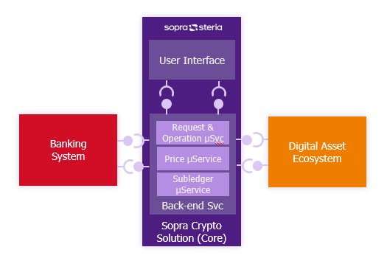
Figure 4 - Application architecture
This picture illustrates the API (Application Programming Interface) that the solution provides or consumes. These API are classified in 3 categories:
- Provided API: API which are published by the solution and that can be consumed by application ‘outside’ the SCS, as Partners or Banking System. Let’s notice that the SCS UI is relying on external API as it’s usually deployed on the internet and thus outside the SCS security zone.
- Internal API: API which are published by components parts of the SCS but only to be used by other components of the SCS. That’s the case of the subledger component API which are only consumed by the Request & Operation component.
- Consumed API: API which are provided by other applications and consumed by the SCS.

The exhaustive list of API endpoints is provided in the integration guide.

Let’s notice that the static part of the configuration service domain is also practically deployed in the price and subleger component.
    - Deployment
In term of deployment, the SCS is a hybrid solution, where the SCS Core has to be deployed on the bank premises while the components from the partners are available in a SaaS approach.
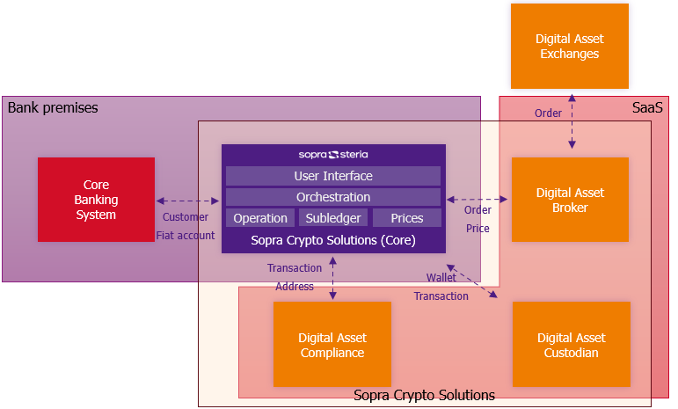
Figure 5 – Deployment
To deploy the SCS Core on bank premises, there are some minimum requirements related to the availability of a container management system as Kubernetes. Cf. the chapter 4 on technical architecture for more information.

  - Current limitations
The solution is currently developed as an ‘accelerator’: it’s not a finalized product. It offers the main features which can be adapted to each project. Some non-functional requirements have not been validated (e.g. performance) or are partially implemented (e.g. security, cf. the technical section for more information).
From a functional point of view, let’s highlight the following limitations:
- A digital asset account can only be held by one and only one customer. There is no management of more complex situation as involving households, mandates, etc. A transfer request or an order request can only be issued by the holder of the account (cf. more details on security control in dedicated section). But the data model is ready to manage such case, it’s just a question of implementing the adequate controls.
- A customer can only hold one and only one digital asset account. The model doesn’t constrain any future evolution.
- Considering the two previous point, the API endpoint to create an account doesn’t currently manage explicitly the customer id (future owner of the account): considering it’s the one linked to the user, the information is retrieved from the JWT. There is no “account label” or “account nickname” neither (in the endpoint, well in the DB) as it’s useless until a customer can hold multiple accounts.
- There is no complex management of user request workflow that could for example support user signature. But the management of request as an object distinct from the operation is there to support such feature; it allows to implement a dedicated workflow for the request, for example to collect signature(s) before triggering the execution.
- For a given digital asset, the customer can only have one deposit address and it’s automatically created. This behaviour is managed at front-end level, to simplify the user experience. But in term of model and API, nothing forbids the creation of multiple deposit addresses for a given digital asset.
- More advanced operations as staking are not supported.
- Management of bank operations, as for example wallet sweeping or exchange liquidity management, must be done manually through the tools provided by the OMS or custodian.
- Multi-bank scenario (aka multi-tenant) is not in scope yet.
- Security of API is not completely in place for now, but cf. dedicated chapter for more information on how to implement it in the scope of an implementation project.
- Management of the Fireblocks Co-Signer module, which brings a complementary layer of security on some actions. Even if this one is illustrated in the use cases (cf. next chapter), it’s currently not implemented as it can be avoided via configuration of the signature policy in Fireblocks. Moreover considering that our solution is controlling the user activity, based on access rights, and that the interactions between our solution and Fireblocks are secured, this extra layer of security is not mandatory.
- Management of different “product”, with different pricing policies. This would require managing different customer portfolio group in the OMS (Wyden), with different margin configurations. For now, we use only one customer portfolio group, in order to ease configuration.
- Management of travel rule is limited to the capture and the storage of the information, but not its transfer. There is no specific logic to identify ‘self-hosted wallet’ and to ensure its ownership.

- Functioning
The way the SCS is implementing the capabilities is described in more details in this chapter. First part provides sequence diagrams which explain the internal workflows and related business logic for the main use cases Second part provides details on the main features.
  - Introduction to the sequence diagrams
The following sequence diagrams rely illustrates interactions between ‘components’ (the lanes) which are either provided directly by the SCS or by the Banking System or by the digital asset ecosystem. For the SCS scope, these components are a bit more fine-grained than the microservices introduced in § 2.4. The objective is to have a better view on the functions which are involved.
Having a finer granularity allows also to make more easily a mapping between the application layer and the business layer, through the capabilities introduced in § 2.2.
The here under schema illustrates the traceability between these layers:
- The SCS microservices and its ecosystem (from a logical point of view) are in pale blue.
- The more fine-grained components, used in sequence diagrams, are in turquoise.
- The capabilities, from the capability map, are in beige.

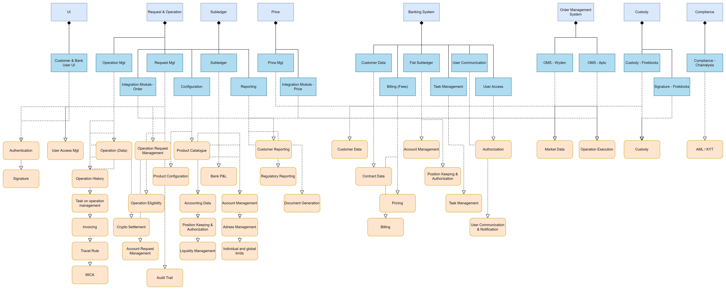
Figure 6 - Link components vs capabilities

  - Customer requests to open a digital asset account
This use case is initiated by a customer who request to open a digital asset account through the UI layer.

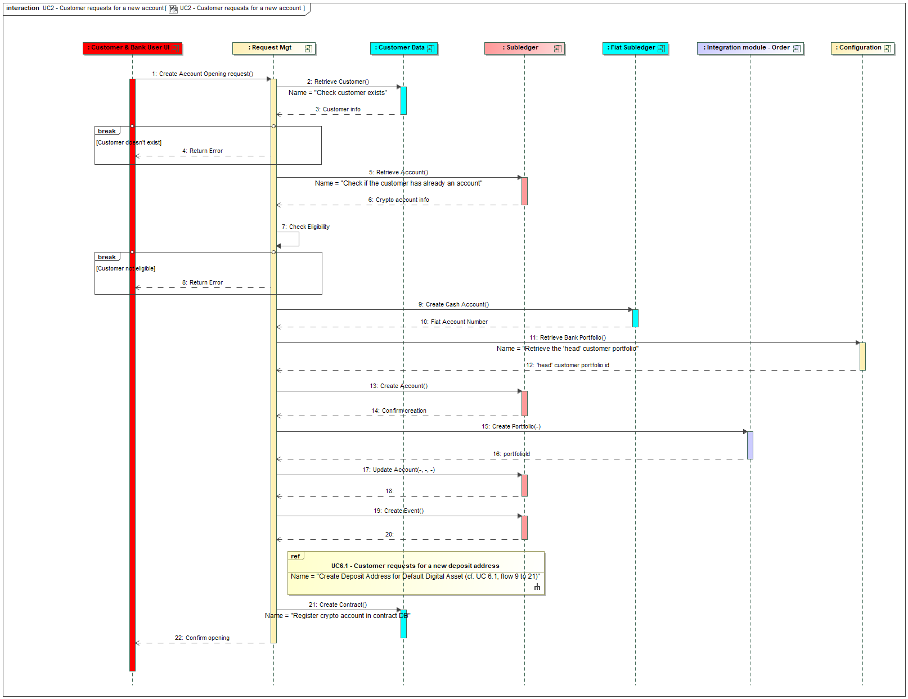
Figure 7 - Customer request to open a digital asset account

The Request Management service is orchestrating the execution of this request. The main steps are:
- From step 2 to step 7: these steps are related to the control of the request and if it can be executed. The main controls check that
  - the customer exists, by interacting with the bank CBS via a consumed API endpoint GET /customers (cf. integration guide for more details on API endpoints)
  - the customer doesn’t have a digital asset account yet, by interacting with the SCS subledger, via an internal API endpoint GET /subledger/accounts (using the customerId as query parameter).
  - the customer is eligible for a digital asset account, as for example by checking the status of the customer. This eligibility control can be overloaded by the project with its own control thanks to some EXIT POINT (cf. integration guide for more details on EXIT POINT management)
- Step 9 to Step 19 are about the execution of the request. Mainly:
  - Step 9 is about opening a fiat account in the bank fiat subledger. This account should have a specific product type in order to limit its use to digital asset activities. This type must be configured (cf. integration guide for configuration tasks). This opening is done by interacting with the bank CBS via a consumed API endpoint POST /accounts (remarks: the base-path of this endpoint is specific to the CBS, which allows distinguishing this endpoint from the SCS one).
  - Step 13 is about creating the account in the SCS subledger, this is done by calling an internal API endpoint POST /subledger/accounts. This will record a new account in the subledger database (this will also initiate the operation and position limits).
  - Step 15 is about creating a portfolio for this customer in the OMS. This is done by calling the ‘create portfolio’ endpoint of the integration module related to order management, which deals also with portfolio creation, cf. §3.13.
  - Step 17 is about updating the account in the SCS subledger in order to register the portfolio id from the OMS (cf. previous step). This is done by calling an internal API endpoint PUT /subledger/accounts.
  - Step 19 is about registering an event into the event database, that will notified to the bank CBS to potentially impact its general ledger.
  - Before step 21, the diagram includes a reference to UC 6.1 which about the creation of a deposit address (cf. § 3.6.1). The objective is to apply the sequence of interactions from step 9 to 21 from this use case to create a deposit address for the default digital asset of the solution. This will optimize the rendering of the page for deposit address creation, as the one for the default digital asset (that will be by default displayed in this page when the user accesses it) will already exist. The default digital asset must come from the solution configuration (not illustrated in the sequence diagram).
  - Step 21 is about registering this digital asset account in the bank central contract repository. Such central repository may not exist and in that case this step should be by-passed (cf. integration guide). This registration is done by interacting with the bank CBS via a consumed API endpoint POST /contracts
The API endpoint which is exposed by the SCS to the UI layer as interface for this service (which actually corresponds to the flow 1 in the diagram) is POST /accounts (cf. integration guide).
Let’s remark that the opening is directly executed, without asking a confirmation to the user. If the UI layer implements a workflow with a confirmation step, the API can be called twice: once in simulation mode (cf. § 4.1.1.c for more information on the behaviour of the simulation mode), and a second time in normal mode once the customer has confirmed his/her action.
Let’s notice that customer compliance, like KYC process, are not in the scope of the SCS. These controls must be realized by the bank at the time of the customer on-boarding.
  - Customer accesses a digital asset dashboard
This use case is accessing a UI page that displays a dashboard with its assets and activities.
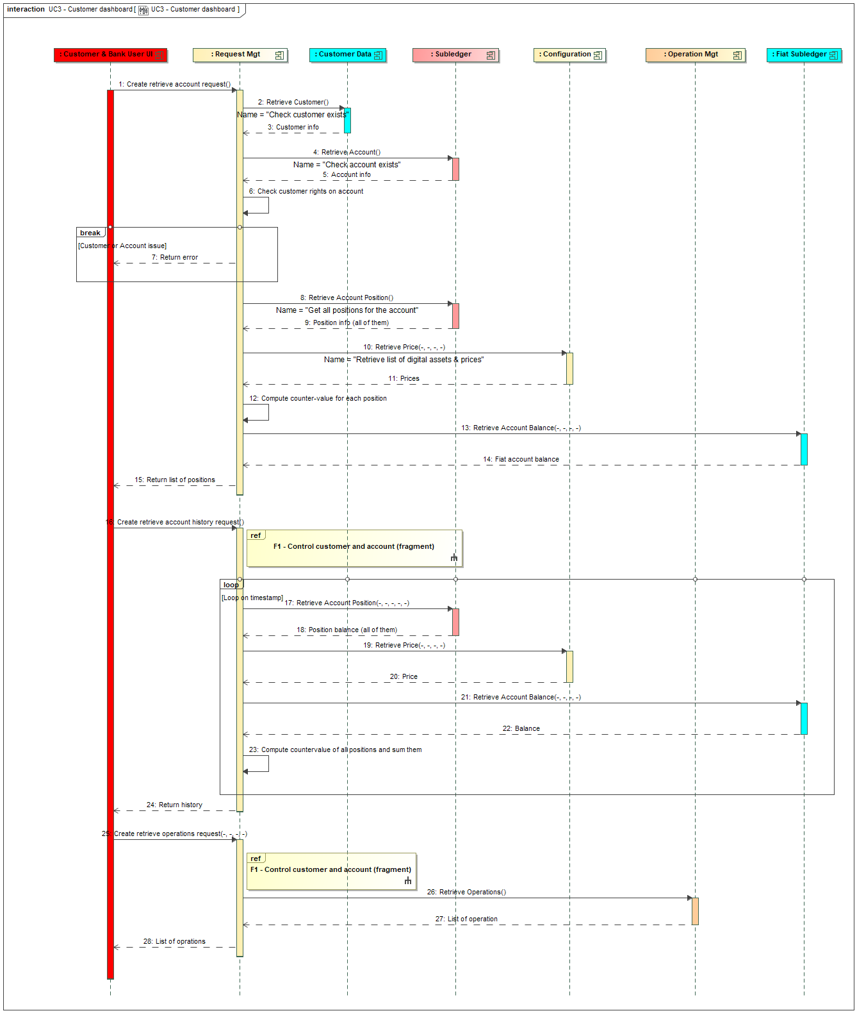
Figure 8 - Customer accesses a digital asset dashboard
The accesses to the dashboard are managed as requests, as it’s mandatory to control that the user is authorized to access the required data. The Request Management service is orchestrating the interactions with other services to provide the required data.
The diagram illustrates three interactions for building the dashboards:
- Steps 1 to 15 are related to retrieve the situation of the digital account with all its positions and their countervalues in reference fiat currency, including the fiat balance (which requires a call to the CBS API endpoint GET /accounts/{accountId}/positions). This part corresponds to the API endpoint GET /accounts/{accountId}.
- Steps 16 to 24 are related to retrieve the history of the digital account position balances, by providing on a given period of time all the valuations of the digital account positions (globalized in the reference fiat currency). This part corresponds to the API endpoint GET /accounts/{accountId}/valuations.
- Steps 25 to 28 are related to retrieve the operations (orders or transactions) which has been executed on this account. In the context of the dashboard, mainly the pending operations should be shown. This part corresponds to the API endpoint GET /operations/{accountId}. This API is accepting query parameter to filter on the operation type and operation status.

The steps 2 to 7 are related to the controls of the request: check that the customer exists (via an interaction with the CBS), that the account exists (via an interaction with the subledger) and that the user as the right to access this information. The references F1 illustrated at the beginning of the two other part of the diagram are a reference to these steps: the same controls must be applied for each request. This controls can be personalized by the bank to manage more complex situations, as management of mandates, via an EXIT POINT.

For the history retrieval, as described in the API documentation, it is built taking into account following parameters:
- a periodType, which identifies if the period has a duration of one day (value: DAY, which is returning 24 points for 24 hours), of one month (value: MONTH, which is returning 30 points for 30 days or one year (value: YEAR, which is returning 12 points for 12 months);
- a lastPeriodDateTime that contains the last date & time of the period, which identifies the last point to include in the set of points. If the period is one day, the time part allows to define precisely the period of 24 hours to evaluate. If one wants a period of one day on the complete day D, this attribute must be set at the D at 24:00:00.
- a list of digital assets. This one is optional: if not list is provided, all the positions of the customer account are included in the evaluations. Otherwise, only the positions related to this list of digital assets are included.
If the periodType is DAY, the valuations will be provided for the last 24 hours with an evaluation every hour. If the lastPeriodDateTime is the current date – time, then the last point in the evaluation is evaluated at the current data – time, but the previous ones are evaluated at the hour XX:00. If the lastPeriodDateTime is in the past, then the last point in the evaluation is evaluated at the closest hour (XX:00). This is related to the storage of price history, which only stores one price per hour (XX:00) in order to reduce the volume of data.
If the periodType is MONTH the valuations will be provided for each day from the lastPeriodDateTime – 30 days. Valuations will be made at midnight.
If the the periodType is YEAR, the valuations will be provided for the first day (at midnight) of each month from the first day of the month corresponding to the lastPeriodDateTime – 12 months.
The evaluation of a position in the reference fiat currency is done using the average rate.
This service also retrieves an evaluation of the variation in percentage of the account value over the period (cf. the field accountEvolution in the API). This percentage is computed based on the revenues realized during the period (thanks to the selling of digital assets), the funds invested in the period (via the buying of digital assets) and the difference of values (balance, without taking into account potential reservations) of the position between the end and the beginning of the period. The formula is thus:

$$Percentage of evolution=\frac{\left(Sum of the revenues\right)+\left(Value at the end\right)-\left(Sum of the investments\right)-(Value at the beginning)}{(Value at the beginning)}×100$$

Let’s remark that the evolutions of the fiat account balance are taken into account via the revenues and investments, but if there are funds which are deposited on the fiat account and not used for buying digital assets, this increase won’t be taken into account by this formula. Operations which are pending (for example a limit order not yet executed) are not taken into account.
These logics, both the way to retrieve the set of valuations on the period and the way to evaluate the evolution, can be personalized via EXIT POINT.
  - Customer logs in
This use case is described after the two previous one (account creation and dashboard) but actually comes first. The objective of this use case is to illustrate the customer log-in and how the UI layer has to be behave depending on the fact that the customer has an account or not. If the customer has no account, he/she should be redirected to the account opening page, otherwise he/she should be redirected to the dashboard page.
Let’s notice that the log-in is not in the scope of the solution, it must be provided by the bank IT landscape. This log-in step must identify the customer linked to the user and this information must be provided by the UI layer via the JWT (used in the API endpoint call).
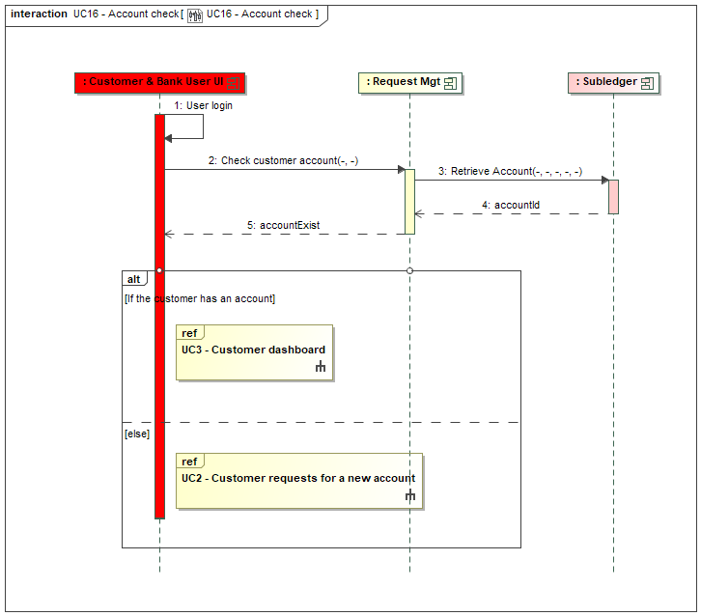
Figure 9 – Customer logs in
The main step in this use case is the step 2 which corresponds to the API endpoint GET /accounts/customer-verifications. This endpoint has no query or path parameters and no input body as the only required information is the customer id which is provided through the JWT. This step checks if the customer has already an account by accessing the subledger with the customer id.
  - Customer request to buy digital asset
This use case is initiated by a customer who requests to buy some digital assets. The order must refer to a “digital asset pair” which is made of the base digital asset (the one to buy) and the asset (can be a fiat currency or another digital asset) which is used to quote the trade and which will be used to fund the buying order. The amount to trade can be expressed either in the base currency (e.g. buy 1 ETH) or in the quote currency (e.g. buy ETH for 100 €, also known as “cash order”).
There are different ways to manage the price; the order can be:
- At market price: the order will be executed as soon as possible, using the price at the time of the execution.
- At limit price: the order will be executed when the market price reaches the provided target price. In that case it’s possible to provide a maturity: either “good till cancel” (i.e. the order remains active until it’s cancelled or the target price is reached), either “good till date” (i.e. the order remains actives until a target date or the target price is reached). In case of integration with Wyden, the order maturity is managed by Wyden. In case of integration with Aplo, the order maturity will be managed by SCS in the future (not available for now).
In the future (not available for now):
- It’ll be possible to create recurrent order (also named DCA – Dollar Cost Average – order).
- It’ll be possible to manage ‘quote’: a quote is a time-limited, binding price offer generated for an order request, which becomes the reference price for execution once accepted by the client. Managing quote could be seen as mandatory to respect MiCA requirements (cf. § 3.29.1). For now, the execution price, as provided by the OMS/broker is used to impact the customer position, even if the price shown at the time of the confirmation is different.

Cf. also the POST /order API endpoint documentation that provides the detail of information that are required to initiate the order.

In the current version of the front-end, the customer has 3 choices when initiating an order:
- Buy: which is limited to the buying of one digital asset against Euro.
- Sell: which is limited to the selling of one digital asset against Euro. Cf. § 3.5 for management of sell order.
- Convert: which corresponds to the selling a digital asset (the base one) against another digital asset (the quote one). From a back-end service perspective, it’s consequently managed as a sell order (cf. § 3.5)
Nevertheless at back-end level all buying and selling of trading pairs are possible (if the trading pairs are accepted by the bank and configured in the OMS).

This use case is illustrated with two diagrams: a first one related to the capture of the customer request, a second one related to the execution of the order.
    - Initiation of the buying order
The Request Management service is orchestrating the execution of this request. In this diagram two interactions with the UI are illustrated: a first one to control and complete (for example by providing the current price) the customer request but won’t really create it, and a second one that should correspond to a confirmation given by the customer where the order will really be created.

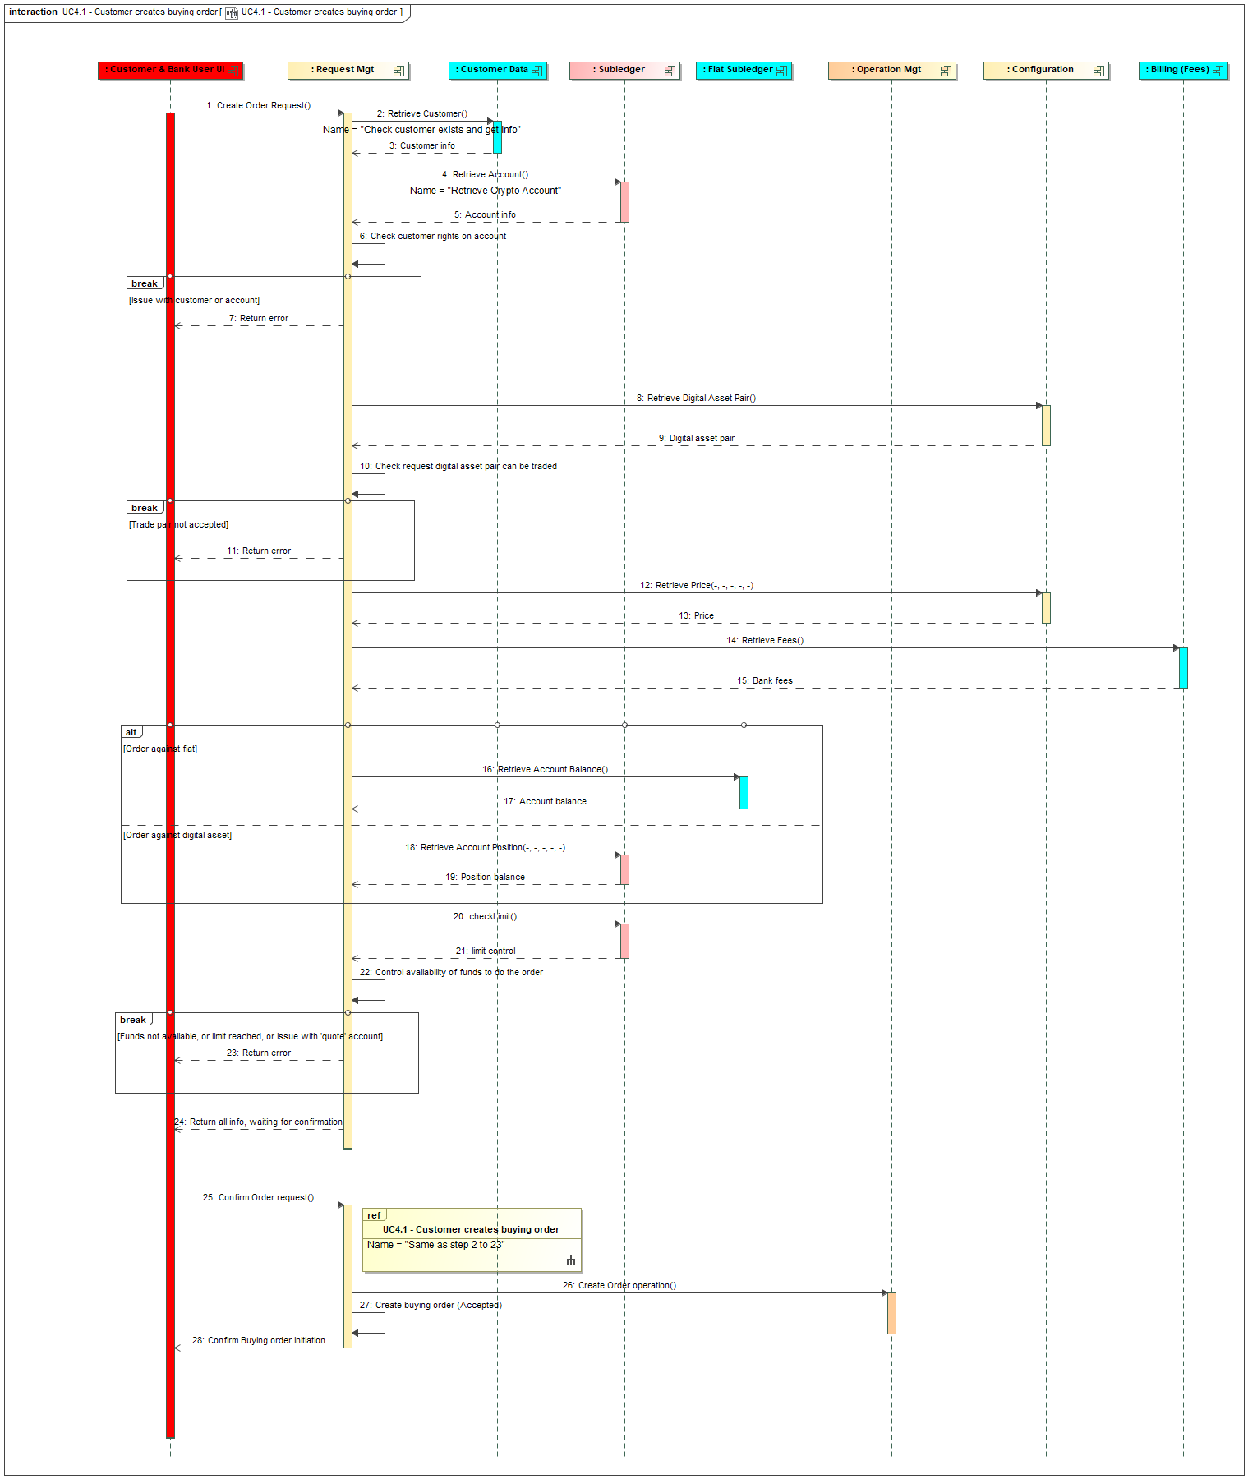
Figure 10 – Initiation of the buying order
The main steps of the first interaction are:
- Steps 2 to 7 are about controlling the request: the customer and the digital account must exist and be in adequate status. The user must have the adequate rights on the digital account to initiate such order.
- Steps 8 to 10 are about accessing the configuration to check that this digital asset pair can be traded. The order amount must be checked against the minimum / maximum amount and the minimum increment.
- Step 12 is about retrieving the price for the digital asset pair, which will be useful to control the available balance. As it’s a buying order, that’s the ‘Offer’ price that has to be retrieved.
- Step 14 is about retrieving the bank fees related to this order and in order to warn the customer and take them into account in the fund availability check. This is done via call to the CBS API endpoint POST /core-banking/customer-billable-operations in simulation mode. Bank fees are supposed to be retrieved in the fiat currency for a buy order.
- Steps 16 to 23 are about controlling the availability of the funds and the limits to initiate the order.
  - Step 14 is related to an order against fiat. It retrieves the available balance on the fiat account linked to the digital asset account. This is done via consuming a CBS API endpoint GET /accounts/{accountId}/positions. If the order is “at market price”, the last known ‘Offer’ price (cf. step 12) is used to estimate the cost of the operation. In case of market order, without relying on a quote mechanism, a margin must be taken when controlling the balance, to take into account the future evolution of the price (between the confirmation of the order and its execution). This “reservation margin” is configured at the level of the digital asset pair and must be added to the price to compute the countervalue. Except if the order is expressed in quote currency (aka cash order), as in this case the control can be based on the target volume. If the order is “at limit price”, that’s the target price provided by the customer which is used to estimate the cost of the operation (and in that case the step 12 is useless, except to return the current price to the caller, for information). Let’s notice that the price provided by the OMS (cf. step 12) should include the bank margin based on the configuration done at OMS level. The bank fees are added to the amount.
  - Step 16 is related to an order against another digital asset. It retrieves the available balance on the position of the customer related to this digital asset. The same logic applies as for fiat to control the available balance (including management of “reservation margin” for market order). The bank fees are also added.
  - Step 20 is related to control the operational and position limits, which are managed by the subledger. This is done through an internal API endpoint POST /subledger/accounts/{accountId}/limit-validations. Cf. chapter 3.15 on how to control the limits in this case.

The main steps of the second interaction are:
- The ‘Ref’ box is referring to the steps 2 to 23 of the first part of the sequence diagram that must be executed again, as the order information is not persisted between these two parts.
- Step 26 is about creating the operation that will be executed (cf. later)
- Step 27 is about persisting the order request for audit purpose (in status ‘Accepted’).
Both interactions are implemented by the same API endpoint POST /orders. The first interaction is using the endpoint in simulation mode, while the second one is using the endpoint in normal mode.
Let’s notice that it could make sense in the future to review this way of working by persisting the order information at the time of the first interaction. The request would then be stored in a status ‘Initiated’. The second interaction would then be realized through a new API endpoint that would be something like PATCH /orders/{orderId}, that would require the update of the request status to trigger its execution. This way of working can be required if there is a need to persist the order request, as for example to manage more complex workflow involving multiple signatures before accepting the order request. But for the moment, in order to keep it simple and considering the current requirements for UI implementation, this approach is not implemented.
    - Execution of the buying order
This use case is triggered by the previous one, once the operation order is created in the service Operation Mgt. This service is orchestrating the execution of the order.

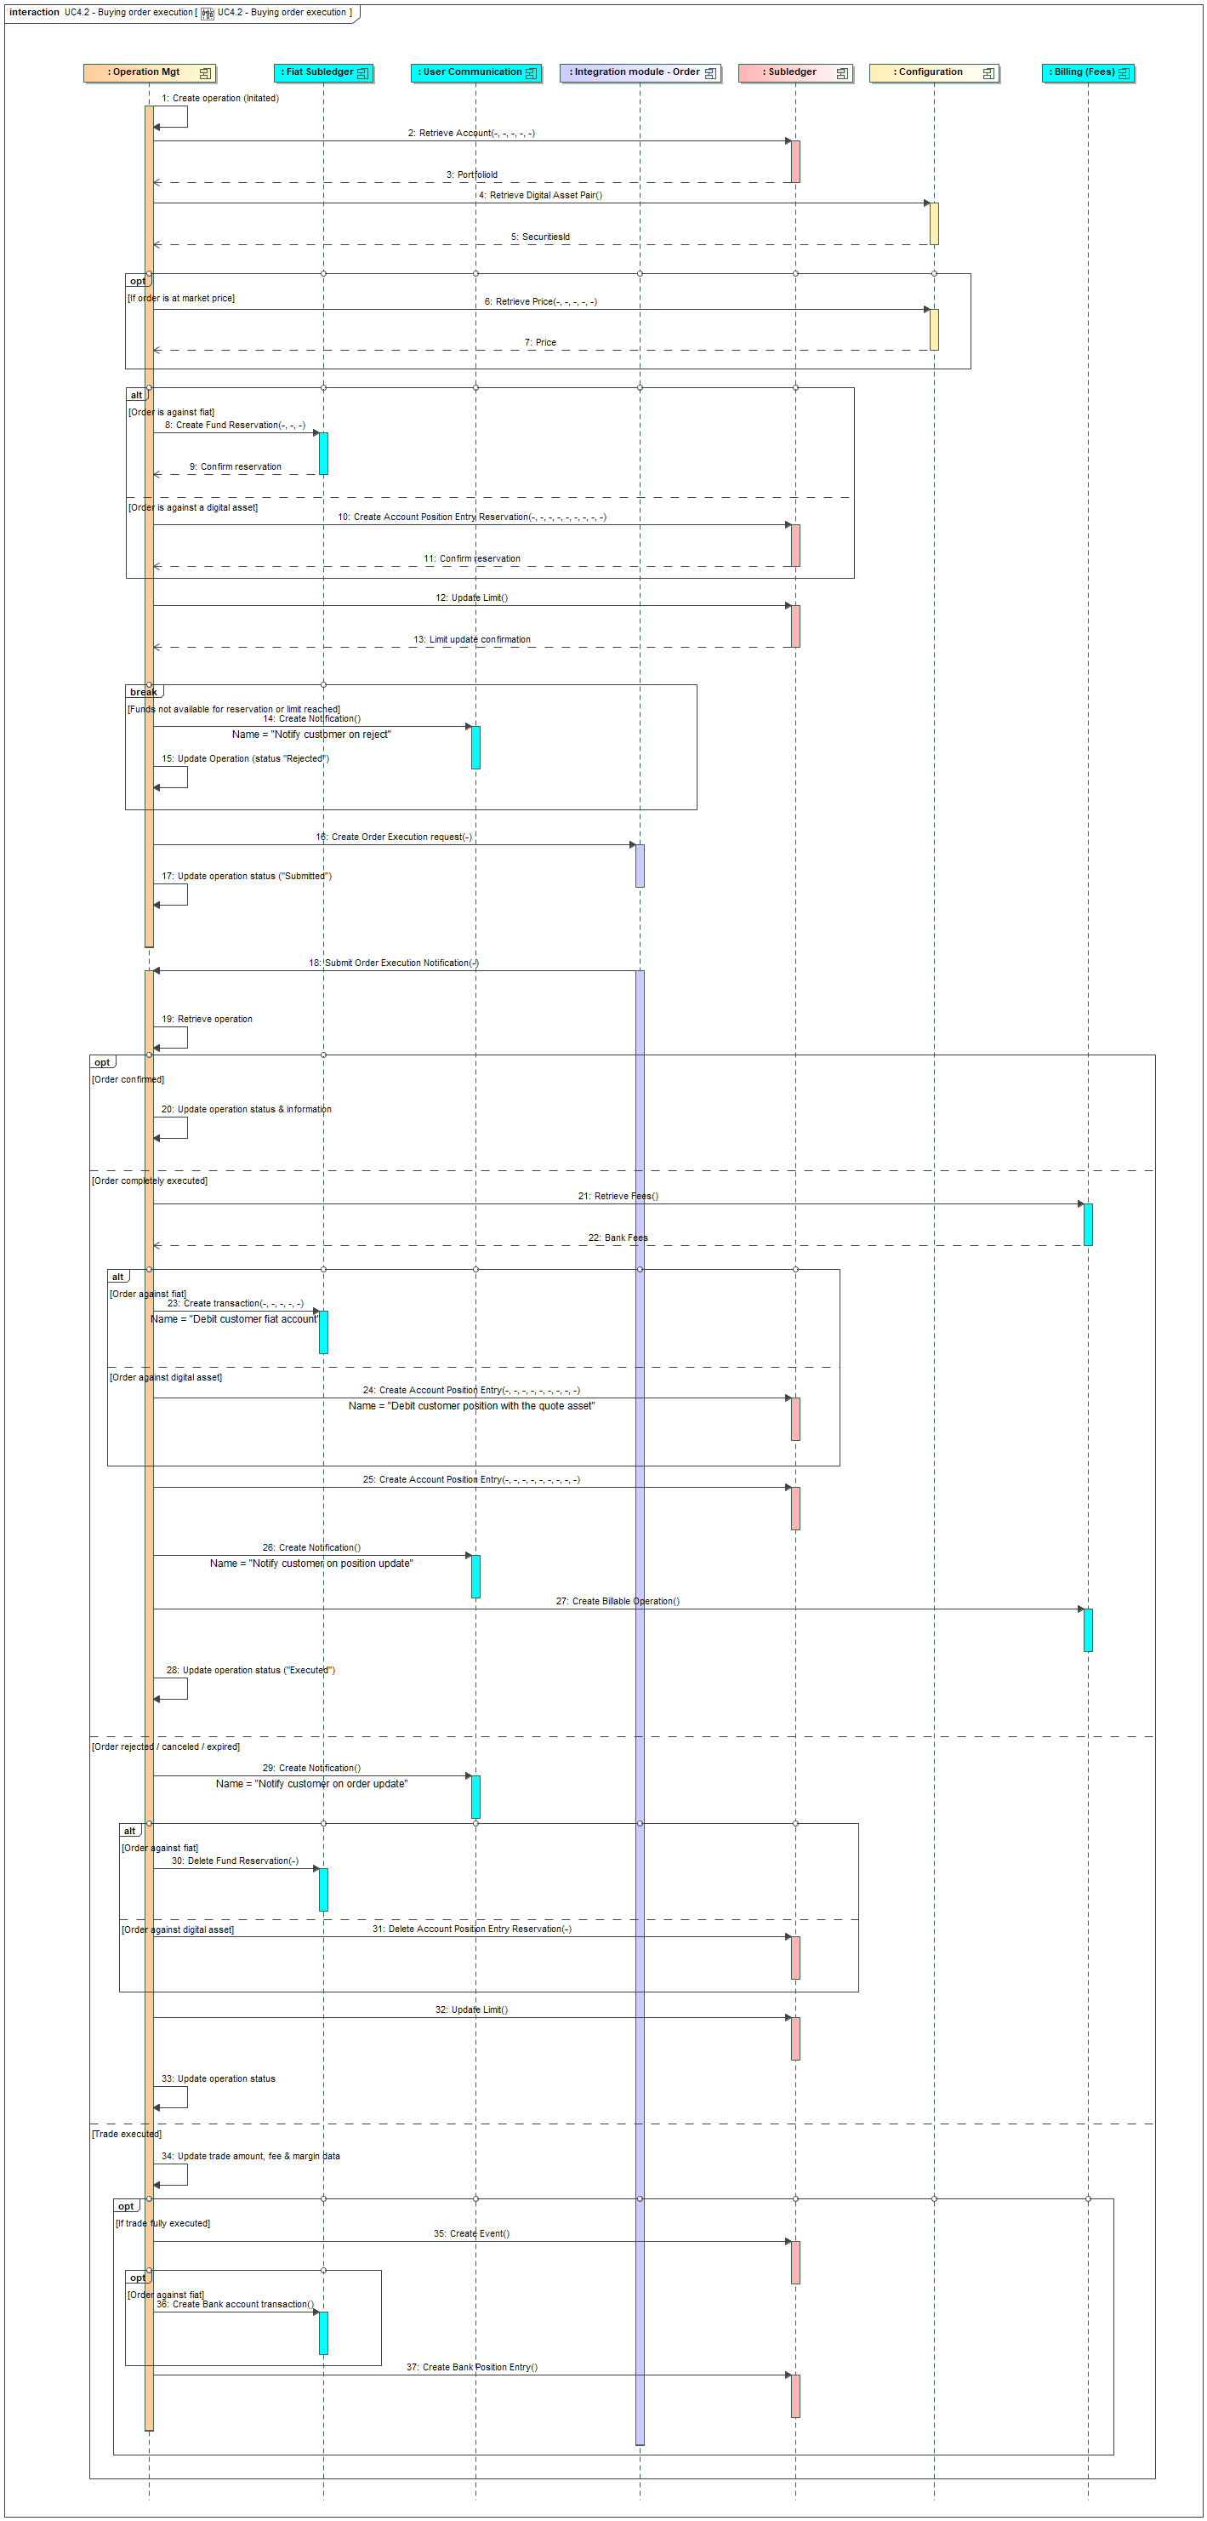
Figure 11 – Execution of a buying order

There are two main parts in this use case:
- Steps 1 to 17 are related to the transfer of the order to the OMS.
- Steps 18 to 33 are related to the update of the order based on notifications provided by the OMS.

The main steps of the first part are:
- Step 2 is about retrieving information from the digital asset account: the portfolio id of the OMS (Wyden) portfolio, which is required to submit the trade.
- Step 4 is about retrieving information from the configuration: the securities id which is linked to the trading pair, which is required to submit the trade to the OMS.
- Step 6 is about retrieving the price of the trading pair, in case of a market order, that will be used to compute the funds to block (cf. next step). The price type to use is the ‘Offer’ one, for a buying order.
- Step 8 is about blocking the funds on the fiat account if the order is against fiat. The amount to block is calculated based on the offer price of the digital asset for an order “at market” (cf. step 6 to get the price) to which the ‘reservation margin’ (coming from the trading pair configuration, cf. step 4) must be added. If it’s an order expressed in quote currency, the target quote amount is used. If it’s a limit order the amount is calculated based on the target price. The bank fees (cf. previous paragraph) are added to the amount. This reservation of funds is realized by calling an API provided by the CBS: POST /accounts/{fiatAccountId}/reservations. If the funds cannot be reserved, the operation is cancelled and the customer is notified. The notification is done by calling an API that should be provided by the CBS: POST /user-notification.
- Step 10 is about blocking the funds on the position of the ‘quote’ digital asset if the order is against another digital asset (i.e. the ‘quote’ one). The amount to block is calculated as for the fiat currency (including use of ‘reservation margin’ or target quote amount in case of an order expressed in quote currency). The bank fees are also added. This reservation is done by calling the internal API endpoint POST /subledger/accounts/{accountId}/positions/{positionId}/reservation-entries . Let’s notice that the position id must be first retrieved (via internal API endpoint GET /subledger/accounts/{accountId}/positions).
- Step 12 is about updating the position and operation limits to take into account the order. This is done via an internal API endpoint POST /subledger/accounts/{accountId}/limit-consumptions. Cf. chapter 3.15 on how to update the limits in this case.
- If the funds (either fiat or digital asset) cannot be reserved due to unavailable funds or a limit is reached, the operation is rejected (cf. steps 14 and 15).
- Step 16 is about creating the order at the OMS. This is done by interacting with order integration module and submitting an order creation request. The amount of the order submitted to the OMS is the one without the banking fees. In case of an order expressed in quote currency, a target volume expressed in the base asset must be computed, to transform the order in a ‘usual’ order. This target volume is computed based on the customer offer price (including the price margin) and the target quote amount (not taking into account bank fees or reservation margin). The transformation of this request into a call to Wyden or Aplo is detailed in § 3.13.
In response to this request, several notifications will be received, via the order integration module to inform on the partial or full execution of the order, or its rejection or cancellation.
This second part illustrates the management of these notifications.

The main steps of this second part are:
- Step 18 is triggered based on the reception of an execution notification message as pushed by the order integration module. The notification can be matched with the original request thanks to the ‘requestId’ which is present in the notification and corresponds to the id assigned by the SCS and submitted with the initial request to the integration module. The notification message contains an event type that drives the rest of the process:
  - NEW à lead to update of the operation to confirm it has been accepted by Wyden, cf. step 20.
  - PENDING_CANCEL à lead to update of the operation to confirm cancellation has been accepted, this case is described in § 3.8 that deals with the cancellation request.
  - CANCELED à lead to update of the operation to confirm it’s cancelled, cf. steps 29 to 33.
  - EXPIRED à lead to update of the operation to set it’s expired, cf. steps 29 to 33.
  - TRADE_EXECUTION à lead to update of the operation with trade execution information, cf. steps 34 and 37.
  - FILLED à lead to update of the operation to confirm its complete execution, cf. steps 21 to 28.
  - REJECTED à lead to update of the operation to inform about rejection, cf. steps 29 to 33.

- Step 19 looks for the operation in SCS DB based on the operation id provided in the notification. If the operation can’t be found, it’s a technical error and the incoming notification must be stored in DLQ for further analysis.
- Step 20 is related to the case when the order is confirmed (could be also the acceptation of the cancellation request). The status has to be updated (to ‘Pending execution’) and information on OMS id stored.
- Steps 21 to 28 are related to the case when the order is correctly executed:
  - Step 21 interacts with the CBS (or SCS for local implementation) to compute the bank fees. This is one must be computed to take into account the customer execution price.
  - Step 23 is about debiting the fiat account of the customer when the order is against fiat. This is done via a CBS API endpoint: POST /accounts/{fiatAccountId}/bookings. Rem: this API endpoint should automatically delete the reservation before booking the transaction. If it’s not the case, the API endpoint to delete the reservation should be called first.
    - In case of an order at market price (which is not a cash order, cf. infra), the amount to book must be based on the execution price, as provided by the OMS, including the price margin. To which the bank fees must be added, which needs to be computed also based on the execution price. If this amount is higher than the reserved amount, the amount is capped to the initial reservation, showing a customer price that matches this amount. This customer price is computed based on the reserved amount, based on the formula: Reserved Amount = Volume * Customer Price + Bank Fees. This adapted customer price will impact the bank margin (cf. infra).
    - In case of cash order, the amount to book is the initial one (the quote amount) plus the bank fees.
    - In case of limit order, the amount to book is the one based on the target limit price. Practically the execution price may be slightly different, but this difference will impact the bank margin.
  - Step 24 is about debiting the position of the ‘quote’ digital asset when the order is against a digital asset. This is done by calling the internal API endpoint POST /subledger/accounts/{accountId}/positions/{positionId}/entries. This endpoint should automatically remove the reservation. The same rules (as for order against fiat) apply to compute the amount to book. The bank fees must be included in the amount which is debited (as it was also part of the reservation).
  - Steps 25 is about registering the update of the digital asset position at customer level in the SCS subledger. First the position must be retrieved, based on the digital asset involved in the order. This is done by calling an internal API endpoint GET /subledger/accounts/{accountId}/positions (this step is not illustrated). Let’s remark that if the position doesn’t exist yet, because it’s the first entry related to this digital asset, the position must be then created by calling the internal API endpoint POST /subledger/accounts/{accountId}/positions (this step is not illustrated). Then step 23 allows to create a new entry by calling an internal API endpoint POST /subledger/accounts/{accountId}/positions/{positionId}/entries. (cf. § 3.8 for more details on position and entry management). If the order was expressed in base currency, the number of units to credit the customer position is the one provided by the OMS (which is depending on the execution price). If the order was expressed in quote currency (cash order), the number of units must be computed based on the target quote amount and the customer execution price. This customer execution price is available in the execution notification and is used to divide the target quote amount to get the number of units. The difference with the number of units acquired by the bank will increase the bank position (cf. later).
  - Step 26 is about notifying the end user on the execution of the order, via a call to the CBS API endpoint.
  - Step 27 is about notifying the CBS about the bank fees which have been booked on customer side.
  - Step 28 is about the update of the status of the operation (‘Executed’).
- Steps 29 to 33 are related to the case the order can’t be executed. There are 3 main reasons for a non-execution: rejection of the order by the OMS or the exchange, cancellation of the order by the customer, expiration of the order if it had an expiration date.
  - Step 29 notifies the end-user on the non-execution, providing the reason.
  - Steps 30 or 31 deletes the reservation (depending if it’s an order against fiat or against digital asset).
  - Step 32 updates the operation and consumption limit to remove the impact of the order. This is done through the POST /subledger/accounts/{accountId}/limit-consumptions (this is not a DELETE, as we want to keep a trace of consumptions).
  - Step 33 updates the status of the operation. When integrating with Wyden, some ‘CANCELLED’ status may actually be managed as a rejection (i.e. not due to an explicit cancellation request triggered by the customer). In case of a ‘CANCELLED’, the service checks if a customer cancellation request exists, and if not the status of the operation is set as ‘REJECTED’.
- Steps 34 to 37 are related to the execution report related trade execution.
  - Step 34 has the objective is to update the executed volume, fees and the margin. This information is available in the notification message provided by the integration module, for each trade execution. Information must be sum up at operation level, computing an average buying bank price (excluding bank margin).
  - The operation service must detect that it’s the last trade execution (in case of multiple execution) when the sum of all the trade execution equals the target quantity. When this target is reached:
    - The bank margin must be computed:
      - In case of a market order, which is expressed in base currency, if the debited amount (in the quote currency) on the customer account is lower than the reserved amount: the bank margin is the expected one (computed based on the difference between the customer price, captured based on notification FILLED) and the bank execution price, captured at this stage – notification TRADE_EXECUTION, taking into account the volume). If the debited amount is capped by the reserved amount, that means that the customer price has been adapted (cf. step 23) and consequently this is reflected in the bank margin. The bank margin is thus the difference between this adapted customer price and the bank execution price (taking into account the volume), which might be negative.
      - In case of an order expressed in quote currency (cash order), the margin is computed based on the difference between the customer price at the time of the confirmation of the order (the one used to determine the target base amount, which is used to trigger the order, cf. step 16), taking into account the volume.
    - An event for accounting purpose is produced, cf. step 35. All information related to the execution (as customer id, account id, amounts, fees, etc) must be registered in order to be able to feed the bank general ledger. This is done via an internal API endpoint POST /subledger/events.
    - If the order is against fiat, the bank subledger must be updated for the position related to the broker (Aplo) or exchange (Wyden). This is illustrated via step 36. Practically it requests first to identify the loro or nostro account that must be impacted. This information is retrieved from the bank position in the SCS subledger which is impacted. To identify that bank position in the SCS subledger, the ‘venue’ information from the trade execution report is used to select the right ‘bucket’. The access to the SCS subledger is done via the API endpoint GET /subledger/banks/positions – this step is not illustrated. Once the loro / nostro account is known, the CBS API endpoint POST /core-banking/accounts/{fiatAccountId}/bookings is used to update its position.
    - Then the SCS subledger must be updated for the bank positions, in line with the principles illustrated in § 2.3.1.c. This is illustrated by step 37 which is practically several steps as there are several bank positions to update. First the bank position related to the broker or exchange must be updated (as illustrated in the principles, the exchange fees must be included), whatever the order is against crypto or fiat. The position to be updated is determined thanks to the ‘venue’. To avoid having to search explicitly for the position, the subledger API endpoint POST /subledger/banks/positions/entries allows to create a new entry based on position type and position bucket. Then the P&L positions must be updated, splitting the different type of P&L (bank fees, margin and exchange fees if relevant). The same API endpoint from the subledger can be used, with adequate value for the position type, bucket and P&L type. If the bank position doesn’t exist yet, it’s created automatically (except for the fiat bank position related to exchange or broker, which must be created manually, cf. § 3.18). Moreover, if the order was expressed in quote currency, the evolution of the price between the initiation of the order and its execution leads to a difference between the funds (in base currency) provided to the customer and the ones the bank has bought. This difference must be booked on a bank position which represents its own asset.
    - Remark: these computations and updates are only possible if the FILLED notification (related to the client side of the execution) has been received, which contains the customer execution price, which is required to compute margin. If this information is not yet available, the information related to the last TRADE_EXECUTION must be stored and the processing of the FILLED notification will have to detect that this information is available and do these computation and updates at that time.
  - Customer requests to sell digital asset
This use case is initiated by a customer who request to sell some digital assets. It’s quite similar to the buying order and the same API endpoint POST /order allows to trigger it.
As for the previous use case, it’s illustrated with two diagrams: a first one related to the capture of the customer request, a second one related to the execution of the order.
    - Initiation of the selling order
There here under diagram is very similar to the one describing the buying order use case.

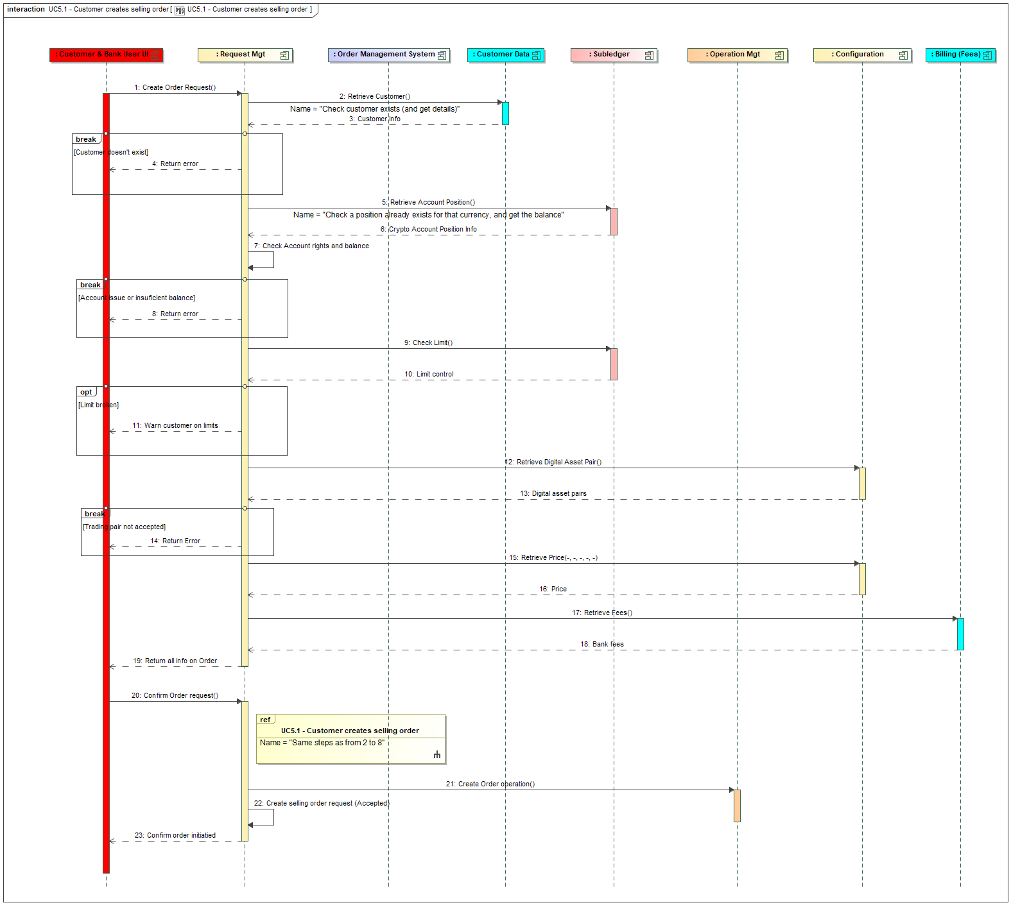
Figure 12 – Initiation of a selling order

The main differences with the previous use case are related to
- The control of the availability of the digital asset the customer wants to sell. Step 5 allows retrieving the balance of the position via the internal API endpoint GET /subledger/accounts/{accountId}/positions. Step 7 must control that the available position is sufficient to accept the order. Let’s notice that the bank fees are not taken into account in the availability check, as they will be subtracted from the received amount.
- The control of the limits. As explained in § 3.15 even if a limit is broken, the request has to be accepted, but the customer has to be warned (cf. step 11).
The other steps are similar.
    - Execution of the selling order
Here also the sequence is similar to the execution of a buying order.

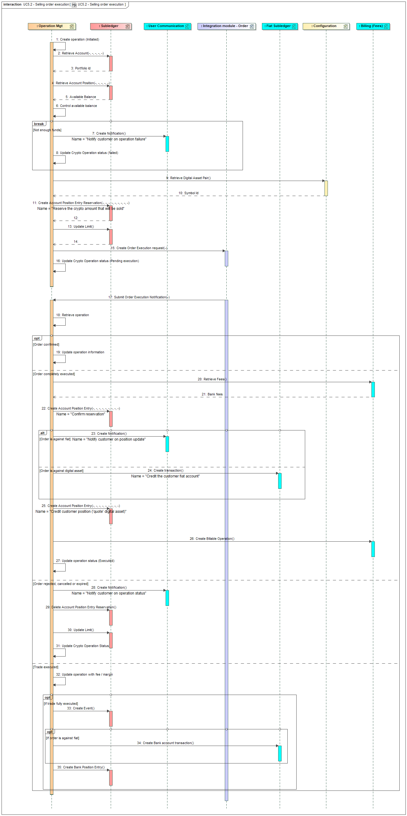
Figure 13 – Execution of a selling order
The main differences with the previous use case are related to:
- The reservation of funds before the execution of the order: in that case the reservation is made on the digital asset position, cf. flow 11 to do the reservation. This reservation is done via calling an internal API endpoint from the subledger: POST /subledger/accounts/{accountId}/positions/{positionId}/reservation-entries. Obviously the funds must be available to accept the reservation. Availability of funds must be check against the available balance of the position (and not the “full” balance) in order to take into account existing reservations or frozen funds. Let’s notice that the bank fees are not taken into account in the reservation, as they will be subtracted from the received amount.
- In case of issues the funds must be un-reserved (cf. flow 29), this is done by an internal API endpoint DELETE /subledger/accounts/{accountId}/positions/{positionId}/reservation-entries.
- The bank fees are supposed to be computed either in fiat currency, for a sell order (against fiat) and in quote currency for a convert order (a sell against another digital asset).
- If the order is executed correctly, the digital asset amounts must be subtracted from the digital asset position. This is done by the internal API endpoint POST /subledger/accounts/{accountId}/positions/{positionId}/entries that takes in input the reference of the reservation to confirm it (cf. flow 22). Next, if the order is against fiat, the fiat side must be executed, which is in the opposite direction than the buying (cf. flow 24). If the order is against digital asset, the counterparty amount in the ‘quote’ digital asset must be credited on the customer position (cf. flow 25). This position may not exist yet and in this case must be first created. In both cases (order against fiat or against digital asset), the bank fees must be subtracted from the amount credited on the position. Regarding the bank position update, all P&L are unrealized but must nevertheless be split in 3 parts to identify different PL types: bank fees, bank price margin and exchange fees.

The other steps are identical.
  - Customer initiates a deposit
A deposit is never initiated in the solution but must be done by the user in the system holding the funds he/she wants to deposit on his/her account managed by the solution. In this other system it’s a withdrawal, where the beneficiary is the account in the solution.
To be able to initiate this withdrawal in the other system, the customer must have a deposit address which can be used as beneficiary of the withdrawal. This deposit address is assigned by the SCS. The first step of this use case is the retrieval of a deposit address by the customer. Then the customer will trigger the withdrawal in the system holding the funds. Then the SCS will be notified by the custodian of the reception of the funds on the deposit address, which is the second part of the use case described in this paragraph.
    - Deposit address creation
In the current front-end implementation, the creation of a deposit address is simplified: when the user accesses the page managing deposit address, a deposit address is automatically created for the selected digital asset. The user doesn’t have the possibility to request another one if one exists already. Practically, the deposit address for the default digital asset (the one which is displayed by default when accessing the page) is already created during the opening of the account (cf. § 3.1). If the user selects another digital asset, if a deposit address doesn’t exist yet for this one, it will be created automatically, by calling the SCS API endpoint POST /deposit-addresses (cf. integration guide). Otherwise, if a deposit address already exists for this digital asset, this one will be displayed automatically.
The here under sequence diagram illustrates the behaviour of the back-end when a POST /deposit-addresses is triggered. The Request Management service is orchestrating the execution of the deposit address creation request. In this diagram there is only one interaction with the UI which is illustrated, which directly creates the deposit address. But practically the API could also be called in simulation mode to validate the request first.

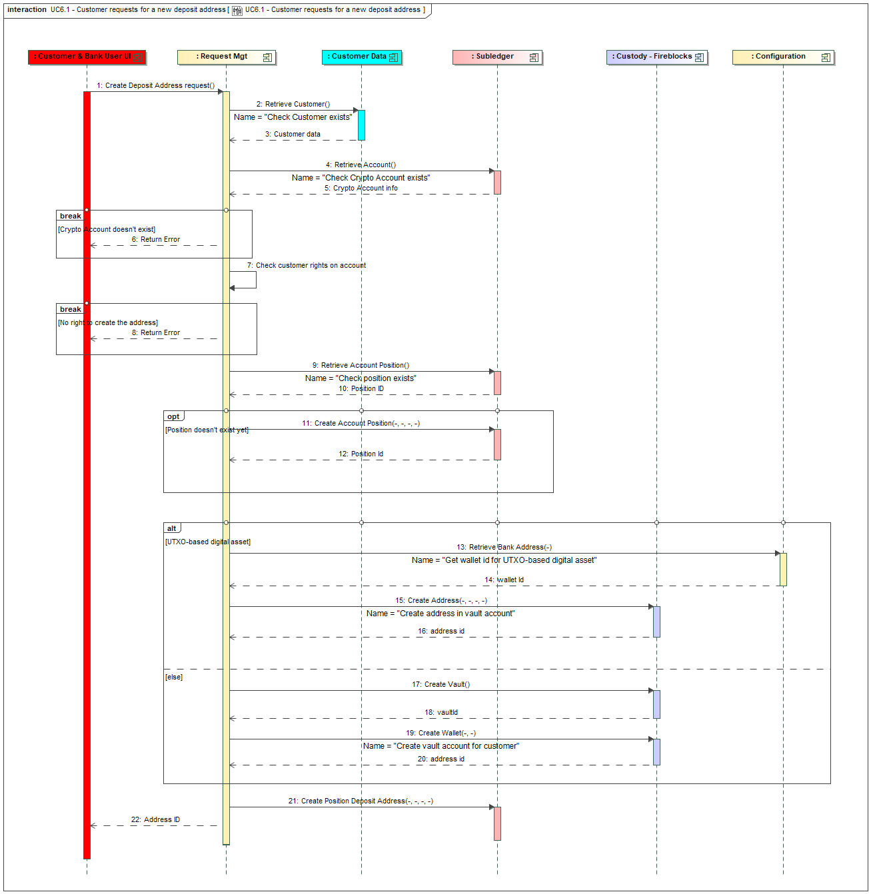
Figure 14 – New deposit address request
Main steps are:
- Steps 2 to 8 are related to control the requests: the customer must exist, a digital asset account must exist, the customer must be entitled to access it, the digital asset related to the deposit address must be traded by the bank, etc.
- Steps 9 to 12 are related to the position: a deposit address is always created for a given digital asset and a position for this digital asset must exist at account level. If it’s not the case yet, the position is created automatically (step 11).
- Step 13 to 20 are related to the creation of the deposit address by the custodian. It’s the responsibility of the custodian to assign the address. Depending if the digital asset is UTXO-based or account-based (cf. the ch. 6 – Glossary) the management of deposit address is different at custodian level (here Fireblocks is used as reference). The characteristics of the digital asset is defined in the configuration of the digital asset (not illustrated in the sequence diagram as information on digital assets is supposed to be already available).
  - Steps 13 to 16 are related to the UTXO-based case: the deposit address can be created under the bank wallet. This bank wallet can be retrieved from the configuration with the context OMNIBUS (cf. integration guide, ch. 6.1.3). Then an API from the custodian must be called to crate the deposit address in this wallet. In case of Fireblocks, the API is POST vault/accounts/{vaultId}/{assetId}/addresses (cf. https://developers1.fireblocks.com/reference/createvaultaccountassetaddress). The vaultId is to be fed with the bank wallet id retrieved in the configuration. The assetId is the identifier of the digital asset as known by the Custodian (Fireblocks), normally it’s identical to the digital asset, but the configuration of digital asset has to maintain the link between both value. The fields description and customerRefId must be both populated with the digital asset account id.
  - Steps 17 and 20 are related to the account-based case: a new vault is created for each deposit address. This is done by calling first the Fireblocks API POST /vaults/accounts (cf. https://developers.fireblocks.com/reference/createvaultaccount). In order to distinct this vault from the other one, the name of the vault should be the concatenation of “CUSTOMER-“ + the digital asset account id + the digital asset. The field customerRefId must also be populated with the digital asset account id. Then an address must be created in this vault by calling the Fireblocks API POST vault/accounts/{vaultId}/{assetId} (cf. https://developers.fireblocks.com/reference/createvaultaccountasset), which creates a wallet and the address in the same time. Let’s notice that we’ll create a vault for each deposit address, while it could be better optimized by using the same vault for different deposit addresses in different digital asset. But this is a bit more complex to manage, and as we want to support the management of multiple deposit addresses in the same digital asset for a given account, we have anyway to create multiple vaults.
  - To maintain bank position related to deposit address, a bank position must exist for each wallet that contains a deposit address. When a new wallet is created, a bank position, with a reference to this wallet must be created. The type of position is “CUSTODY” and the bucket “CUSTOMER”. THIS MUST BE ADDED ON THE SEQUENCE DIAGRAM
- Step 21 is related to the creation of the deposit address in the subledger, based on the address assigned by the Custodian (cf. previous steps). The vault id must be also stored in the deposit address, cf. field walletId in the model. The creation of the deposit address is done by calling the internal API POST /subledger/accounts/{id}/positions/{id}/deposit-addresses.
The API endpoint which is exposed by the SCS as interface for this service (which actually corresponds to the flow 1 in the diagram) is POST /deposit-addresses (cf. integration guide). In simulation mode, only the steps 2 to 8, related to request validation regarding customer and eligibility, are applied.

    - Deposit receipt
The receipt of the deposit is triggered based on a notification (webhooks) issued by the Custodian (Fireblocks). The Fireblocks environment must be configured to generate the notification to SCS URL dedicated to webhooks (cf. integration guide), which calls the SCS API endpoint POST /transaction-notifications. The information in the notification is a TransactionDetails (cf. https://developers.fireblocks.com/reference/webhooks-structures-eventtypes-transaction#transactiondetails).
Several notifications can be received (cf. field eventType):
- transaction.created that informs on the creation of the transaction on the blockchain, but which is not confirmed yet. The status field should be CONFIRMING
- transaction.status.updated that informs on updates on a transaction. The status field informs on the new status. In our context, we monitor:
  - REJECTED, which informs the deposit has been rejected
  - COMPLETED once the transaction is confirmed and competed.
We create the operation once it’s notified, so the customer knows the operation is under process, but the subledger is only updated once the transaction is completed or rejected for AML (but the position is then frozen).

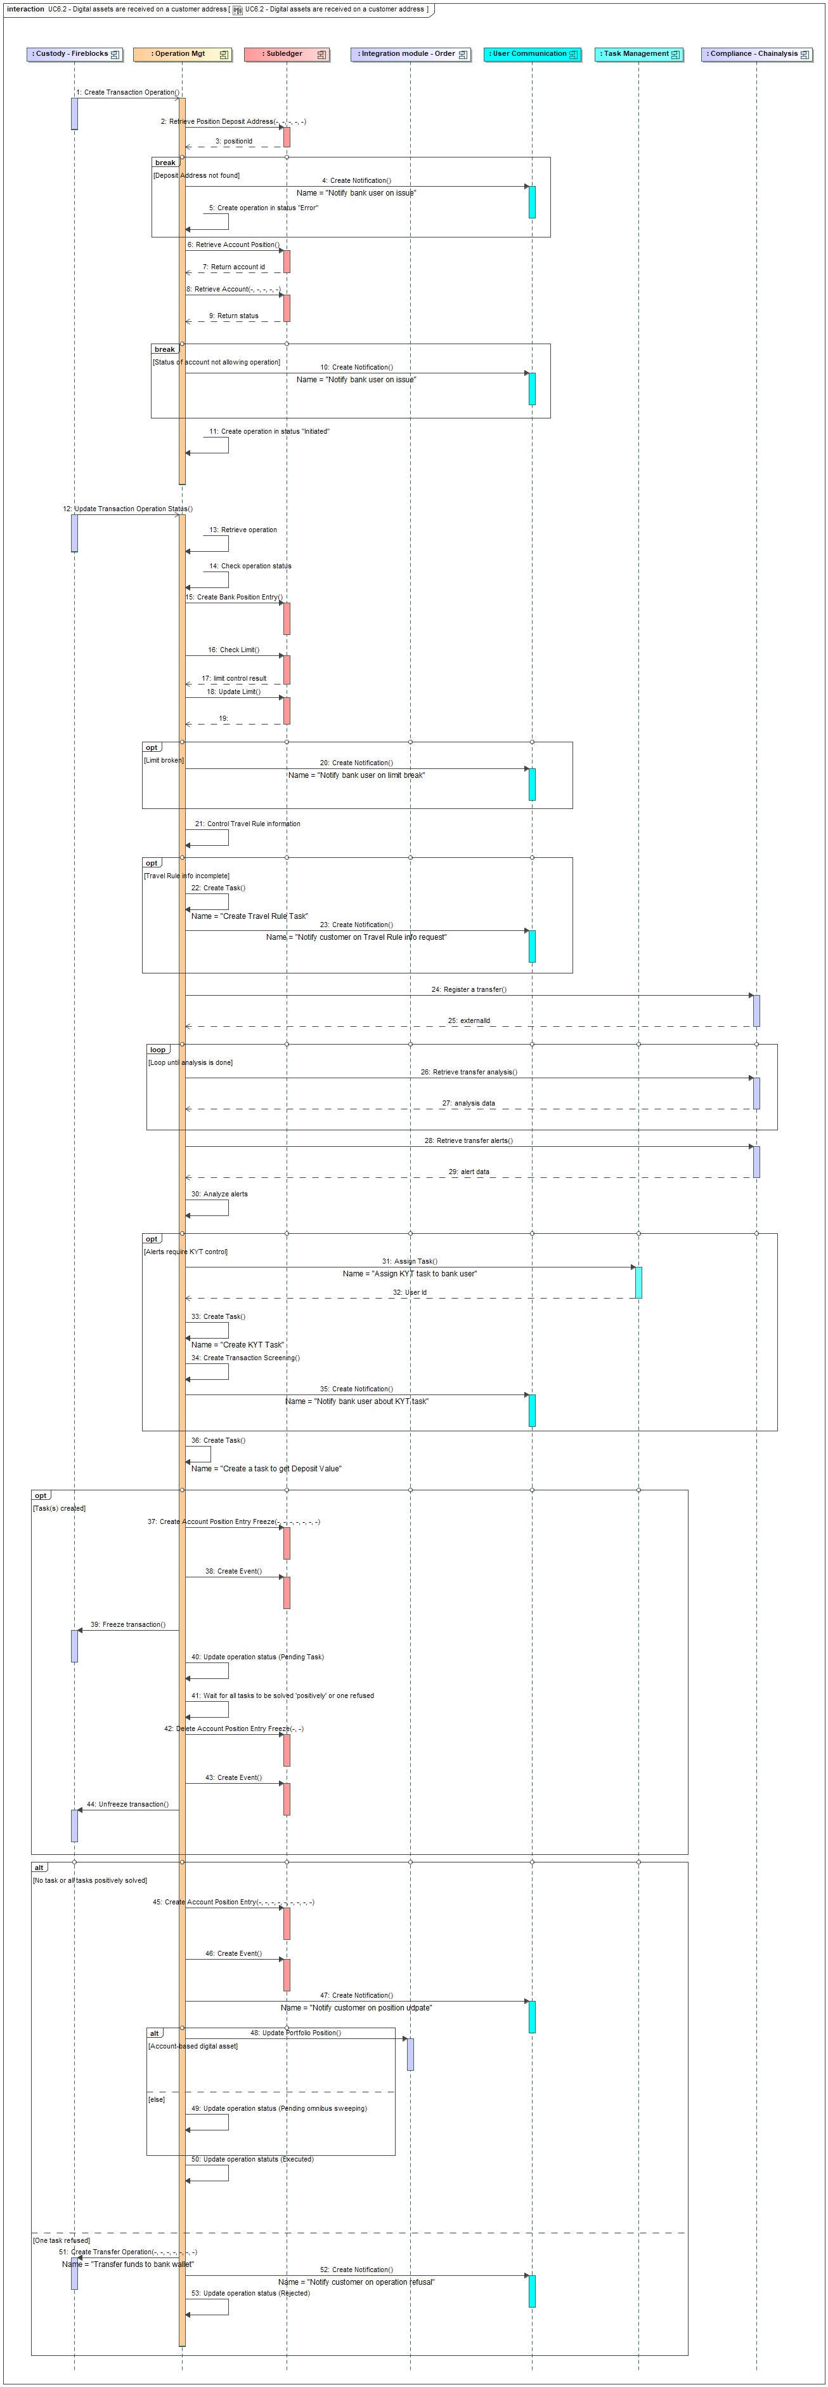
Figure 15 – Deposit receipt
The main steps are:
- Steps 1 to 11 are about the registry of the operation in the SCS database based on the first notification. The notification must contain information on the transaction allowing to create it. The destinationAddress in the TransactionDetails should be the deposit address registered in the SCS. Based on this address, the corresponding account can be retrieved (cf. step 3, via a call to an internal API GET /subledger/deposit-addresses). If the deposit address in not find in the SCS, the operation is nevertheless created but in a status ‘Error’ and a bank user must be notified (via CBS API). We need to retrieve also information on account before creating the operation. There is no check on the status of the account: if the account is blocked, the funds will nevertheless be put on the account as they are received by the bank, but the customer won’t be able to use them. If some Travel Rule information are received with the deposit notification, they have to be stored in the Travel Rule object.
- Steps 12 to 52 are about the update of the operation based on next notification.
  - Step 13 is about the retrieval of the operation, this can be done based on the transaction hash.
  - Step 14 is about the control of the operation status. Objective is to filter notification which are not relevant for this use case: the management of funds unfreezing is described in an other use case. Practically, both will be implemented in the same service.
  - Step 15 updates the bank position for the received funds (in mirror, as explained in § 2.3.1.c). This is done thanks to the SCS subledger API endpoint POST /subledger/banks/positions/entries (which will identify the right position to update thanks to the position type and position bucket which is fed with the wallet id).
  - Steps 16 to 20 are about the management of limits. There is first a control of the limits, then an update of the limits. As explained in § 3.15 limits are consumed even if there are exceeded as the deposit is received. If a limit has been broken, a bank customer is notified.
  - Steps 21 to 23 are related to Travel Rule information management. Cf. chapter 3.17 for more information on Travel Rule. It starts with a control if the transaction information contains Travel Rule information; in the current SCS implementation it should not be the case. If it’s not the case, the customer must complete the information, which is done by creating a task assigned to him/her (step 22). The customer is notified about the need to complete this information (step 23). The funds will be frozen later (cf. steps 36 and following).
  - Steps 24 to 35 are about the control of the transaction regarding KYT.
    - Step 24 initiate the deposit analysis in the compliance engine (Chainalysis), this is done by calling the API endpoint POST /users/{usersId}/transfers (cf. integration guide). The parameter usersId has to be set to the accountId, in order to group all requests per customer account. In return to this call we must store the ‘externalId’ which identifies the transaction in Chainalysis
    - Step 26 is a loop on call to Chainalysis via the API endpoint GET /transfers/{externalId} to monitor the analysis. The analysis is done once the ‘updatedAt’ attribute in the answer is not null anymore.
    - Step 28 retrieves the (potential) alerts linked to the transaction. This is done by calling the API endpoint GET /transfers/{externalId}/alerts.
    - Step 30 analyses the alert (cf. the alertLevel in the answer) to identify if the deposit is suspicious. A default logic is provided in an EXIT point that can be adapated by the bank.
    - If the deposit is suspicious, a task for the compliance officer must be created. This is done through steps 30 to 34:
      - Step 31 calls a CBS API (POST core-banking/tasks), so a user is notified that something must be done. This API endpoint must retrieve the user id to which the task is assigned, as it will be used in SCS task management.
      - Step 33 registers the task in SCS
      - Step 34 stores the detail of the screening information
      - Step 35 generates a notification towards a bank users
  - Step 36 creates a task to request the deposit value, in order to be able to compute gain for tax reporting.
  - Steps 37 to 45 are related to the management of task(s). If a task has been created (three could have been created if travel rule information is missing, the deposit is suspicious and the deposit value is required), the deposit is frozen (step 37), an event is generated (step 38) and the transaction is also frozen in Fireblocks (step 39, via a call to API endpoint POST /transactions/{txId}/freeze, where the txId is the Fireblocks internal id), then the operation is set in a status ‘Pending Task’, waiting for human action on task. Step 41 represents the fact that the process is put on hold waiting for a resolution of all tasks, cf. the dedicated use cases (§ 3.9 and § 3.10) for the resolution of tasks. If all the tasks are positively resolved or if one is negatively resolved, then the process can continue, starting first by ‘unfreezing’ the funds (cf. steps 42, 43 and 44 – this last one is a call to Fireblocks API endpoint POST /transactions/{txId}/unfreeze). Remark: in future version, it could be interesting to manage a delay while a deposit is pending for task resolution: after this delay, the deposit could be automatically refused.
  - Steps 45 to 50 are about the management of operation once it can be correctly processed. In that case the position of the customer is updated (call to the API POST /subledger/accounts/{id}/positions/{id}/entries, cf. step 45), then an event is registered to potentially impact the bank ledger (step 46), then the customer is notified (call to the CBS API, step 47) and the customer portfolio at OMS level is updated to maintain the synchronization between the SCS subledger and the OMS portfolio (step 48). This is done by calling the order integration module ‘update portfolio position’ endpoint (cf. § 3.13). Finally the operation status must be updated: if it’s an account-based digital asset, the status is set to ‘Pending Omnibus Sweeping” (step 49), while if it’s an UTXO-based digital asset, the status is set to ‘Executed’ (step 50). Deposit of UTXO-based digital asset doesn’t need to be swept as the deposit address is a ‘sub-address’ of the omnibus account. The omnibus sweeping for account-based digital asset is the scope of the next paragraph.
  - Steps 51 to 53 are about the management of operation if one task processing leads to the reject of the deposit: the funds must be transferred from the deposit address to a bank wallet (step 51, via a call to the Fireblocks API endpoint POST /transactions). The bank wallet which stores suspicious fund is defined in the configuration (cf. the ‘FRAUD’ context). Then the customer should be notified (step 51) and the operation is set in status ‘Rejected’ (step 53).

    - Deposit sweeping
In case of deposit of account-based digital asset, the funds are on a customer deposit address that should be moved to the omnibus wallet of the bank, in order to be available for future operations initiated by any customer. For now, this step is not automated by the solution; it has to be done manually using the custodian console (Fireblocks console). The reason is the cost: such operation is a blockchain operation that consumes some gas fees, which are at bank charge. If the amount on the deposit address is low, moving these fees can be too costly: for now we let the bank user decides manually when to do the sweeping depending on these costs.
  - Customer requests to withdraw digital asset
This use case is initiated by a customer who request to withdraw some digital assets. He/she must be the holder of an active digital asset account with available funds
This use case is illustrated with several diagrams: a first one related to the whitelisting of a beneficiary address, a second one related to the initiation of the withdrawal, and then specific diagrams related to the execution of the withdrawal depending on the context.
For this use case, the solution is managing the fees in an explicit way: the customer has to pay some fees which are computed thanks to a billing engine which must be provided by the CBS. The objective is that the amount in digital asset which is transferred is a net amount: the one the customer wants to send to the beneficiary. The network fees will be eventually paid by the bank (as the customer is debited of the net amount while the bank wallet is debited of the gross amount) and these ones should be compensated by the operation fees . It’s up to the bank to configure correctly its pricing engine in order to ensure these operation fees are not lower than the network fees. Cf. also dedicated paragraph on fee management (§ ).
    - Whitelisting of address
The whitelisting of an address is mainly there to isolate the capture of the beneficiary address and to warn the customer of the importance of keyed in a correct address. Moreover, it allows the customer reusing this address for multiple withdrawals. The Custodian, like Fireblocks, requires the creation of a whitelisted address as a first step to be able to use it in withdrawal operation afterwards. The SCS process is consequently aligned on this way of working. It relies on the compliance engine, Chainalysis, to do a first control on the address, to potentially warn the customer if there is a risk of fraud. It’s up to the bank to configure which kind of risk will be notified to the user and if this notification is blocking or not.
In the here under picture, the Request Management service is orchestrating the execution of whitelisted address creation request. In this diagram there is only one interaction with the UI which is illustrated, which directly creates the whitelisted address. But practically the API can also be called in simulation mode to validate the request first.

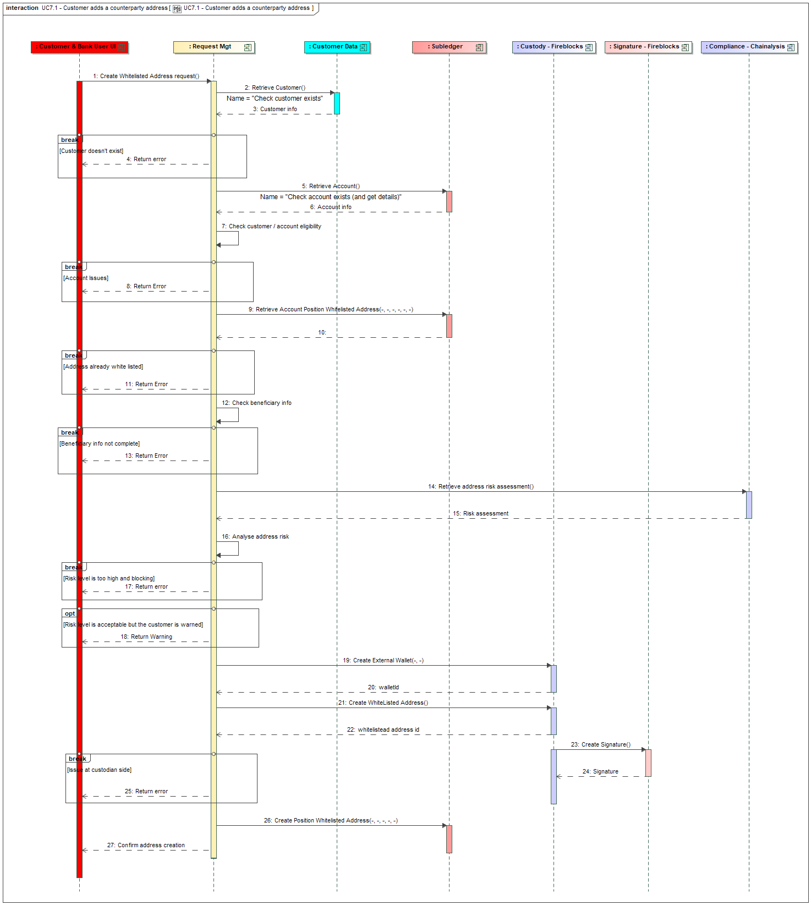
Figure 16 – Whitelisted address creation
The main steps are
- Steps 2 to 8 are the usual steps to control the request against the customer, the account and the eligibility of the customer.
- Step 9 checks that the address is not already whitelisted for this account. If it’s the case, an error is sent to the customer (step 11). Let’s notice that the same address can be whitelisted for two different accounts (i.e. this situation is not an issue).
- Step 12 checks that the party name, holder of the address, is provided. This information will be used later on to complete Travel Rule information (cf. § 3.18). If the information is not complete enough, an error is returned (step 13).
- Step 14 calls a Chainalysis API endpoint GET /entities/{addressId} to get the risk assessment level of the whitelisted address.
- Step 16 analysis the returned information to decide if the address can be accepted or not. This logic can be adapted by the bank via an EXIT POINT. 3 options are possible:
  - Block the creation of the whitelisted address, by returning an error (step 17)
  - Warn the user about the risk but let him/her decide to create the whitelisted address or not (step 18). This warning step can only work in simulation mode (cf. § 4.2.1.c), otherwise the complete logic of the service will be executed and the UI won’t be able to manage correctly the warning message (i.e. to let the user decides to continue or not).
  - Continue the process if there is no risk or if the bank estimates that the customer should not be warned.
- Step 19 creates an external wallet in Fireblocks. Cf. the Fireblocks documentation on the management of external wallet. We create a wallet for each whitelisted address for simplicity reason even if one wallet could group multiple addresses for different digital asset (but this is more complex to manage). This is done by calling the POST /external_wallets API (cf. https://developers.fireblocks.com/reference/createexternalwallet). The name of the wallet must be the concatenation of “CUSTOMER – “ and the digital asset account id. The field customerRefId must also be populated with the digital asset account id.
- Step 21 creates the address in the external wallet previously created. This is done by calling the POST /external_wallets/{walletId}/{assetId} API (cf. https://developers.fireblocks.com/reference/addassettoexternalwallet). The walletId is the id returned by the previous call, the assetId is the identifier of the digital asset to which the whitelisted address belongs. The address itself is in the body of the message, in the address field. This step creates the address in a status “WAITING_FOR_APPROVAL” at Fireblocks side.
- Steps 23 and 24 are initiated by Fireblocks based on the co-signer module which automatically signs this kind of operation, depending on the configuration of the signature policy at Fireblocks level. Cf. the integration guide for the setup of the co-signer module. These steps allow approving the address at Fireblocks level. For now, these steps are not implemented, relying on signature policy which avoids its usage (cf. § 2.6)
- Step 26 is registering the whitelisted address in SCS DB. This is done through the internal API POST /subledger/accounts/{id}/positions/{id}/whitelisted-addresses. The custodyId must contain the walletId provided by Fireblocks at step 14. Remark: as introduced in the model (cf. § 2.2.1) a whitelisted address is always linked to a position (related to the given digital asset): if a position doesn’t exist yet at the time of the whitelisting, the position should be first created (but practically this should never happen, as if the customer creates a whitelisted address, it’s to do a withdrawal afterwards, which means he/she has already a position).

The API endpoint which is exposed by the SCS to the UI layer as interface for this service (which actually corresponds to the flow 1 in the diagram) is POST /whitelisted-addresses (cf. integration guide). In simulation mode, only the steps 2 to 18, related to request validation regarding customer and eligibility, are applied.

    - Customer requests withdrawal
Once the beneficiary address is whitelisted, the customer can request a withdrawal from his/her account to this whitelisted address.
The Request Management service is orchestrating the execution of this request. In this diagram two interactions with the UI are illustrated: a first one to control and complete (for example by estimating the transaction fees) the customer request but won’t really create it (cf. usage of simulation mode), and a second one that should correspond to a confirmation given by the customer where the withdrawal will really be created.
There is no control on compliance at the time of the request creation; the control is done during the execution of the withdrawal.

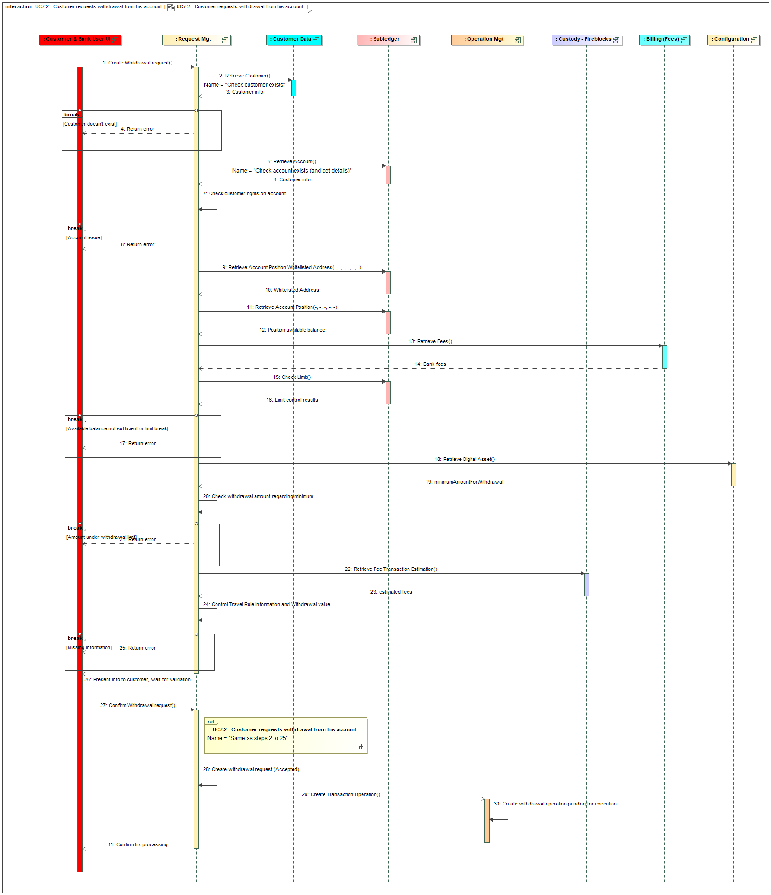
Figure 17 – Customer initiates withdrawal

First part of the diagram is related to the control and enrichment of the request. The main steps are
- Steps 2 to 8 are the usual steps to control the request against the customer, the account and the eligibility of the customer. In step 2, more detailed information are retrieved on customer, to get its name, address, etc, in order to feed Travel Rule information.
- Step 9 checks that the beneficiary address exists as a whitelisted address.
- Step 11 is about checking the available position in order to make the check on the available balance later on.
- Step 12 calls the CBS to retrieve the bank fees for this withdrawal. The computation of the fee is done by calling a Bank API endpoint: POST/customer-billable-operations.
- Step 15 controls the position and operation limits, as described in § 3.15.
- The availability check is made taking into account the requested amount to transfer plus the bank fees. If the available position is not sufficient or if limit is broken, the request is rejected (cf. step 17). Let’s notice that the withdrawal amount must respect the min / max / precision as configured at asset level.
- Step 18 is about retrieving the minimum amount for a withdrawal transaction for that digital asset, which is configured at the level of the list of digital assets the bank is trading. The objective is to refuse withdrawal with an amount lower than that amount (cf. steps 20 and 21). This check is implemented to comply with some blockchains that manage such minimum amount and to avoid that the transaction fees are too high regarding the transaction amount.
- Step 22 is about retrieving the estimation of the fees that will be taken by the network, by calling a Custodian (Fireblocks) API: POST /transactions/estimate_fee (cf. https://developers.fireblocks.com/reference/estimatetransactionfee). To call this API the complete information on the withdrawal must be provided. The network fees are available in return in the networkFee field, for different level of priority, cf. the section related to low, medium and high; we consider the medium one. The objective of this call is to be sure that the transaction is meaningful and that amount of the withdrawal is not too low regarding the fees. This should normally not happen thanks to the control on the withdrawal amount (cf. step 20), but it may nevertheless happen in case of out-dated configuration. If there is an error when calling the API endpoint (which will happen if the fees are higher than the transaction, or if the fees cannot be calculated), the withdrawal must be rejected (cf. step 25).
- Step 24 is about controlling that Travel Rule information and withdrawal value (to compute later on gain/loss in the context of tax reporting) have been provided. If it’s not the case, the withdrawal must be rejected (cf. step 25).
The API endpoint which is exposed by the SCS to the UI layer as interface for this first part of the service (which actually corresponds to the flow 1 in the diagram) is POST /withdrawals?simulationIndicator=true.

Second part is related to the real execution of the request. Main steps are:
- Same steps (from 2 to 25) as in the first part, to control and enrich the request
- Step 28 is about creating the withdrawal request in SCS.
- Steps 29 and 30 create the withdrawal operation in SCS. The Travel Rule information are automatically captured through customer data (for the originating side) and through the whitelisted data (for the beneficiary side), and stored at operation level.

The API endpoint which is exposed by the SCS to the UI layer as interface for this second part of the service (which actually corresponds to the flow 27 in the diagram) is POST /withdrawals.

Let’s notice that, as for buying and selling order management, it could make sense in the future to review this way of working by persisting the withdrawal request information at the time of the first interaction. The request would then be stored in a status “Initiated”. The second interaction would then be realized through a new API endpoint that would be something like PATCH /withdrawals/{withdrawalId}, that would require the update of the request status to trigger its execution. This way of working can be required if there is a need to persist the withdrawal request, as for example to manage more complex workflow involving multiple signatures before accepting the withdrawal request. But for the moment, in order to keep it simple and considering the current requirements for UI implementation, this approach is not implemented.

    - Withdrawal execution
Once the withdrawal request is accepted it must be executed. There are 3 scenarios to consider:
- The beneficiary is also in the bank. In that case no need to create an “on chain” operation, it’s just an update of both positions, without changes in bank position. There is no compliance check as there is no transaction and that we can consider that both bank customers are “safe”.
- The digital asset is an UTXO based asset. In that case there is a possibility to group (batch) the transactions, in order to reduce the transaction fees (even if the customer will pay for transaction fees as for a single transaction, leading to higher margin for the bank).
- The digital asset is an account-based asset. In that case, it must be a single transaction.

The first diagram is related to the identification of the scenario.
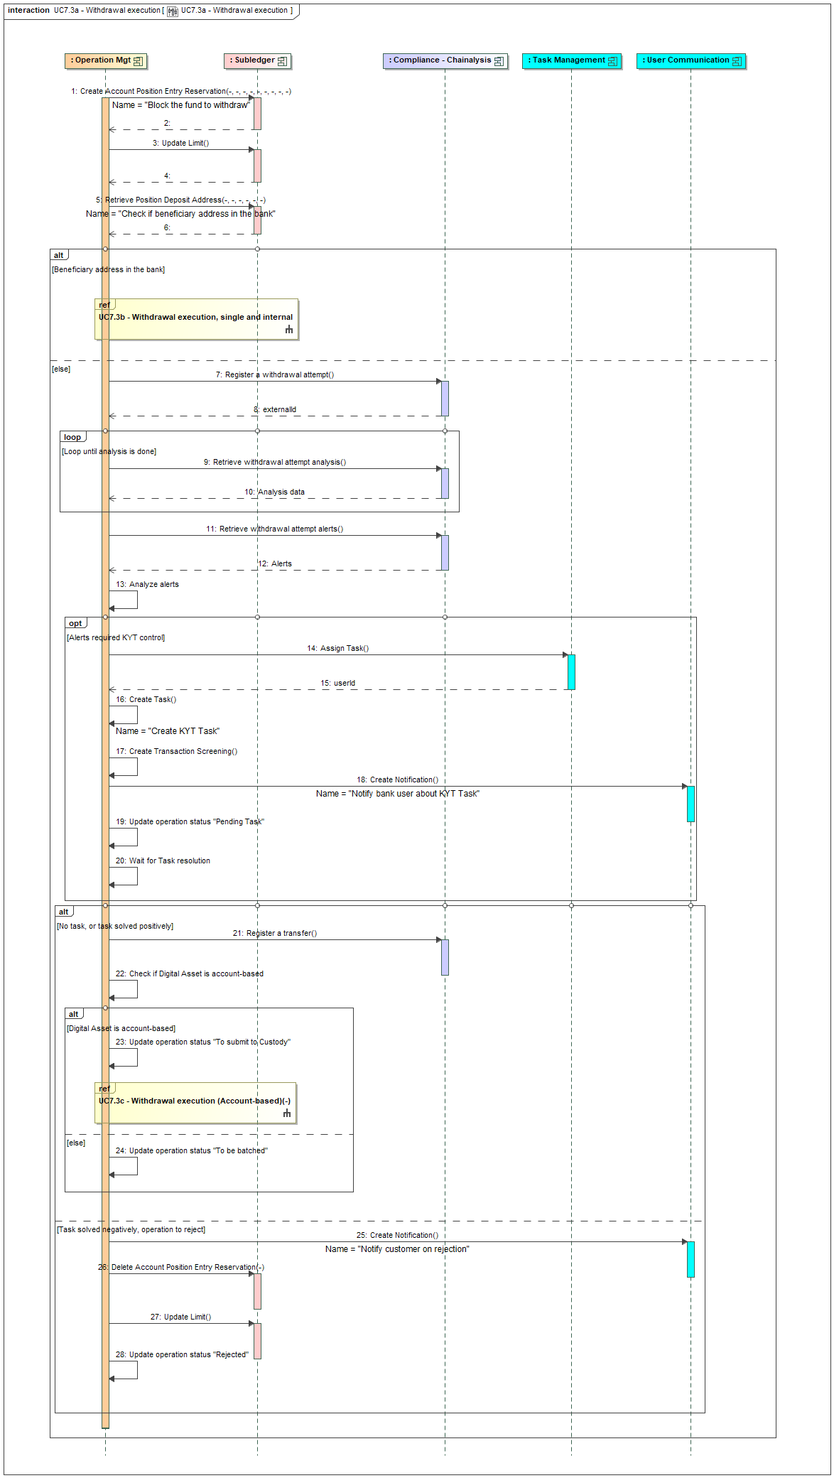
Figure 18 – Withdrawal execution
The main steps are:
- Step 1 is related to the reservation of the funds on the digital asset position, in order to avoid their use during the execution of the operation. The amount to reserved is the requested amount plus the bank fees (but network fees excluded)
- Step 3 is updating the limit consumption (cf. § 3.15 for more information)
- Step 5 is about searching for the beneficiary address in the deposit addresses which are registered in SCS. This is done using the internal API GET /subledger/deposit-addresses. If there is a match, that means that the withdrawal is “internal”.
- If the withdrawal is “internal”, cf. next diagram for its execution.
- If the withdrawal is “external”,
  - First the KYT compliance must be checked. This done by calling the compliance engine (Chainalysis):
    - Step 7 registers the withdrawal attempt in Chainalysis by calling the API endpoint POST /users/{userId}/withdrawal-attempts (cf. integration guide). The userId is the SCS accountId. In return we get a ‘externalId’ which is used to monitor the analysis
    - Step 9 illustrates a loop on call to the Chainalysis API endpoint GET /withdrawal-attempts/{externalId} to monitor the analysis. Once the analysis is done, the field ‘updatedAt’ is not null anymore.
    - Step 11 gets the details on alert from Chainalysis once the analysis done, by calling the API endpoint GET /withdrawal-attempts/{externalId}/alerts.
    - Step 13 analyses the alerts to decide if the withdrawal must be blocked for manual review or not. This logic can be adapted by the bank via an EXIT POINT.
    - If the withdrawal must be checked then:
      - Step 14 call the CBS to identify the bank user to which the task must be assigned
      - Step 16 creates the task in SCS
      - Step 17 registers the details on the compliance analysis
      - Step 18 call the CBS to notify the bank user on the task assignation.
      - Step 19 updates the status of operation to ‘Pending task’
      - Step 20 illustrates the fact that the execution process is put on hold waiting for task execution.
  - If there is no KYT suspicion or if the task is solved ‘positively’ (i.e. the withdrawal is accepted), the withdrawal can be triggered
    - Step 21 register the transfer in Chainalysis for continuous monitoring, by calling the API endpoint POST /users/{userId}/transfers, but with a direction set to ‘sent’. This step is to be done whatever there was a KYT suspicion or not.
    - Then the nature of the digital asset must be checked (step 22). If it’s an account-based digital asset, the withdrawal must be executed as a single transaction. This case is described later on. In other cases (i.e. external withdrawals for UTXO-based digital account), the operation can be batched. The step 24 updates the status of the operation so it will be batched later on, when the batch process is triggered (cf. detail later on).
  - If the withdrawal is rejected, following the processing of the task related to KYT:
    - The customer is notified (step 25)
    - The reservation of the funds is cancelled (step 26)
    - The consumption of the limits are cancelled, at least the ones still in the same period of time than initially (step 27),
    - The status of the operation is updated (step 28).

Second diagram is related to the execution of an internal withdrawal.

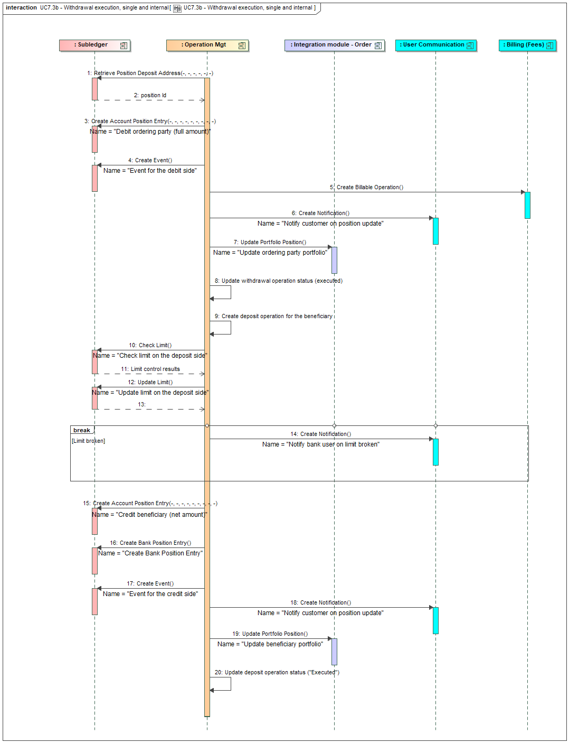
Figure 19 – Internal withdrawal execution
The main steps are:
- Step 1 is related to the retrieve of the position id related to the beneficiary address. This is done through the internal API GET /subledger/deposit-addresses.
- Step 3 is related to the debit of the position for the ordering account for the complete amount (bank fees included). This is done through the internal API POST /subledger/accounts/{accountId}/positions/{positionId}/entries. This is should automatically removed the reservation that was created previously.
- Step 4 is related to the registry of an event for the debit side. This is done through the internal API endpoint POST /subledger/events
- Step 5 is related to the notification of the CBS on the bank fees booking. This is done through a CBS API POST/customer-billable-operations.
- Step 6 is related to the notification of the customer of the withdrawal execution
- Step 7 is related to the update of the customer portfolio at OMS level, using the order integration module ‘update portfolio position’ endpoint.
- Step 8 is related to the update of the withdrawal operation (executed). The fees taken by the bank (that should be returned from the step 4) must be registered at (withdrawal) operation level, in order to justify bank P&L in the future.
- Step 9 is related to the creation of an operation to identify the deposit on the beneficiary account. Having a distinct operation for this side will ease search for operation from the beneficiary point of view.
- Step 10 and 12 are related to the control of the limits for the deposit side and its update. If there is an issue with limit control, a bank user is notified (step 14, as in the case of the deposit scenario, cf. § 3.6.2).
- Step 15 is related to the credit of the position of the beneficiary account. This is done through the internal API POST /subledger/accounts/{accountId}/positions/{positionId}/entries. The amount to credit to the position is the net amount (without bank fees).
- Step 16 is related to the credit of the bank position with the bank fees. This is done through the internal API POST /subledger/banks/positions/entries (which will identify the right position to update thanks to the position type ‘BANK-CUSTODY-PL’ and position bucket ‘BANK-FEES’, and possibly create the position if it doesn’t exist yet).
- Steps 17, 18 and 19 are similar to steps 4, 6 and 7 for the beneficiary side
- Step 20 is related to update of the operation status for the deposit side.

The third diagram is related to the execution of withdrawal of account-based digital asset.

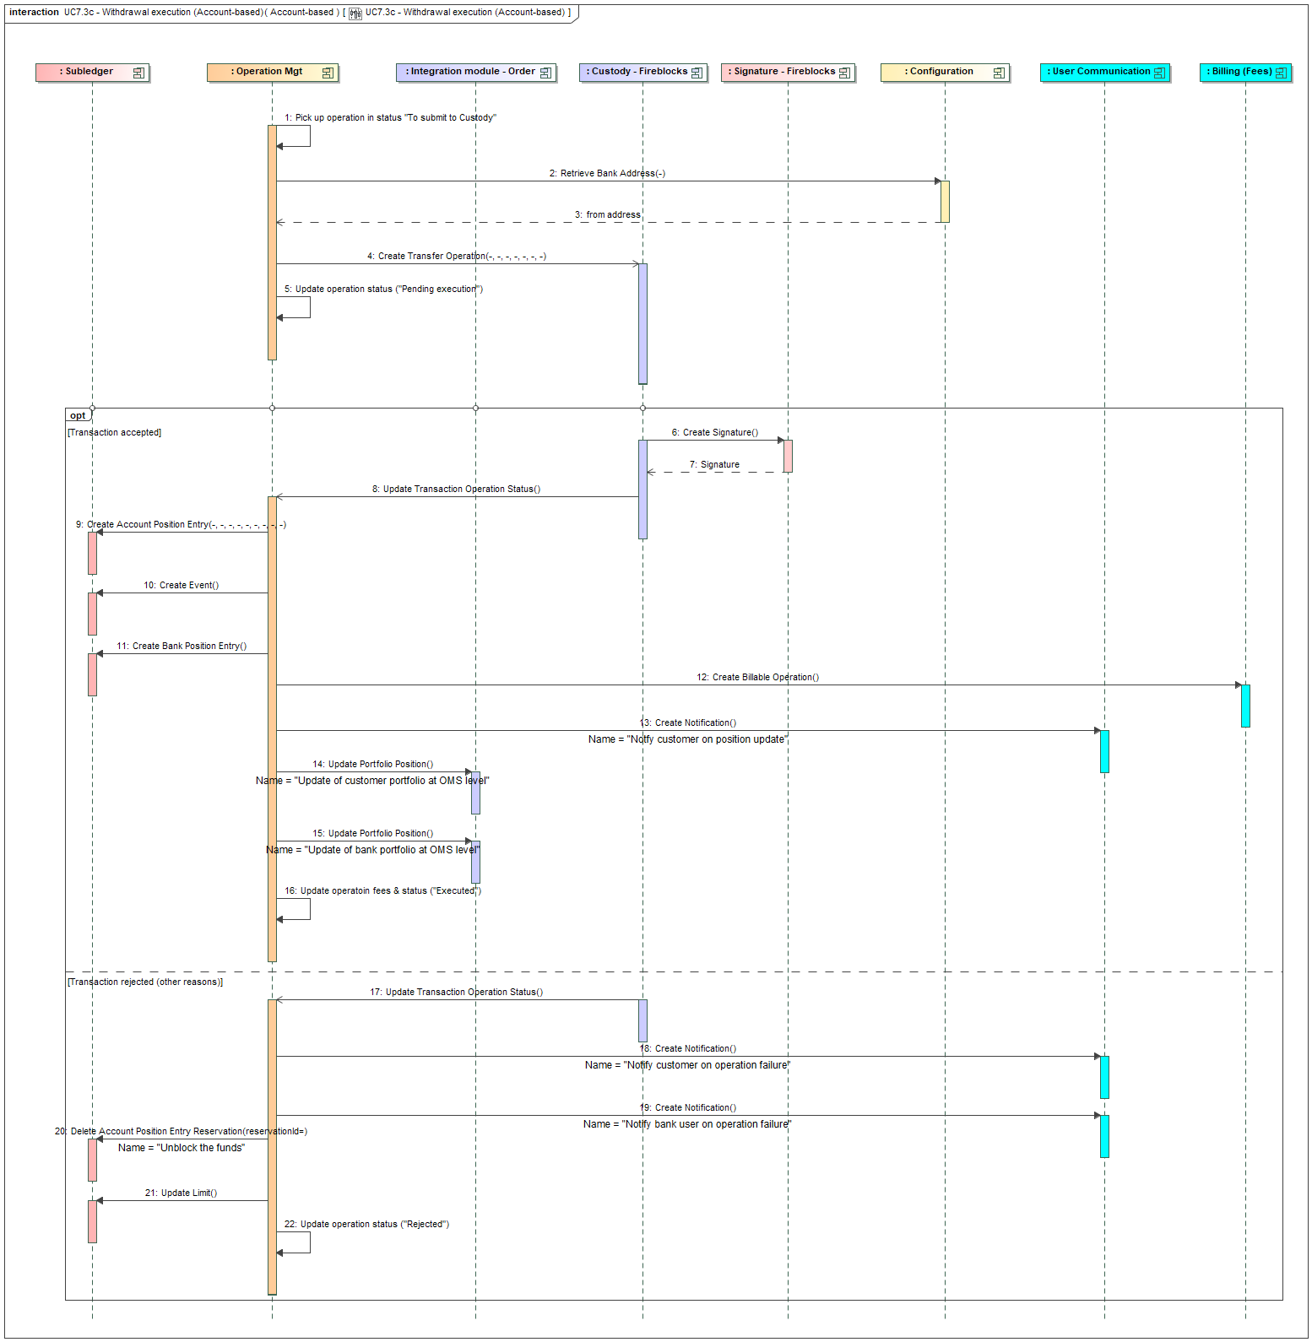
Figure 20 – Account-based withdrawal execution
The main steps are:
- Step 1 is about retrieving the operation which are pending for submit to the custodian
- Step 2 is about retrieving from the configuration the bank wallet (at custodian level) that is used to initiate withdrawal. Cf. the integration guide for this configuration. The context to use is ‘WITHDRAWAL’
- Step 4 is about creating the withdrawal in Fireblocks. This is done by calling the API POST /transactions (cf. https://developers.fireblocks.com/reference/createtransaction). In this case, it’s a single transaction (i.e one source, the bank withdrawal wallet, and one destination, the external wallet that contains the whitelisted address). The amount of the transaction is the net amount and it must be specified that the fees are to be added (in Fireblocks API, it means the treatAsGrossAmount indicator must be set to false).
- Steps 8 and 17 are identical: the reception of a notification from Fireblocks that informs us on the transaction execution, as for the deposit execution, via a call to the SCS API endpoint POST /transaction-notifications. The same wehbook and notification is used (cf. TransactionDetails, https://developers.fireblocks.com/reference/webhooks-structures-eventtypes-transaction#transactiondetails). Several notifications can be received (cf. field evenType):
  - transaction.created that informs on the creation of the transaction in Fireblocks, but which is not submitted to blockchain yet.
  - transaction.status.updated that informs on updates on a transaction. The status field informs on the new status. We can have (not all statuses are listed, only the ones that may be relevant):
    - REJECETED, which informs the deposit has been rejected
    - PENDING_SIGNATURE once the transaction is screened, but needs to be confirmed (cf. API co-signer module, steps 6 and 7), not relevant for the SCS process
    - BROADCASTING or CONFIRMING when the transaction is broadcasted on the blockchain and then confirmed by the blockchain, not relevant for the SCS process
    - COMPLETED once the transaction has been executed.
    - FAILED if an issue occurs
- Steps 6 to 16 are related to the situation where the operation is executed.
  - Steps 6 and 7 are initiated by Fireblocks based on the co-signer module which automatically signs this kind of operation, depending on the configuration of the signature policy at Fireblocks level. Cf. the integration guide for the setup of the co-signer module. These steps allow approving the address at Fireblocks level. For now, these steps are not implemented, relying on signature policy which avoids its usage (cf. § 2.6).
  - Step 8 is the processing of the notification that informs the execution. Only the status “COMPLETED” must be taken into account, other status (as for example BROADCASTING) must be ignored.
  - Step 9 is about creating the entry in the subledger to update the position, reducing it by the requested amount plus the bank fees. This is done by calling the internal API endpoint POST /subledger/accounts/{accountId}/positions/{positionId}/entries.
  - Step 10 is about the registry of an event for the debit side. This is done through the internal API endpoint POST /subledger/events
  - Step 11 is about updating the bank position in the SCS subledger. This is done by calling the SCS subledger API endpoint POST /subledger/banks/positions/entries. Several calls must be done: one for the received funds and one for each type of fees (as illustrated in § 2.3.1.c).
  - Step 12 is about informing the CBS about the booking of the bank fees, via the CBS API endpoint POST/customer-billable-operations.
  - Step 13 is about notifying the customer on the position update, via the CBS API endpoint POST /user-notifications
  - Step 14 is about updating the customer portfolio at OMS level by calling the order integration module ‘update portfolio position’ endpoint.
  - Step 15 is about updating the bank portfolio at OMS level by calling the order integration module ‘update portfolio position’ endpoint. Bank portfolio id must be retrieved from configuration (not illustrated, the context is WITHDRAWAL)
  - Step 16 is updating the operation status to “Executed”, including the update of the information related to fees: the network fees that are applied during the execution may differ from the estimation that was provided to the customer.
- Steps 17 to 22 are related to the situation where the operation is rejected
  - Step 17 is the processing of the notification
  - Steps 18 and 19 informs the customer and a bank user about the failure
  - Step 20 cancels the reservation of the funds on the customer account
  - Step 21 update the consumption limits to remove the initial consumption.
  - Step 22 updates the operation status.

The fourth diagram is about the processing of withdrawals in batch mode for UTXO-based digital asset. This process must be triggered periodically, depending on bank configuration.
Above schema illustrates the creation of one batch, but actually there will be several batches: one per digital asset, as a batch can be related to only digital assets. That means that practically there is a loop on all digital assets to foresee to trigger the batch processing for each of them.
If a batch is rejected, all its operations are submitted again as single operation in order to possibly let some of them be processed and only reject the ones which are really creating issues.

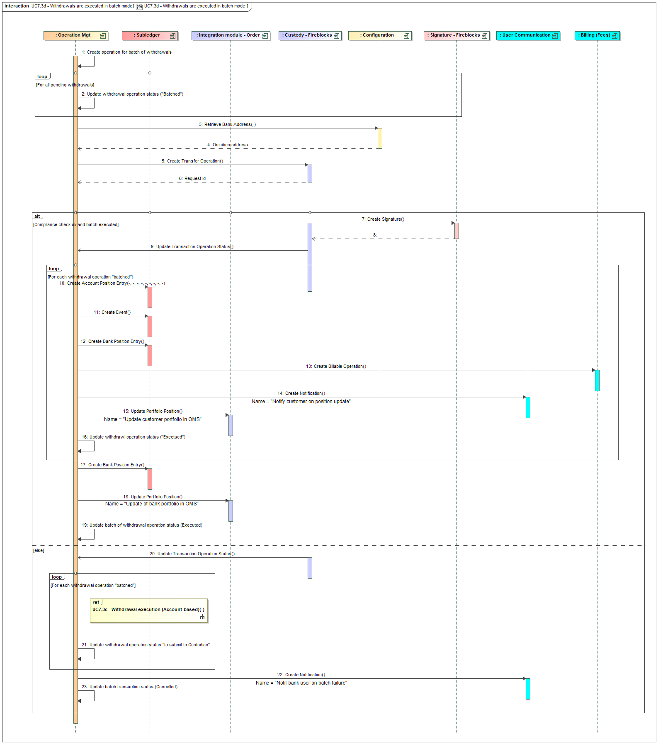
Figure 21 - Batch execution for UTXO assets

The main steps are:
- Step 1 is about creating a new operation to materialize the batch. This is an internal operation, not directly linked to a request, with a specific type (BATCH).
- Step 2 is a loop on all withdrawal pending for batch execution, to update their status to indicate that batch execution is on-going. Information about each withdrawal must be kept in memory in order to create the transaction in step 5.
- Step 3 is about retrieving the bank wallet from which the transaction will be initiated (cf. same step in previous diagram)
- Step 5 is about creating the batch transaction in Fireblocks. This is done by calling the API POST /transactions (cf. https://developers.fireblocks.com/reference/createtransaction). In this case, there is one source (the bank withdrawal wallet) and as many destinations as withdrawal operation (using the whitelisted address as destination). The amount of the transaction is the sum of the net amounts and it must be specified that the net amount has to be transferred (cf. the treatAsGrossAmount indicator must be set to false).
- Steps 7 to 17 are related to the case the batch transaction is accepted and executed
  - Steps 7 and 8 are initiated by Fireblocks based on the co-signer module which automatically signs this kind of operation, depending on the configuration of the signature policy at Fireblocks level. Cf. the integration guide for the setup of the co-signer module. These steps allow approving the address at Fireblocks level. For now, these steps are not implemented, relying on signature policy which avoids its usage (cf. § 2.6)
  - Step 9 is the notification of the batch transaction execution. Same remarks on statuses as in the previous case for single transaction execution: next steps are only applicable if the status is COMPLETED.
  - Steps 10 to 16 are done in a loop for each of the withdrawal operation
    - Step 10 is about creating the entry in the subledger to update the position, reducing it by the requested amount plus the bank fees. This is done by calling the internal API endpoint POST /subledger/accounts/{accountId}/positions/{positionId}/entries
    - Step 11 is about the registry of an event for the debit side. This is done through the internal API endpoint POST /subledger/events
    - Step 12 is about updating the bank position in the SCS subledger for the fees. This is done by calling the SCS subledger API endpoint POST /subledger/banks/positions/entries (for each type of fees).
    - Step 13 is about informing the CBS about the booking of the bank fees, via the CBS API endpoint POST/customer-billable-operations.
    - Step 14 is about notifying the customer on the position update, via the CBS API endpoint POST /user-notifications
    - Step 15 is about updating the customer portfolio at OMS level by calling the order integration module ‘update portfolio position’ endpoint
    - Step 16 is updating the withdrawal operation status to “Executed”, including the update of the information related to fees: the network fees that are applied during the execution will differ from the estimation that was provided to the customer, as they are aggregated in the batch. These fees should be equally distributed on each withdrawal.
  - Step 17 is about updating the bank position in the SCS subledger for the withdrawn amount (globally, without the fees). This is done by calling the SCS subledger API endpoint POST /subledger/banks/positions/entries. The position bucket must be filled in with the wallet id.
  - Step 18 is about updating the bank portfolio at OMS level, for the whole batch amount, by calling the order integration module ‘update portfolio position’ endpoint. Bank portfolio id must be retrieved from configuration, context WITHDRAWAL (not illustrated)
  - Step 19 is updating the batch operation status to “Executed”.
- Steps 20 to 23 are executed in case of reject of the batch.
  - Step 20 is the notification of the reject
  - Step 21 is a loop on all withdrawal operation to update their status so they can be executed as a single transaction, as for account-based digital asset (‘To submit to Custodian’). There is a reference to this use case to execute that part.
  - Step 22 is about notifying a bank user about the reject of the batch, via the CBS API endpoint POST /user-notifications
  - Step 23 is an update of the batch operation status to indicate it has been rejected.
  - Customer requests to cancel an order
When a buy or sell order is created with a limit on the price it can stay pending for execution, waiting the limit to be reached, for a while. During this time the customer can request to cancel the order. A recurring order can also be cancelled before it reaches its end date (or if it has no end date); in that case it stops the future execution but doesn’t cancel the already executed ones.
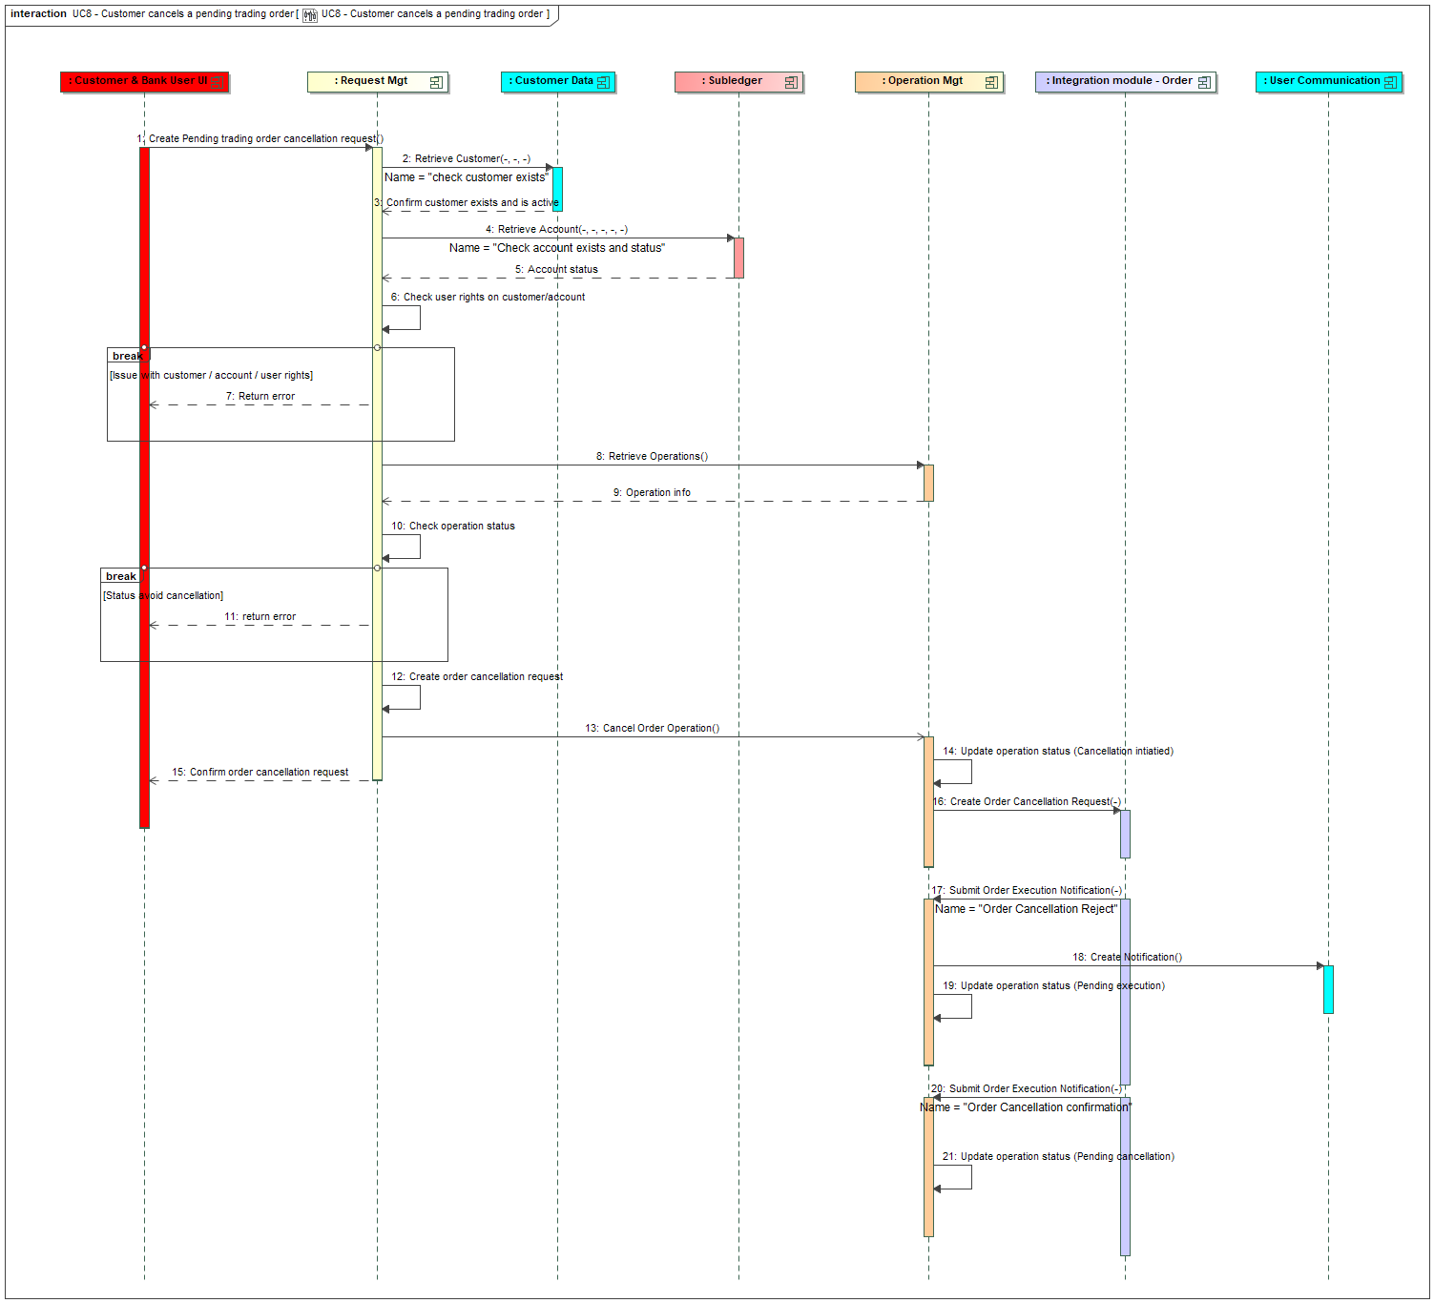
Figure 22 – Customer request cancellation of an order
The main steps in this use case are:
- Steps 2 to 7 are the usual checks on the customer and the eligibility of the request.
- Steps 8 to 10 are related to the check of the status of the operation: it must be pending, waiting for execution. If it’s not the case, the request is rejected (step 11).
- Step 12 records the request in DB.
- Step 13 triggers the cancellation of the pending operation:
  - Steps 16 is requesting the cancellation at OMS level via the order integration module, by calling the ‘create order cancellation request’ endpoint.
  - Step 17 illustrates the case where the cancellation order request is rejected, which is notified by order integration module. In this case we notify the customer (via step 18) and then update the status back to ‘pending execution’ in order to let the execution of the order continue as expected.
  - Step 20 illustrates the case where the cancellation request is confirmed, via a notification received from the order integration module (step 21).
  - The execution of the cancellation will be followed based on further notifications and is described in § 3.4.2 (for buying order) and § 3.5.2 (for selling order).

The API endpoint which is exposed by the SCS to the UI layer as interface for this service (which actually corresponds to the flow 1 in the diagram) is DELETE /orders/{operationId} (cf. integration guide). In this diagram the cancellation is directly executed, without asking a confirmation to the user. If the UI layer implements a workflow with a confirmation step, the API can be called twice: once in simulation mode, and a second time in normal mode once the customer has confirmed his/her action. In simulation mode, only the steps 2 to 11, related to request validation regarding customer eligibility and operation status, are applied.
  - Continuous monitoring
This use case is related to the continuous monitoring of transactions which is managed by the compliance engine. This continuous monitoring may generate alerts on transactions which have been already executed. If such alert occurs, a task is created in SCS and a user (compliance officer) is warned. It’s up to the compliance officer to manually take action and then close the task (cf. § 3.11). This is a background process which should run periodically, ideally once a day (but could be adjusted by the bank depending on its risk sensibility).

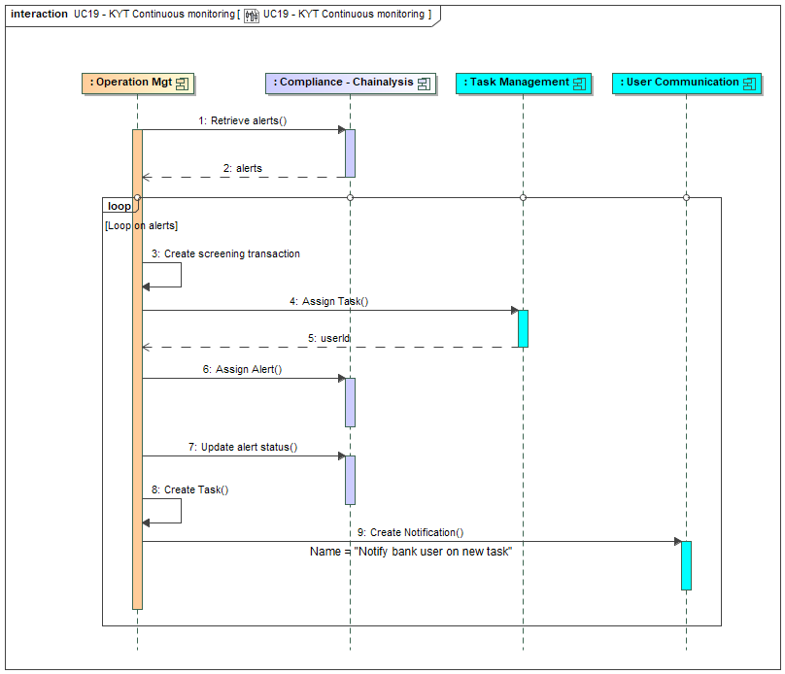
Figure 23 - Continuous Monitoring
The main steps are:
- Step 1 retrieves alerts in the compliance engine (Chainalysis) by calling the API endpoint GET /alerts. This endpoint has multiple query parameters to filter the alerts. The following filters should be used: [isContinuousMonitoring] set to ‘true’, [createdAt_gte] set to the last run of the process.
- Steps 3 to 9 are a loop on the received alerts:
  - Step 3 registers the information on the alert in SCS database.
  - Step 4 interacts with the CBS to get the user to whom the alert must be assigned to.
  - Step 6 assigns the alert in Chainalysis to the user (via his/her email address)
  - Step 7 updates the alert in Chainalysis to set its status to ‘In Review’.
  - Step 8 creates the task in SCS (the type of task is specific for continuous monitoring)
  - Step 9 interacts with the CBS to notify the bank user on the new task.

  - Travel Rule completion
When a deposit is received on a customer account, if Travel Rule information are missing (and in the current implementation, there will always be missing) the deposit is put on a pending status and a task is created asking the customer to provide Travel Rule information. This is illustrated in § 3.6.2.
This use case deals with the capture of Travel Rule information provided by the customer and triggers the next steps of the deposit execution. Practically this action is done by resolving the open task (cf. § 3.27 for more details on task behaviour).

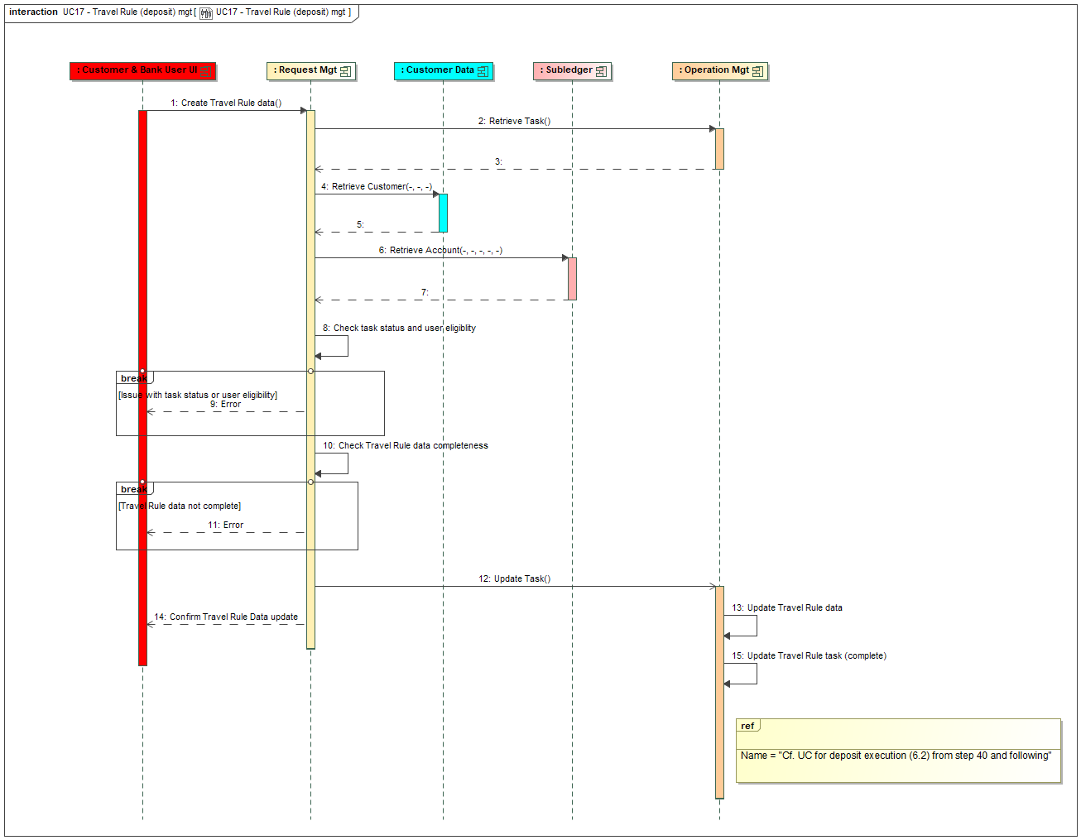
Figure 24 - Travel Rule data management
The main steps are:
- Step 2 checks the existence of the task related to the Travel Rule
- Step 4 checks the customer, owner of the account related to the operation
- Step 6 checks the account, related to the operation
- Steps 8 controls the eligibility of the request. In this context of completing a task related to missing Travel Rule information on a deposit, the following controls must be done:
  - Check user is a customer who can access the customer and account in the scope of the deposit
  - Check the task: it must be a ‘Travel Rule’ task and its status must be open and must be assigned to that customer.
  - Check the status of the operation: must be ‘Pending Task’.
If one of this control is not ok, an error is generated (step 9)
- Step 10 checks that the Travel Rule data are complete (cf. § 3.18 for required data) but not really its validity (except from a format point of view).
- Step 11 returns an error to the user if the previous check is not correct.
- Steps 13 and 15 updates the travel rule info and the task, which triggers the next steps of the deposit execution, which is described in the UC related to deposit execution (cf. § 3.6.2) from step 40.

The API endpoint which is exposed by the SCS back-end layer to the UI is a PATCH /tasks/{taskId}. This API endpoint manages a ‘simulation mode’ as for other use cases. An API endpoint GET /tasks exists to first retrieve the list of tasks, which can be filtered by user, by type, etc (cf. API documentation).
  - KYT task management
This use case describes the management of task assigned to compliance officer related to suspicion of frauds on transaction. These tasks are created based on alerts raised by the compliance engine (Chainalysis) on deposit or withdrawal attempts or during continuous monitoring. Cf. also more general description of task management in § 3.27.
There are 4 possible options:
- The task is updated, the user is completing some information (e.g. note) or assigning it to another user. The user can also request some justification documents to the customer, this leads to the creation of a new task assigned to the customer.
- The task is closed considering that the transaction is not suspicious. In case of deposit, this triggers the update of the customer balance. In case of withdrawal this triggers its execution.
- The task is closed considering that the transaction is indeed suspicious and must be rejected. In case of deposit, this triggers the transfer of the received funds on a bank wallet; the management of these funds must be manually processed in agreement with the authorities. In case of withdrawal, the withdrawal is rejected.
- The task is closed and related to continuous monitoring alerts; in that case there is no update on the transaction; it’s up to the compliance officer to take manual action (as for example block the account) if needed.

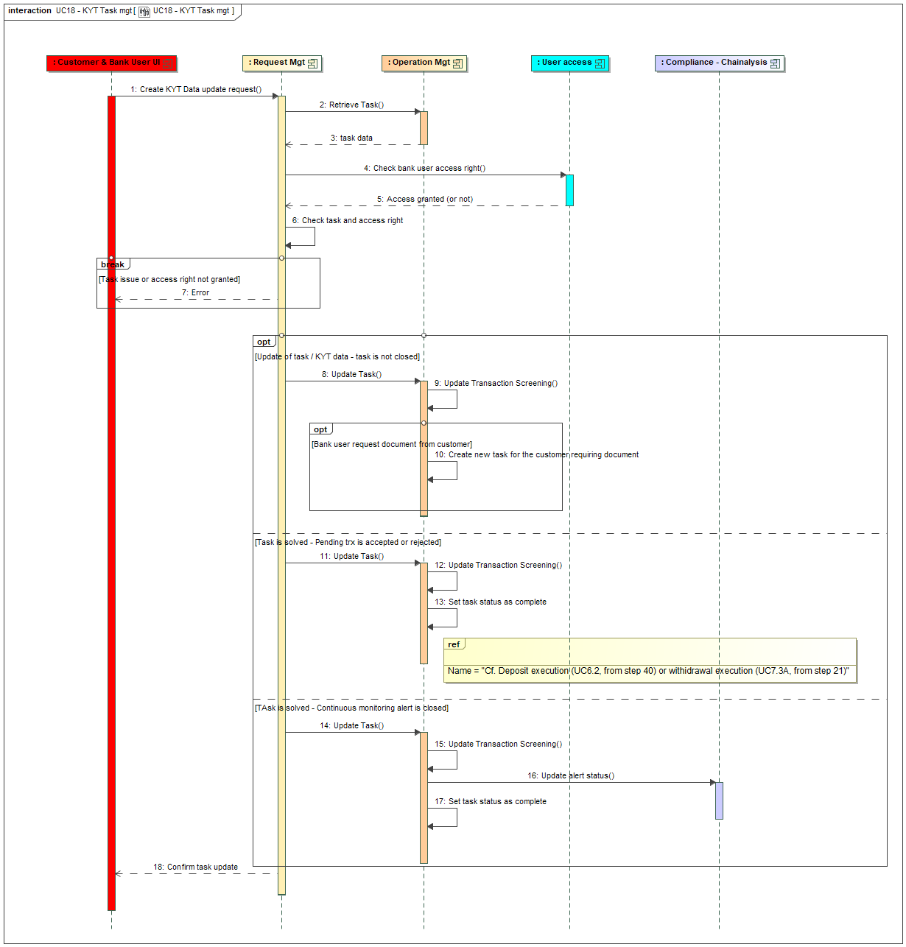
Figure 25 - KYT Task management
The main steps are:
- Step 2 checks the existence of the task related to the KYT issue
- Step 4 checks the user access right related to this action, by calling a CBS API endpoint POST /core-banking /bank-user-access-controls (cf. integration guide)
- Step 6 controls the eligibility of the request. The previous step must have confirmed the user is granted to do such action. The task must be in status ‘to complete’ and be related to KYT issue or KYT continuous monitoring alert. If one of this control is not ok, an error is generated (step 7)
- Steps 8 to 10 are related to an update of the task and the related ‘transaction screening’ data. Possibly a new task can be created if the user request some justification documents to the customer. This new task is assigned to the customer and of a ‘document request’ type.
- Steps 11 to 13 are related to the resolution of the task, either to accept the transaction or to refuse it. The processing of the transaction is managed in the related scenario: cf. § 3.6.2 from step 40 for deposit or cf. § 3.7.3, main use case from step 21.
- Stesp 14 to 17 are similar as previous in the case of the resolution of a task related to continuous monitoring alert. Step 16 is updating the status of the task in Chainalysis, via the API endpoint POST /alerts/{alertIdentifier}/statuses to set it to ‘Dismiss’.

The API endpoint which is exposed by the SCS back-end layer to the UI is a PATCH /tasks/{taskId}. This API endpoint manages a ‘simulation mode’ as for other use cases. An API endpoint GET /tasks exists to first retrieve the list of tasks, which can be filtered by user, by type, etc (cf. API documentation).

  - Price management
The SCS is maintaining the prices of trading pairs in its own database. This historical information is required to build the evolution of portfolio value (cf. § 3.2). We rely on a market data provider to get the information.
A price for a trading pair is depending on the following dimensions:
- The time
- The type of price. We manage 3 types:
  - Bid: the price proposed by the actors who’re looking to sell the asset. It’s this price we use to evaluate the value of a selling order and evaluate the value of the portfolio.
  - Offer: the price proposed by the actors who’re looking to buy the asset. It’s this price we use to evaluate the value of a buying order
  - Average: the average price computed based on the Bid and Offer ones
- The margin, which depends on the account type. The margin can be included in the price provided by the market data provider, if it’s configured at that level (as it can be the case for Wyden) or can be managed by SCS when it’s not managed by the market data provider or easier to manage at SCS level (as it’s the case for Aplo)
Currently we support Wyden and Aplo as price providers. The following sequence diagrams illustrates the two possible integrations.
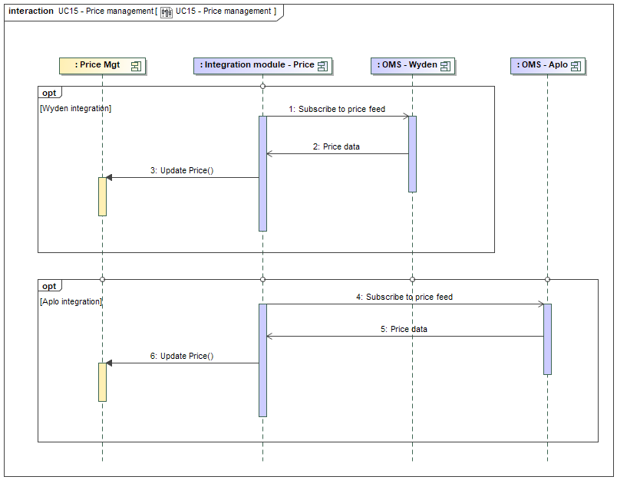
Figure 26 - Price management
In case of integration with Wyden, it starts with a first FIX message to subscribe to market data update (step 1): MarketDataRequest (V), which is then followed by a set of MarketDataSnapshotFullRefresh (W) which contains the information (step 2). The subscription message is triggered in the integration module. It receives a new W message each time there is a change in price, which can occur very often. These W messages are received indefinitely until there is an issue or if the FIX session is stop. We don’t store the price evolution continuously but only every hour, at XX:00. We could also receive a message MarketDataRequestReject (Y) in answer to the request if there is an issue with the request.
The structure of the messages is:
- MarketDataRequest(V), cf. https://doc-infinity.wyden.io/inboundfixguide/index.html#marketdatarequest-v
  - Tag 262 (ID request): Unique ID request generated by SCS
  - Tag 263 (Type): 1 – Snapshot plus update
  - Tag 264 (Depth): 1 – Top of the book
  - Tag 265 (Update type): 0 – Full refresh
  - Tag 267 (Group of Entry type): We ask for these 3 types:
    - Tag 269 (Entry Type): 0 – Bid
    - Tag 269 (Entry Type): 1 – Offer
  - Tag 146 (Group of Symbol):
    - Tag 48 (Security Id): The security ID as assigned by Wyden (next to the Symbol, cf. configuration)
    - Tag 10000 (Wyden Portfolio): The id of the group portfolio for Customers
    - These two tags are repeated for all the tradable pairs.
- MarketDataSnapshotFullRefresh (W), cf. https://doc-infinity.wyden.io/inboundfixguide/index.html#marketdatasnapshotfullrefresh-w
  - Tag 262 (ID request): Unique ID request (as generated by SCS and communicated in the request)
  - Tag 55 (Symbol): e.g. BTCUSD
  - Tag 167 (SecurityType): Always FOREX
  - Tag 207 (Exchange): Always “Bank” in the context of broker desk
  - Tag 268 (Group of Entries):
    - Tag 269 (Entry Type): 0 – Bid, or 1 – Offer
    - Tag 270 (Entry price): Price
    - Tag 271 (Entry Size): Size of the entry (not relevant for us)
    - Tag 272 (Entry Date): Date
    - Tag 273 (Entry Time): Time
The tag 262 in the answer allows to match it with the subscription request. For now, it’s not that important, but if in the future we want to manage price for different portfolios, we’ll have to use this tag to identify to which portfolio the price is related (as there is no information on the portfolio in the answer). That also means that a subscription request must be submitted for only one portfolio, in order to have distinct request id.
This information is pushed into the price service via a normalized message (step 3)

In case of integration with Aplo, the price feed is setup by connecting a websocket and subscribing to it, cf. step 4 (cf. https://docs.trade.sheeldmatch.com/#subscription-messages). A subscription message is built which list the trading pairs, the type of price and a default volume. Each item contains thus the following information:
- instrument: the trading pair, e.g. BTC-EUR.SPOT
- side: ‘buy’ (for the offer side) or ‘sell’ (for the bid side)
- notional: ‘1’ (a default volume)
The feed will answer with a first event of type (field event) ‘subscribed’ which can be ignored. Then a flow of event ‘feed’ which contains the prices (step 5). It contains a timestamp (applicable for all prices) and then a list of price (field ‘price’).
This information is pushed into the price service via a normalized message (step 6)

A background process is managing the subscription and the answer, storing hourly the average price in the SCS database (cf. 3.18). This background process exposes a service, via an API endpoint, to get the current price of a trading pair, either at Bid, Offer or Average price (which is computed based on the two previous ones) including the margin. It relies on a cache which is fed by the normalized messages and allows answering with the last known price. This endpoint can be used in screens that requires the last known price.

If the margin is managed by SCS (this is depending on a global configuration parameter, cf. integration guide), the margin must be configured in SCS. The margin depends on the trading pair (or can be defined as the same value of all trading pairs) and the account type. The margin is a percentage which is added to the offer price and subtracted to the bid price.
  - Order integration module
The order integration module creates an uncoupling layer between the core operation service of the SCS and the two OMS (Order Management System) the solution can currently be connected to: Wyden or Aplo. This module is practically a sub-component of the operation microservice and exposes internal endpoints to the core service, which are ‘normalized’ to be able to cope with different OMS. In the previous use cases, the interaction with the OMS is not completely described: only the interactions with the integration module are represented. The objective of this paragraph is to describe the interactions between the integration module and Wyden or Aplo, detailing the mapping between the normalized endpoints and the reality of the Wyden or Aplo endpoints.

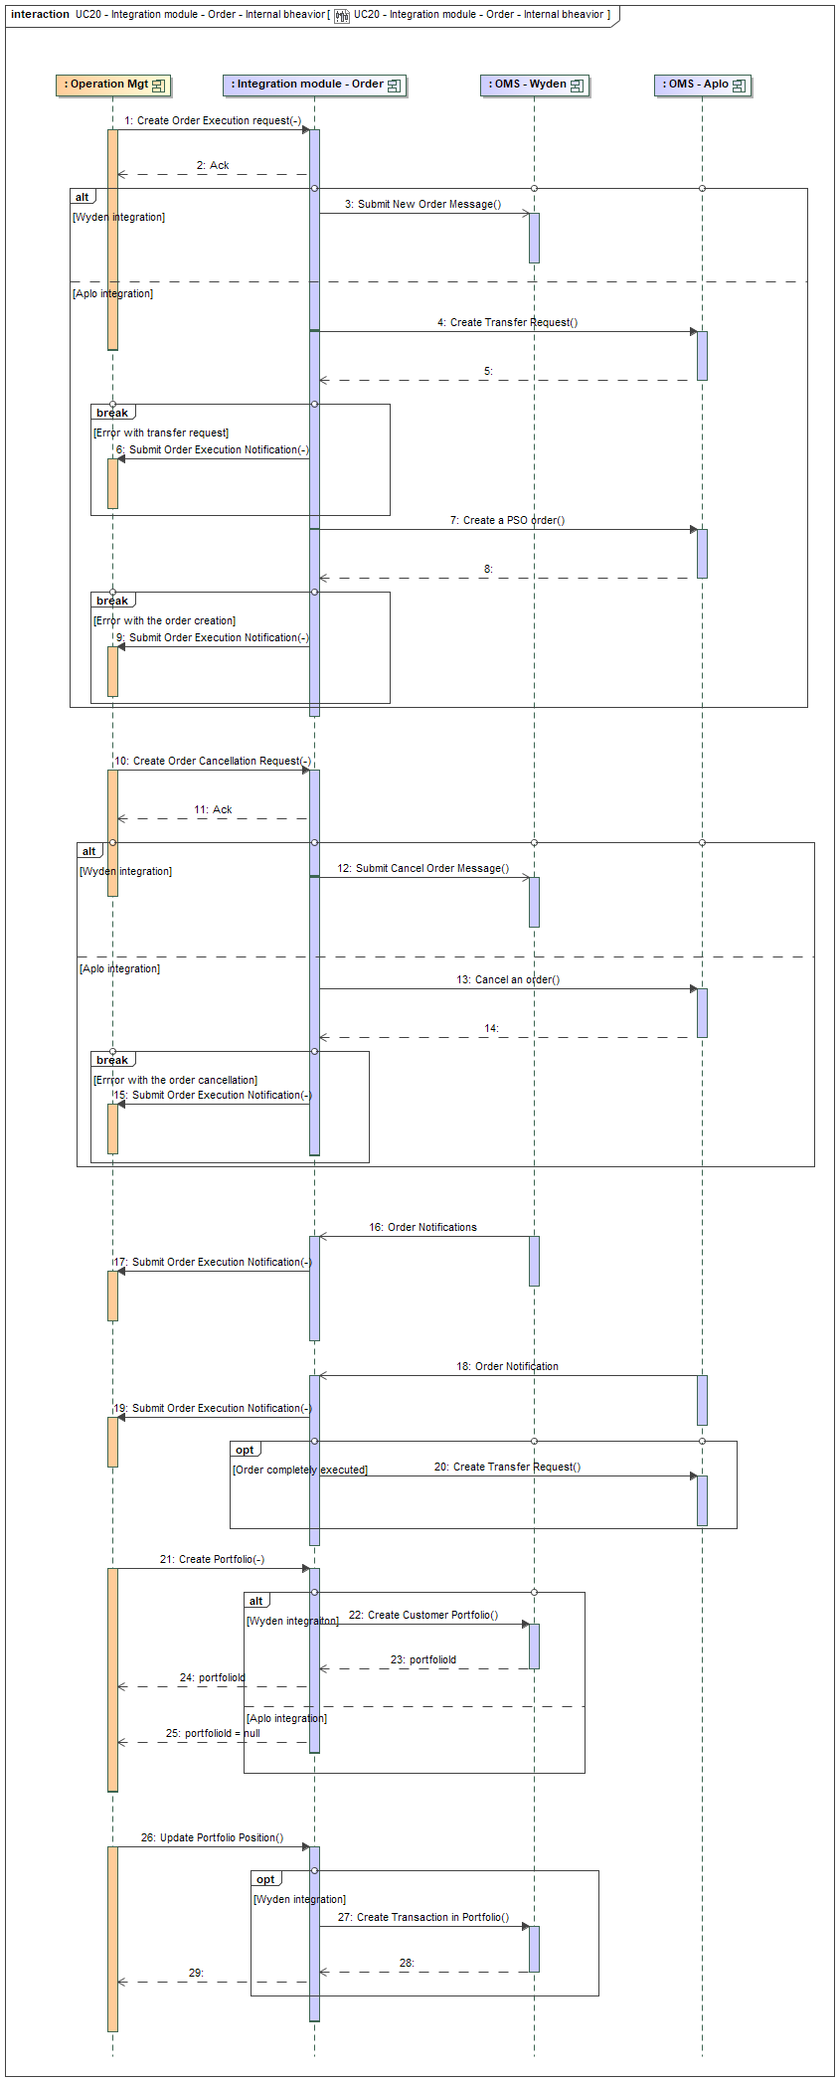
Figure 27 - Order integration module
First part of the diagram, from step 1 to 9 illustrates the creation of an order execution request. A normalized endpoint is exposed by the integration module, which is consumed by the operation service (cf. step 1). This normalized message contains the following information:
- requestId: an unique identifier of the request, as assigned by the operation service
- accountId: the identifier of the digital asset account from which the order is initiated
- accountType: a type of account, that can vary depending on the product. Currently not used, but will allows to manage different margins or execution priority.
- portfolioId: the portfolio id linked to the account id.
- digitalAssetPair: the pair of digital asset to trade
- creationDateTime: the time at which the order was accepted by the SCS.
- orderType: type to identify BUY order vs. SELL order
- orderPriceType: type to identify if the order is at MARKET price or with a LIMIT price
- noOfUnits: the number of units of the main digital asset involved in the order
- targetPrice: the target price in case of limit order or the agreed price in case of market order.
- timeInForce: the management of expiration of limit order, either GTC – Good to Cancel or GTD – Good to Date
- expirationDate: the expiration date in case of GTD order.
The processing of the request is asynchronous, the integration module replies to the request with a simple acknowledgement (cf. step 2). Let’s notice that for now this first interaction is done via synchronous calls but could be transformed in the future into asynchronous calls.

If the integration is done via Wyden, this request is transformed into a FIX message NewOrderSingle (D). The message is built this way:
- Tag 11: requestId
- Tag 54: 1 for orderType:BUY or 2 for orderType:SELL
- Tag 60: current time
- Tag 38: noOfUnits
- Tag 40: 1 for orderPriceType:MARKET or 2 for orderPriceType:LIMIT
- Tag 44: targetPrice (if Tag 40 is 2 – LIMIT)
- Tag 59: 1 for timeInForce:GTC or 6 for timeInForce:GTD (if Tag 40 is 2 – LIMIT)
- Tag 126: expirationDate (if tag 59 is 6 – GTD)
- Tag 55: digitalAssetPair
- Tag 167: SecurityType, always the same value: FOREX
- Tag 48: SecurityID: link to the symbol, retrieved from configuration, based on digitalAssetPair (e.g. BTCUSD@FOREX@Bank)
- Tag 10000: WydenPortfolio: the id (Wyden one) of the customer portfolio, based on configuration (cf. [CONTEXT]=’CUSTOMER’). In the future may be driven by the accountType.
This message is pushed (step 3) to Wyden through the FIX engine (not illustrated, cf. § 3.18 on FIX integration).

If the integration is done via Aplo, this request triggers first a call to the Aplo REST endpoint POST /accounts/{accountId}/transfer-request (step 4) to transfer the funds which are used as counterparty of the order from the bank funding subaccount to the bank trading sub-account. The input body for this call is made of:
- assetId: the quote asset in the trading pair (digitalAssetPair) if it’s a buy order, otherwise the main asset in the trading pair if it’s a sell order.
- sourceId: always ‘funding’
- destinationId: the MPID as setup in the configuration (cf. [MPID]).
- quantity: computed based on the target price (targetPrice) and the volume (noOfUnits).
If there is not enough funds available on the funding virtual account, this request is rejected: in that case the order has to be rejected. The integration module creates a notification message to inform the core operation service about this reject (cf. infra on how to build this message), and call the internal endpoint provided by the core operation service that allows receiving these notification messages (step 6). If the transfer of funds succeeds, the integration modules call the Aplo REST endpoint POST /participants/{MPID}/orders/pso/mkt if it’s market order or POST /participants/{MPID}/orders/pso/lmt if it’s a limit order to trigger the execution (step 7). The input body for this call is made of:
- token: requestId
- side: ‘B’ for orderType:BUY or ‘S’ for orderType:SELL
- instrument: the Aplo equivalent of the digitalAssetPair, retrieved from configuration
- volume: noOfUnits
- price: targetPrice (if it’s a limit order)
- timeInForce: GTC [for now, Aplo doesn’t propose a GTD option – we’ll integrate GTD in the same time as recurrent order to benefit from the background process dealing with maturity. In the meantime, for the sake of simplicity, if the order is a GTD one, the date will be ignored and transformed in to a GTC]

Let’s notice that in case of a market order, the funds transferred to the trading sub-account could be not sufficient to guarantee the execution of the order. It’s the responsibility of the bank to maintain a minimum level of ‘float’ on the trading sub-account to avoid such situation.
In case of issue with this request, a notification message must be sent back to the operation service (step 9).

Second part of the diagram, from step 10 to 15, is describing the management of order cancelation request. A normalized endpoint is exposed by the integration module, which is consumed by the operation service (cf. step 10). This normalized message contains the following information:
- requestId: an unique identifier of the cancellation request, as assigned by the operation service
- originalRequestId: the identifier of the original request, as assigned by the operation service
- orderId: the identifier of the original order, as assigned by the OMS.
The processing of the request is asynchronous, the integration module replies to the request with a simple acknowledgement (cf. step 11). Let’s notice that for now this first interaction is done via synchronous calls but could be transformed in the future into asynchronous calls.

If the integration is done via Wyden, this request is transformed into a FIX message OrderCancelRequest (F). The message is built by providing the original request id (originalRequestId) in tag 41 (OrigClOrdID) and the new request id (requestId) in tag 11 (ClOrdID). [TO CHECK IF WE NEED TO COMPLETE THE OTHER INFORMATION ON THE ODER? IF YES, NEED TO COMPLETE THE INTERFACE]
This message is pushed (step 3) to Wyden through the FIX engine (not illustrated, cf. § 3.18 on FIX integration).

If the integration is done via Aplo, this request triggers first a call to the Aplo REST endpoint DELETE /participants/{MPID}/orders/{token} where the token contains the originalRequestId. In case of issue with the answer, it needs to generate a ‘CANCELLATION REJECTED’ notification, cf. infra.

Third part of the diagram, from step 16 to 20, is describing the management of order execution notification which are received from Wyden or Aplo and transformed into normalized notification message to be pushed to the operation service. This normalized notification message contains the following information:
- requestId: the unique identifier of the request, as initially assigned by the operation service
- orderId: the identifier of the order, as assigned by the OMS
- eventType: a code which identifies the event which is notified. Possible value:
  - NEW: confirms the creation of the order
  - PENDING_CANCEL: confirms the reception of a cancellation
  - CANCELLED: informs the order has been cancelled
  - REJECTED: informs the order has been rejected
  - CANCELLATION_REJECTED: informs the cancellation order has been rejected.
  - EXPIRED: informs the order has been expired (for GTD order)
  - TRADE_EXECUTION: informs about the execution of the trade – several events of this type may be received in case of multiple partial executions.
  - FILLED: informs the order is completely filled.
- eventStatusReason: a free field that may contains detailed information on the event / status
- tradeExecutionId: in case of TRADE_EXECUTION event, an unique id that identifies the execution
- tradeExecutionDateTime: the time at which the trade execution occurred
- tradeExecutionPrice: the price at which the trade execution occurred
- tradeExecutionNoOfUnits: the number of units involved in the trade execution
- tradeExecutionFee: the exchange fees related to the trade execution (distinct from the bank margin)
- tradeExecutionFeeCurrency: the currency related to the exchange fees
- tradeExecutionVenue: the venue on which the trade execution occurred.
- customerPrice: the price related to the (global) execution, including the bank margin

In case of Wyden, the notifications are received as FIX message ExecutionReport (8), step 16, via the FIX engine (not illustrated). In the broker desk configuration, we receive (at least) two pairs of messages: one for the client side of the execution (these execution reports are available in the ‘trade’ FIX session) and one for the street side of the execution (these ones are available in the ‘drop-copy’ FIX session). And in case of SOR (Smart Order Routing) configuration at the OMS (Wyden), there is also a pair of messages for the SOR order (also in the ‘drop-copy’ FIX session). The integration module needs to capture these different messages and filter them to initiate the normalized messages. The filter rules are the following
- ExecutionReport on the client side with execution type (tag 150) ‘NEW’ and order status (tag 39) ‘NEW’ à Normalized notification with eventType ‘NEW’
- ExecutionReport on the client side with execution type (tag 150) ‘ORDER_STATUS’ and order status (tag 39) ‘PENDING_CANCEL’ à Normalized notification with eventType ‘PENDING_CANCEL’
- ExecutionReport on the client side with execution type (tag 150) ‘ORDER_STATUS’ and order status (tag 39) ‘CANCELLED’ à Normalized notification with eventType ‘CANCELLED’
- ExecutionReport on the client side with execution type (tag 150) ‘ORDER_STATUS’ and order status (tag 39) ‘EXPIRED’ à Normalized notification with eventType ‘EXPIRED’
- ExecutionReport on the client side with execution type (tag 150) ‘REJECTED’ and order status (tag 39) ‘REJECTED’ à Normalized notification with eventType ‘REJECTED’
- ExecutionReport on the street side where the security exchange (tag 207) is not ‘SOR’ or ‘bank’ and with execution type (tag 150) ‘TRADE’ and order status (tag 39) ‘PARTIALLY_FILLED’ à Normalized notification with eventType ‘TRADE_EXECUTION’
- ExecutionReport on the street side where the security exchange (tag 207) is not ‘SOR’ or ‘bank’ and with execution type (tag 150) ‘FILL’ and order status (tag 39) ‘FILLED’ à Normalized notification with eventType ‘TRADE_EXECUTION’
- ExecutionReport on the client side with execution type (tag 150) ‘FILL’ and order status (tag 39) ‘FILLED’ à Normalized notification with eventType ‘FILLED’
All other messages can be filtered out.
The rules to build the normalized notification message are:
- requestId: Client Generated Order id, tag 11 (ClOrdId) in client message or tag 583 (ClOrdLinkId) in street message.
- orderId: Order Id, tag 37 (OrderId)
- eventStatusReason: Order Rejection reason, tag 103 (OrdRejReason) in case of REJECTED.
- tradeExecutionId: Execution Id, tag 17 (ExecId), in case of TRADE_EXECUTION
- tradeExecutionDateTime: Transaction time, tag 60 (TransactTime) in case of TRADE_EXECUTION
- tradeExecutionPrice: Last Price, tag 31 (LastPx) in case of TRADE_EXECUTION
- tradeExecutionNoOfUnits: Last Quantity, tag 32 (LastQty) in case of TRADE_EXECUTION
- tradeExecutionFee: cf. tag group 136 (NoMiscFees), for the fee type (tag 139) [4] – Exchange fees, and value in tag 137 (Amt), in case of TRADE_EXECUTION
- tradeExecutionFeeCurrency: cf. tag group 136 (NoMiscFees), for the fee type (tag 139) [4] – Exchange fees, and value in tag 138 (Currency), in case of TRADE_EXECUTION
- tradeExecutionVenue: Security Exchange, tag 207 (SecurityExchange)
- customerPrice: Average Price, tag 6 (AvgPx) in case of FILLED
This process is also following the OrderCancelRequest (F) which are sent by Wyden if a cancellation request is rejected. If such message is received, it leads to a notification message with an eventType ‘CANCELLATION_REJECTED’. The message is then build this way:
- requestId: Client Generated Order id, tag 11 (ClOrdId)
- orderId: Order Id, tag 37 (OrderId)
- eventStatusReason: Cancellation Rejection reason, tag 102 (CxlRejReason).
The created message is pushed to the operation service via a call to the ad hoc endpoint (step 17). For now this endpoint is synchronous, but it could evolve to an asynchronous endpoint in the future.

In case of Aplo the notifications are received via a websocket (cf. https://docs.trade.sheeldmatch.com/#trading-websocket), cf step 18. Several notifications are received per order execution, which are identified by a type. We can have type A (add request), B (balance), R (remove), O (Order) and T (Trade). We’ll care mainly about the O notification (which can be seen as the ‘client’ side of Wyden) and the T notification (which can be seen as the ‘street’ side of Wyden). The rules to filter the messages are the following:
- O message with a reason ‘Add: Success’ à Normalized notification with eventType ‘NEW’
- R message à Normalized notification with eventType ‘PENDING_CANCEL’
- O message with a reason ‘Remove: Success’ à Normalized notification with eventType ‘CANCELLED’
- O message with a reason ‘Remove: Removed due to expiration’ à Normalized notification with eventType ‘EXPIRED’
- O message with a status ‘error’ à Normalized notification with eventType ‘REJECTED’
- T message with a reason ‘Execution: Normal execution’ à Normalized notification with eventType ‘TRADE-EXECUTION’
- O message with a reason ‘Execution: Normal execution’ and volume = 0 à Normalized notification with eventType ‘FILLED’
All other messages can be filtered out.
The rules to build the normalized notification message are:
- requestId: token.
- orderId: token (there is no new order id assigned by Aplo)
- eventStatusReason: reason
- tradeExecutionId: mid (in case of TRADE_EXECUTION)
- tradeExecutionDateTime: time (in case of TRADE_EXECUTION)
- tradeExecutionPrice: price (in case of TRADE_EXECUTION)
- tradeExecutionNoOfUnits: volume (in case of TRADE_EXECUTION)
- tradeExecutionFee: 0 (the fees are communicated later by Aplo)
- tradeExecutionFeeCurrency: EUR
- tradeExecutionVenue: venue (in case of TRADE_EXECUTION).
- customerPrice: price, on which the bank margin is applied, considering bank margin is not managed via Aplo but in SCS (in case of FILLED).
The message related to the eventType ‘CANCELLATION_REJECTED’ is generated in case of error in return of the DELETE /participants/{MPID}/orders/{token} REST API call as illustrated earlier.
The created message is pushed to the operation service via a call to the ad hoc endpoint (step 19). For now this endpoint is synchronous, but it could evolve to an asynchronous endpoint in the future.
If it’s the last notification (cf. status ‘FILLED’) a call to Aplo must be made to move the received funds from the trading sub-account to the funding sub-account. That’s a call to the Aplo REST endpoint POST /accounts/{accountId}/transfer-request (as in step 4). It may be possible that there are also some ‘quote’ assets (in case of a buy order, otherwise the main asset in case of a sell order) remaining on the trade sub-account; these ones are left there, considering they become part of the ‘float’ required to guarantee execution of market order.

Fourth part of the diagram, from step 21 to 24, illustrates the creation of a portfolio at OMS level. We use the term of portfolio to refer to the segregation of assets at OMS level per customer. This concept exists in Wyden and is named ‘portfolio’. It exists also in Aplo and is named ‘virtual account’. In the current integration, we only used it with Wyden, not with Aplo.
In the case of Wyden, this is done by calling the API endpoint POST /rest/portfolio (cf. https://rest.wyden.io/#create-a-portfolio), cf. step 22. The name of portfolio in Wyden (which must be unique) is set to the accountId value. The portfolio has to be created in a structure (“portfolio group”) which is provided by the configuration (cf. integration guide, usage of the portfolio defined by the context [Customer]). The interface of the ‘create portfolio’ endpoint of the integration module foresees a field ‘account type’ which in the future will allow to determine the right structure in which creating the portfolio.
In the case of Aplo, we don’t create virtual accounts per customer. There is no interaction with Aplo and the integration module returns a portfolio id which is set to ‘null’.
Fifth part of the diagram, from step 26 to 29, illustrates the update of portfolio position at OMS level. This is only applicable for Wyden. In the case of Aplo, a call this endpoint of the integration module won’t have any impact.
In case of Wyden, this is a call to the API endpoint POST /transaction to update the position (step 27). The portfolioId, stored at the level of digital asset account, is required to update the right position.

The order integration module publishes also an internal endpoint to retrieve positions at exchanges or at broker level. This endpoint is used to build the operational dashboard related to bank positions (cf. § 3.30.4). For now, this endpoint is only implemented for Wyden, integration with Aplo will come later. This endpoint requires in input an identification of the exchange, which corresponds to the ‘exchangeId’ of the related position in our subledger for bank positions. Practically we won’t interact with Wyden but with Fireblocks, considering that Fireblocks is configured to have access to the exchanges. The Fireblocks API endpoint providing exchange information is GET /exchange_accounts/{exchangeAccountId} (cf. https://developers.fireblocks.com/reference/getexchangeaccount), which returns the list of exchanges and for each a table with a list of assets that contains the balance of each assets at the exchange. The internal endpoint of the integration module is publishing a similar endpoint, returning following information:
- exchangeId: the identification of the exchange, provided in input.
- exchangeName: Name of the exchange
- A list of positions, with:
  - id: the identification of the position
  - assetSymbol: the symbol of the asset (e.g. BTC)
  - balance: the balance of the position
  - available: the available balance of the position
  - Limit update request
The customer can request an update of the operation limit. This request must currently be validated by an operation manager to be applied.
There following sequence diagram illustrates the two steps of this process: first the creation of the update request from the customer then the validation of this request by a bank user. The first part of the diagram illustrates the retrieval of limits, introducing the related API and its behaviour. This use case relies on the usage of a task, cf. § 3.27 for more information on task management.

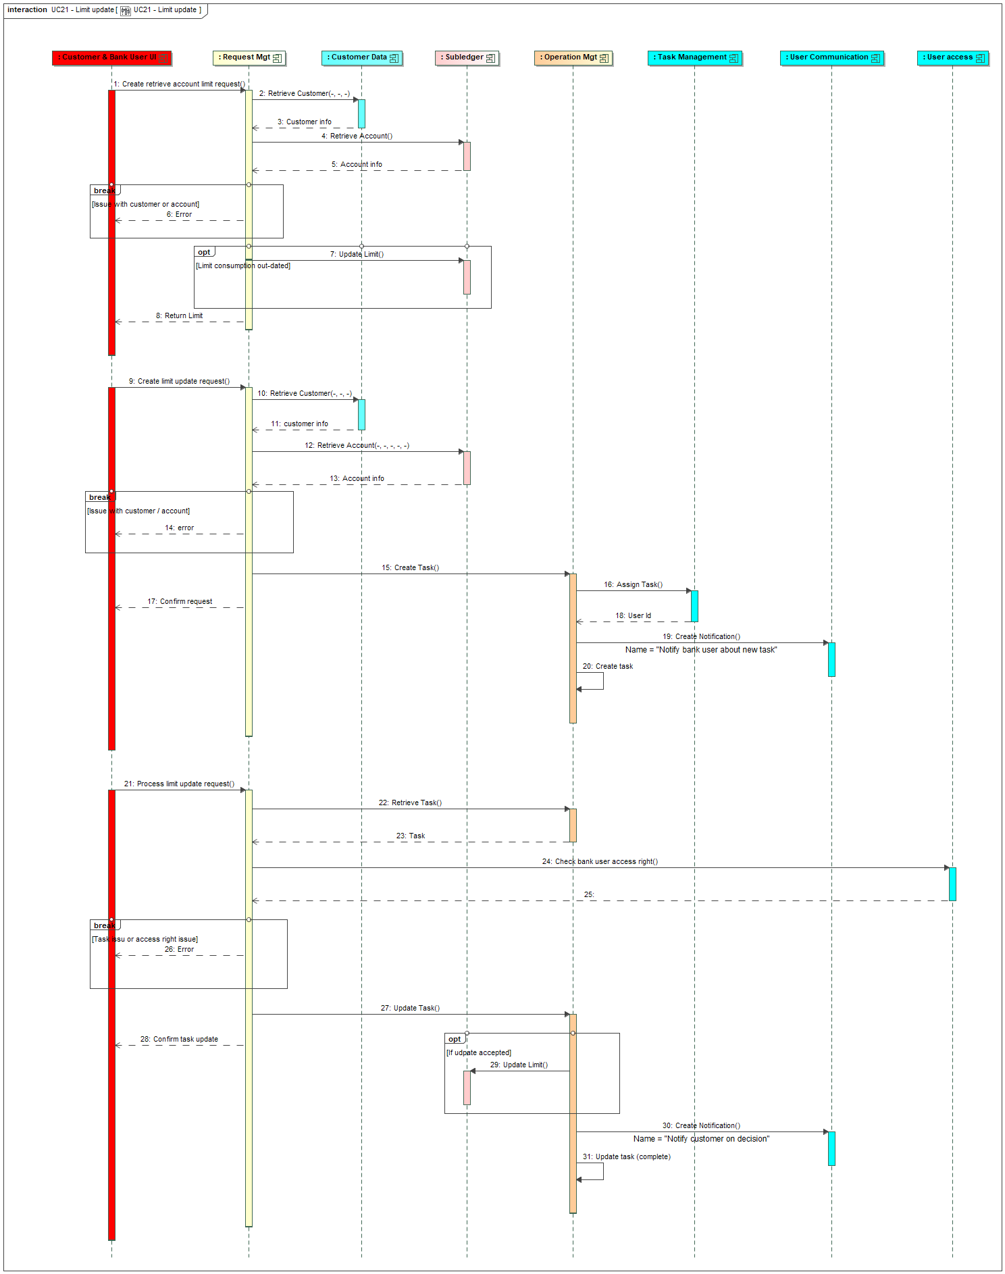
Figure 28 - Limit update management
First part, from steps 1 to 8, is related to the retrieval of limit information. The main steps are:
- Step 1 captures the customer request, via a call to the API endpoint GET /accounts/{accountId}/limits (cf. integration guide) initiated by the customer through the UI.
- Steps 2 to 6 controls that the user can indeed access such information for this account.
- Step 7 updates the limit consumption if required. As limit consumption are usually reset to 0 at the time of the limit control, the limit consumptions retrieved from the data base may be out-dated. In that case they are updated to display to the consumer up-to-date limit consumptions.
- Step 8 return the limit thresholds and their consumptions.

Second part, from steps 9 to 20 capture of the customer request to update limits. The main steps are:
- Step 9 captures the customer request, via a call to the API endpoint POST /accounts/{accountId}/limit-updates (cf. integration guide) initiated by the customer through the UI.
- Steps 10 to 14 controls that the user can indeed create such request for this account.
- Step 15 triggers the creation of a task, which is assigned to a bank user (cf. step 16 to get the user id and step 19 to notify the user).
- Step 20 registers the task.
Third part, from steps 21 to 31, is related to the processing of the task by a bank user. The main steps are:
- Step 21 triggers the processing of the task, via a call to the API endpoint PATCH /tasks/{taskId} (cf. integration guide) initiated by the bank user through the UI. The API endpoint GET /tasks allows the UI to get a list of tasks to show to the user.
- Steps 22 to 26 controls that the task exists and that bank user can indeed process this task (the step 16 checks the user rights against the customer).
- Step 27 triggers the update of the task. There are two options: the bank user accepts or refuse the task. If the task is accepted, the limits are updated (cf. step 29). In both cases, the customer is notified on the decision (step 30) and the task is set as complete (step 31).
  - Tax Report
The SCS allows the generation of yearly tax reports. The way to compute tax data depends on the fiscal country of the customer. For now the solution supports the French regulation and the Dutch regulation.
The Dutch regulation is simple: the customer just has to report the value of his/her portfolio at the beginning of the year with his/her other assets in ‘Box 3’ (cf. https://www.beleggerspel.nl/kenniscentrum/belasting-crypto-nederland).
The French regulation is quite complex and requires a calculation of the gain generated by each operation considering the complete value of the portfolio (cf. https://www.legifrance.gouv.fr/codes/id/LEGISCTA000050366754/2026-07-01).
In order to support these different approaches, a tax-related data calculation service is triggered each time an operation is completely executed. In the case of a Dutch customer, this service won’t do anything, while in case of a French customer, it’ll realize some calculation and store this tax data next to the operation data.
The yearly tax report content can be pushed to the bank system in json format for futher formatting and transmission to the customer. It can also be uploaded to the UI where it can be transformed into a PDF for download (the default SCS implementation relies on a Angular library - pdfmake version 0.2.20 npm library).
The here under first picture illustrates the computation process. Then the details on how to compute tax-related information are provided. A second picture illustrates the interaction between the UI and the services to retrieve the information.
    - Tax-related data computation
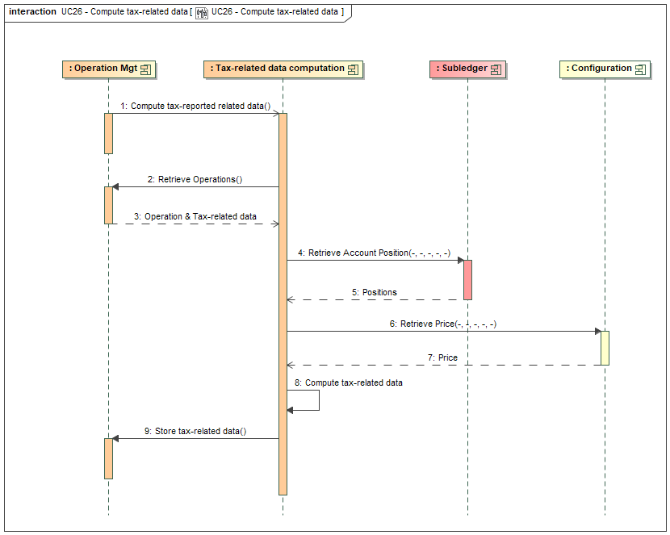

Figure 29 - Tax-related data computation
The computation logic is actually part of the operation service but illustrated in a separated lane in the picture to better detail its behaviour. The implementation of this logic is isolated as it differs depending on the fiscal status of the customer. Several implementations co-exist in parallel, with related data. This diagram illustrates the behaviour in line with the French regulation. In case of Dutch customer, there is no calculation at the time of the operation execution. The related data is stored as an annex to each operation.
- Step 1 is triggered by the operation service once the operation is completely executed. For example in case of a sell order, this service is triggered after step 25 (cf. § 3.6.2). Currently the diagrams related to operation execution are not updated to illustrate this call. This execution is asynchronous. The fiscal status of the customer drives the implementation to trigger.
- Step 2 retrieves the information on the executed operation but also the information of previous operation to get previous tax-related information. As detailed later, to follow French regulation, we need to get the value of the portfolio at the time of the previous operation.
- Step 4 retrieves all the positions of the account. As detailed later, to follow French regulation, we need to compute the value of the whole customer portfolio.
- Step 6 retrieves the prices related to each position, in order to be able to compute the portfolio value.
- Step 8 computes the gain/loss. The computation logic is detailed here under.
- Step 9 stores the the results in the tax-related data object, which is a sub-object of the operation object. The tax-related data object has a status, which is set to ‘INCOMPLETE’ if information on the value of the deposits and withdrawals is missing, as in such case it’s not possible to compute accurately the gain or loss (cf. the details of the computation logic). The completion of this information is described in another scenario.
This computation logic is also called when the value of the deposit is provided by the customer. In that case the computation logic update the data for the deposit, but also updates all the more recent operations to update the acquiring cost and the gain/loss.

    - Gain / Loss computation
For now the computation of the gain/loss is based on the French regulation (cf. this text: https://www.legifrance.gouv.fr/codes/id/LEGISCTA000050366754/2026-07-01). For Dutch citizens, there is no need to compute a gain or a loss; the tax report only contains the value of the account, with all positions converted in Euro, at the start of the year.
This logic depends on the tax residence of the customer. The tax residence must be provided by the bank when SCS retrieves customer information at the time of the account opening. The information is stored at account level. If a customer changes of residence, this information must be updated accordingly. The background process doesn’t check for the tax residence of each customer to avoid massive interactions with the bank system.

The French regulation considers the whole assets owned by the customer and compute gain/loss based on a ‘global’ portfolio, which practically can be distributed in different banks, systems or wallets. To be able to compute accurately the gain/loss, it requires to have the complete view on the customer global portfolio. Consequently, if the customer has asset outside the bank, the computation that is made by SCS is not correct. Anyway, the SCS is computing a gain/loss as the customer would only own assets through the bank. Up to the customer to aggregate information from other sources if needed.

The rule for the computation of the gain/loss (FR: “Plus ou moins-value”) are the following:
- It relies on following information:
  - Total acquisition cost of the portfolio (FR: “Prix total d’acquisition du portefeuille”): which can be summarized as the sum of the investment in the portfolio, including the direct fees. But it’s a bit more complex as illustrated here under.
  - Disposal proceeds (FR: “Prix de cession”): which can be summarized as the revenue (income) of an operation (e.g. a sale), including the direct fees. But it’s also a bit more complex as illustrated here under.
  - Total portfolio value (FR: “Valeur globale du portefeuille”): the aggregated value of all the positions in the portfolio.
- It’s computed via the following formula (as defined in French regulation):
$$Gain or Loss=Disposal proceeds-Total acquisition cost*\frac{Disposal proceeds}{Total portfolio value (before the disposal)}$$
  - Let’s remark that this way to compute gain or loss involves the total portfolio value. Which means that even if one given sale could be seen as a loss (e.g. the customer bought 1 ETH at 2 000 € and now sells it at 1 500 €, which is seen as a loss of 500 €), can be a gain depending on the evolution of the total portfolio value.
- After a disposal, the total acquisition cost must be reduced by the portion of the initial capital included in this disposal, which corresponds to the second part of the previous equation.
- For deposits and withdrawals, there is a need to get the related value of this action.
  - Let’s first remark that as we consider that the SCS account contains all the customer assets (i.e. he/she has no other digital assets outside the bank), a deposit or withdrawal is always made with a third party. Otherwise, if a deposit or withdrawal is made between two accounts belonging to the same customer, it has no impact on the gain / loss calculation, as it has no impact on the global portfolio (i.e. it’s just internal movement inside that global portfolio).
  - A deposit doesn’t generate a disposal, but it impacts the total acquisition cost and the portfolio value. The impact depends if the deposit is considered as a gift or as exchange of some goods or services. If it’s a gift, the value is based on the current value of the asset. If it’s not a gift, the value is based on the estimated value of the exchanged goods or services. In any case, it’s up to the customer to provide this information for each deposit.
  - A withdrawal generates a disposal except if it’s gift. In other words the value of the disposal proceeds corresponds to the estimation of the value of the goods / services which are received in exchange of the asset. This disposal generates a gain and impacts the total acquisition cost (which must be reduced as described higher). It’s also the responsibility of the customer to provide the value of each withdrawal.
- The exchange of a digital asset against another digital asset (convert or swap order) are not generating a gain or loss.
- In the yearly report, we compute the gain or loss for a given year, starting on the 1st of January and ending on the 31st of December. The total acquisition cost is an information which is evolving continuously, starting from 0 when the account is opened – but there is no reset on yearly basis.
- Gain and Loss on the same year can be compensated, but not from one year to another.

We can illustrate these rules on the following example:
- On the 01/01/2026, a customer opens a new account and buys 2 ETH at 1 000 €, with 60 € of bank fees.
  - There is no disposal
  - No gain or loss
  - Total acquisition cost = 2 * 1000 + 60 = 2 060 €
  - New total portfolio value = 2 * 1 000 € = 2 000 €
- On the 15/03/2026, the customer buys 1 BTC at 20 000 €, with 400 € of bank fees.
  - There is no disposal
  - No gain or loss
  - Total acquisition cost = 2 060 [previous value] + 1 * 20 000 + 400 € = 22 460 €
  - Total portfolio value = 2 * 1 400 € [current price of ETH] + 1 * 20 000 € = 22 800 €
- On the 10/04/2026, the customer sells 0.5 ETH at 1 200 €, with 10 € of fees.
  - Disposal proceeds = 0.5 * 1 200 – 10 € = 590 €
  - Total portfolio value (before the operation) = 2 * 1 200 [ETH] + 1 * 22 000 [BTC] = 24 400 €
  - Gain or loss = 590 [disposal proceeds] – 22 460 [previous acquisition cost] * 590 [disposal proceeds] / 24 400 [portfolio value before operation] = 46.91 €
  - Total acquisition cost = 22 460 [previous value] - 22 460 [previous acquisition cost] * 590 [disposal proceeds] / 24 400 [portfolio value before operation] = 21 916.91 €
  - New portfolio value = 1.5 * 1 200 [ETH] + 1 * 22 000 [BTC] = 23 800 €
- On the 10/05/2026, the customer receives 3 ETH which he/she values at 2 500 € (while the price of ETH is at 1000 €).
  - There is no disposal
  - No gain or loss
  - Total acquisition cost = 21 916.91 [previous value] + 2 500 [value of the deposit] = 24 416.91 €
  - New portfolio value = 4.5 * 1 000 [ETH] + 1 * 24 000 [BTC] = 28 500 €
- On the 01/06/2026, the customer exchanges 0.5 BTC against 1500 XRP, with 200 € of bank fees
  - There is no disposal
  - No gain or loss
  - Total acquisition cost = 24 416.91 [previous value]. There is no acquisition cost change as it’s an internal exchange.
  - New portfolio value = 4.5 * 1 200 [ETH] + 0.5 * 21 000 [BTC] + 1 500 * 7 [XRP] = 26 400 €
- On the 15/08/2026, the customer withdrawals 1 000 XRP, in exchange of goods evaluated to 5 000 € with 10 € of fees.
  - Disposal proceeds = 5000 – 10 € = 4 990 €
  - Total portfolio value (before the operation) = 4.5 * 1 300 [ETH] + 0.5 * 22 000 [BTC] + 1500 * 6 [XRP] = 25 850 €
  - Gain or loss = 4 990 [disposal proceeds] – 24 416.91 [previous acquisition cost] * 4 990 [disposal proceeds] / 25 850 [portfolio value before operation] = 276.64 €
  - Total acquisition cost = 24 416.91 [previous value] - 24 416.91 [previous acquisition cost] * 4 990 [disposal proceeds] / 25 850 [portfolio value before operation] = 19 703.55 €
  - New portfolio value = 4.5 * 1 300 [ETH] + 0.5 * 22 000 [BTC] + 500 * 6 [XRP] = 19 850 €
- On the 15/09/2026, the customer sells 0.5 BTC at 23 000 €, with 50 € of bank fees
  - Disposal proceeds = 0.5 * 23 000 – 50 € = 11 450 €
  - Total portfolio value (before the operation) = 4.5 * 1 200 [ETH] + 0.5 * 23 000 [BTC] + 500 * 5.5 [XRP] = 19 650 €
  - Gain or loss = 11 450 [disposal proceeds] – 19 703.55 [previous acquisition cost] * 11 450 [disposal proceeds] / 19 650 [portfolio value before operation] = -31.20 €
  - Total acquisition cost = 19 703.55 [previous value] - 19 703.55 [previous acquisition cost] * 11 450 [disposal proceeds] / 19 650 [portfolio value before operation] = 8 222.35 €
  - New portfolio value = 4.5 * 1 200 [ETH] + 500 * 5.5 [XRP] = 8 150 €
- On the 10/11/2026, the customer sells 500 XRP at 5 €, with 5 € of bank fees
  - Disposal proceeds = 5 * 500 – 5 € = 2 495 €
  - Total portfolio value (before the operation) = 4.5 * 1 400 [ETH] + 500 * 5 [XRP] = 8 800 €
  - Gain or loss = 2 495 [disposal proceeds] – 8 222.35 [previous acquisition cost] * 2 495 [disposal proceeds] / 8 800 [portfolio value before operation] = 163.78 €
  - Total acquisition cost = 8 222.35 [previous value] – 8 222.35 [previous acquisition cost] * 2 495 [disposal proceeds] / 8 800 [portfolio value before operation] = 5 891.12 €
  - New portfolio value = 4.5 * 1 400 [ETH] = 6 300 €
- Considering that there is no more operation on 2026, the total gain / loss for 2026 is 456.12 €.
- The here under embedded XLS presents the same data, with the formula to compute the different values.
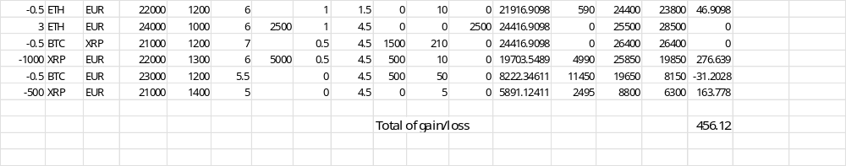

DISCLAIMER: this is our interpretation of the regulation, it must be validated by the bank legal department as compliant with its own interpretation.
    - Tax report retrieval

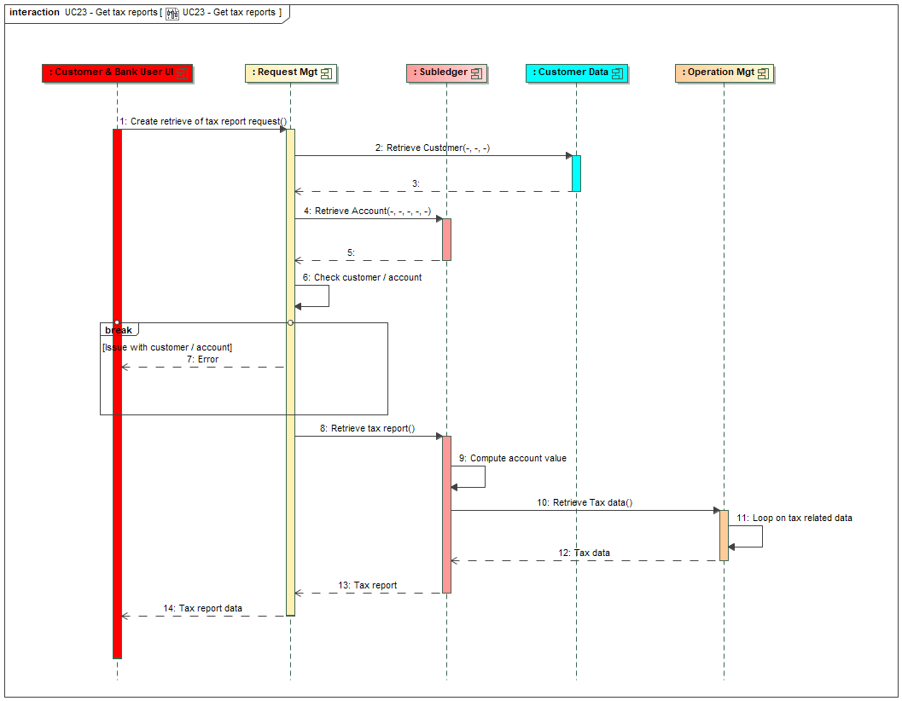
Figure 30 – Retrieve Tax reports
This diagram is related to the retrieval of tax reports from the UI. There are two REST API endpoint which are provided and which fits with this diagram:
- GET /accounts/{accountId}/tax-reports: provides the list of tax reports for the customer. The answer contains only the metadata related to tax-reports (i.e. year, gain/loss for the year), but not the detail of each one.
- GET /accounts/{accountId}/tax-reports/{year}: provides the tax report for the customer for a given year. The answer contains all the details, with the exhaustive list of operations which are part of that year. Based on this information, the generation of a PDF file is possible.
The main steps are:
- Step 1 is the API call from the UI
- Steps 2 to 6 are the usual eligibility check regarding customer and account, to check that the user is entitled to access that customer and account.
- Steps 8 to 13 retrieve information from the account, via the subledger service. Depending on the fiscal country, these steps may be processed differently and some information may be retrieved from the operation services. For French regulation, there is a loop on the tax-related information attached to each operation on the required period of time. If the API is about getting the list of all tax reports, the loop is on all operations, summing information per year to identify each report. For Dutch regulation, the value of the account at the beginning of the year must be calculated, taking into account the right price (as for the calculation of the account valuation, cf. § 3.3). The list of operations is also provided for information.
- Step 14 pushes the information to the UI. Up to the UI to transform it into a PDF if the information is related to one report.
For now there is no background process that would generate all tax reports at the beginning of the year in order to push them to the bank system, for example to aggregate them with other reporting.

  - Statement reports
The SCS allows the generation of statement reports on customer requests. A statement report gives a view on the customer account on a given period, showing the evolution of the positions and the related operations. For now it’s only generated when the customer requests one via the UI; the back-end service generates a JSON file which is transformed into a PDF for download (the default SCS implementation relies on a Angular library - pdfmake version 0.2.20 npm library). If a bank wants to generate such reports periodically as it usually does for fiat account statement, the same logic could be applied to generate a JSON file that would need to be integrated with the bank IT system.
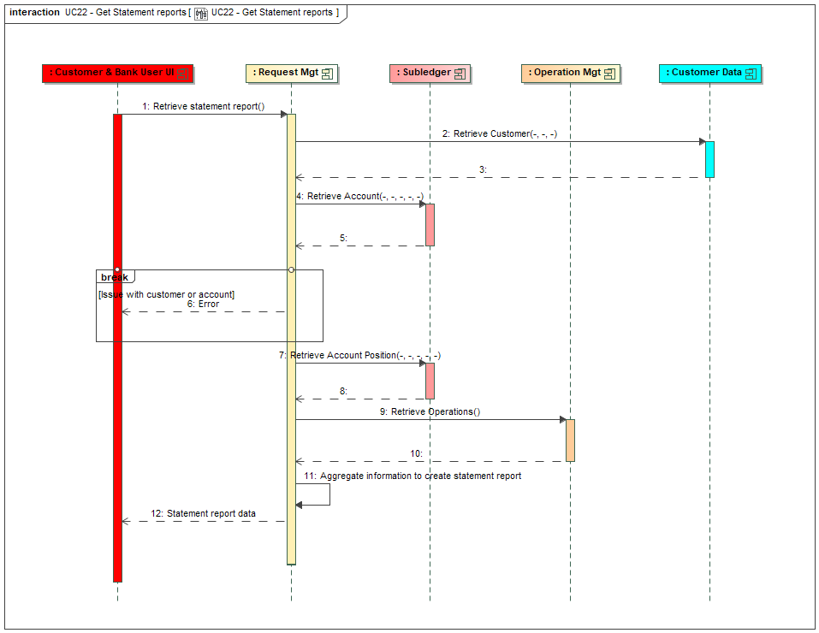
Figure 30 - Statement report generation
Main steps of the process are:
- Step 1 is the capture of the customer request, which corresponds to a call to the REST API endpoint POST /accounts/{accountId}/statement-reports. Cf. the documentation of the REST API endpoint for more details. It allows to select the digital asset to list in the statement reports (if no information is provided, all of them are included), the type of operation to include (if no information is provided, all of them are included) and the period (start date + end date).
- Step 2 to 6 are the usual eligibility check regarding customer and account, to check that the user is entitled to access that customer and account.
- Step 7 retrieves information related to positions at start date and at end date from the subledger service.
- Step 9 retrieves information related to operations between the two dates from the operation service.
- Step 11 aggregates the information, computing the percentage of evolution and the percentage of each position. Cf. the documentation of the REST API endpoint that gives the fields which must be provided.
- Step 12 pushes the information to the UI. Up to the UI to transform it into a PDF.
  - Bank position configuration
This use case is related to the manual configuration of bank positions. Some bank positions must be created manually before being able to create order or transfer as some information related to exchange / broker / custodian configuration are required to execute these operations. The information that can be provided when managing manually bank position are:
- The fiat bank account (either a loro in case of broker or a nostro in case of exchange, cf. § 2.3.1.b) that holds the bank funds in case the bank position relates to a fiat position at broker (Aplo) level or at exchange level (via Wyden).
- The exchange id (technical id) which allows retrieving the positions at exchange level. This one is communicated with the fiat bank account.
- The wallet id (vault account in Fireblocks) in case of position at custodian (Fireblocks). A bank position for each type of wallet (e.g. Omnibus, Withdrawal, etc, cf. the installation guide) must be created.
Before creating these positions, the first action is to create the bank account. As explained in the integration guide, this is currently done technically.
Not all bank positions must be created manually before being able to create order or transfer. For example, for bank position at exchange in digital asset, they can be created automatically by the solution when required.
For bank positions related to custody, all the positions in the assets managed by the bank are automatically created and initialized with a balance that matches the balance provided by the custodian. For bank positions in Euro related to exchange, the balance of the linked loro/nostro account is also used to initiate the internal position.
There here under sequence diagram illustrates the case of the creation of the bank position but is also applicable to update them: either the linked fiat bank account, either the linked wallet id..

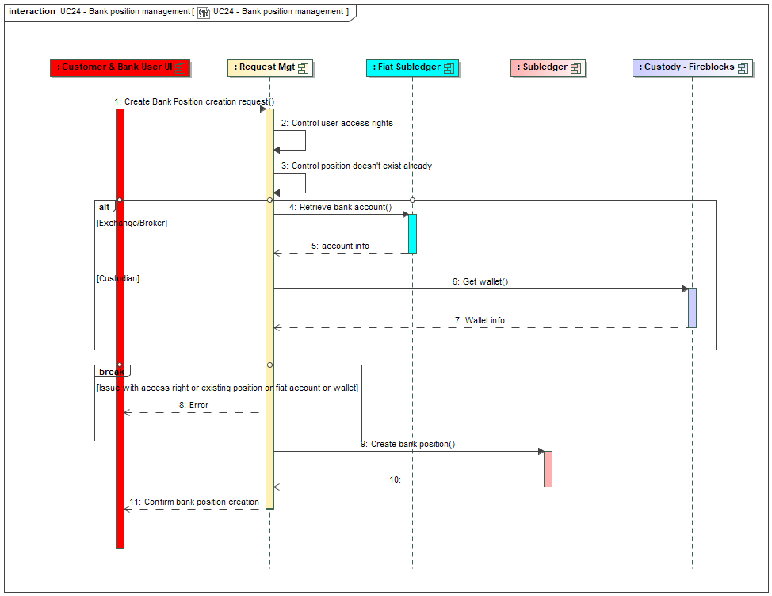
Figure 31 - Create bank position
The step 1 is triggered by bank user in the UI, which lead to the call to the API endpoint POST /banks/positions (respectively PATCH /banks/positions/{positionId}). The service must control the quality of the information and more precisely:
- The validity of the provided information: position type – which must be of ‘EXCHANGE’ or ‘CUSTODY’ or ‘BROKER’ type, position bucket (which is either the exchange name or the wallet name, fiat account id or wallet id.
- The user role regarding this function (step 2)
- Check that a position for the same criteria (position type, position bucket) doesn’t exist yet (step 3). If the request is about an update, the position must exist.
- If the position type is EXCHANGE or BROKER, check that the provided bank fiat account exists in the fiat subledger. This is done by calling the bank CBS API endpoint GET /core-banking/accounts/{fiatAccountId}/positions (step 4). Let’s notice that the check is done based on an account Id (and not an account Number), it’s up to the front-end to convert the IBAN provided in screen into an Id by using the CBS API endpoint POST /core-banking/account-id-requests. This retrieves the bank position value (useful for step 7).
- Otherwise, in case of position type is CUSTODY, check that the provided wallet id exists at custodian level (step 6). This is done by calling the Fireblocks API endpoint GET vault/accounts/{vaultAccountId} (cf. https://developers.fireblocks.com/reference/getvaultaccount), where the wallet id is used as vaultAccountId. This API endpoints returns a list with all assets in the wallet and their positions (useful for step 7).
- If everything is ok, the position is created in the subledger (step 7), including a ‘fake’ bank position entry to justify the initial balance if there is one (this bank position entry has a specific position entry type ‘INIT’). If the position type is CUSTODY, there is a loop on all assets to create the corresponding positions (not illustrated in the diagram). If the request is about an update, the position is updated.
Remark: in future versions, it’ll be possible to manage ‘manual operation’ to update the initial position of a bank position, even for position in digital asset at exchange (which for now are created with an initial position set to 0).
  - Document upload for KYT issue
This use case is related to KYT issue when the compliance officer asks to the customer to provide documents to justify the transaction (cf. step 10 in § 3.12) and describes how to manage the task which is created and assigned to the customer.
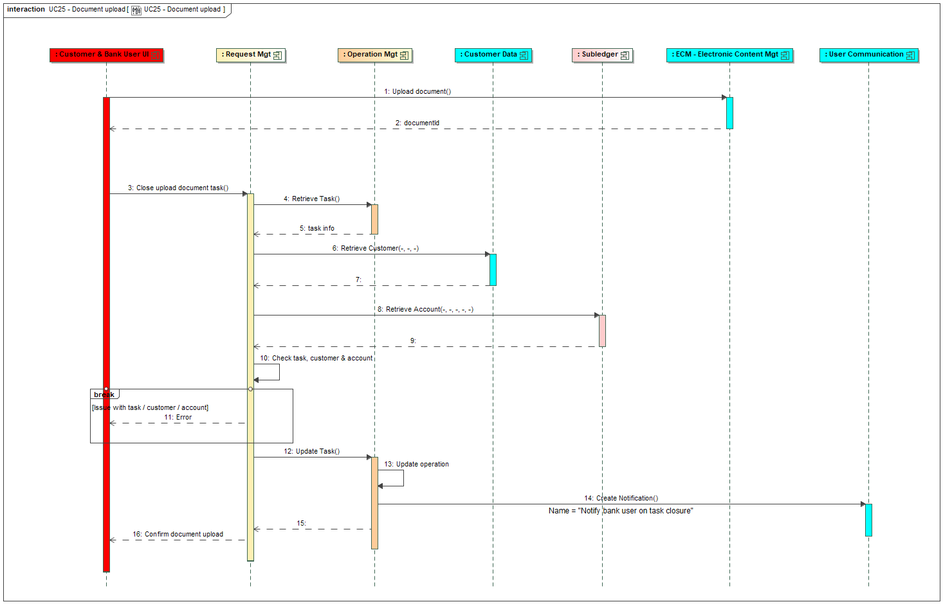
Figure 32 - Document upload for KYT issue
The upload of the document(s) and the resolution of the task are two distinct steps. The upload of the document(s) is illustrated via step 1 and 2 where we take the hypothesis that the document(s) are directly stored in the bank ECM (Enterprise Content Management) system which returns a document id per document. This part may be outside the scope of SCS [TO CONFIRM WITH UX TEAM]
Then the resolution of the task is triggered by a PATCH /tasks/{taskId} (cf. step 3) for a task related to document upload. The id(s) of the document(s) are provided in the payload of the task. Then the process is illustrated through the following steps:
- Steps 4 to 11 controls the task type and status, the customer and the account status and the link between the task and the account to ensure this customer is entitled to act on the task. In case of issue an error is generated.
- Step 12 updates the task status to close it, step 13 updates the operation to link the document id(s) to it and step 14 warns the compliance officer about the task closure.
  - Recurring Orders
When creating a buy order the user can select a type of order “Recurring order”. This will create an order that will be executed several times, with always the same characteristics (i.e. it will always buy the same amount of digital asset at market price) in the future. That’s what is also known as DCA – Dollar Cost Averaging, a technic to ease regular investments.
In that case the user must provide the following information:
- A periodicity (e.g. monthly, weekly) – mandatory
- A start date – optional (if not provided, the first order will be immediately executed)
- An end date – optional (if not provided, the order will be repeated until manual cancellation).
Its execution is triggered automatically through a background process. It’s up to the bank to schedule its daily execution in its global scheduling planning, at the right time of the day. This process should run every calendar day as there is no concept of closing day on crypto market. Consequently the process doesn’t manage closing day neither: if the next execution date falls on a bank close day, it will be triggered at that date. But if the bank doesn’t run the process on bank close days, the next run will trigger the order that should have been triggered during the bank close day.
If an order can’t be executed, for example because the funds on the fiat account are not sufficient, this order will be skipped (no retry mechanism the following days), but the next maturity date will be processed (if possible).
From a user perspective a recurring order is managed as a limit order: it’s listed in the ‘pending order’ section, with the ability for the user to cancel it, which will stop its future execution. Each execution of the order is then listed as an individual operation.
The creation of a recurring order is similar to the creation of a buying order as described in § 3.5.1, except that there is no need to control the available balance if the execution starts in the future. The order is created with a type ‘RECURRING’ and executed immediately or not depending on the start date. Let’s remark that the bank fees which are displayed at the time of the creation of the order are only for information, as the bank fees will be computed for each execution, taking into account the bank pricing policy at execution time.
From an implementation point of view, a recurring order is managed as an operation with a future execution date, which once executed automatically creates the next operation. When the customer submits the request to create a recurring order, the first operation is created and either executed directly if the start date is the current date, or put on hold waiting for its execution by the background process when the start date is reached. Once the first operation is executed (either immediately or by the background process), it creates the next one ‘on hold’ with the next execution date. And so on. That means that there is no management of an explicit object that identifies the recurring order; the process relies on the existing operation object. The operation object must contain a maturity date which is the basis to trigger the execution at the right date. That’s the operation in status ‘WAIT_MATURITY’ (status code when the operation is on hold waiting for maturity date) which is used to display the recurring order in the list of pending orders.
The responsibility of the background process is to select all the operation in maturity ‘WAIT_MATURITY’ for which the maturity date is the current date or in the past. For each operation, the background process triggers its execution by calling the operation service. The execution is similar to the execution of a buying order at market price as described in § 3.5.2, except that the bank fees must be computed (by calling the bank pricing engine) before each execution (and not rely on the amount stored in the operation). In parallel, the background process computes the next maturity date and creates the next operation in status ‘WAIT_MATURITY’. Except if the order has an expiration date which is reached by this next maturity date; in that case there is no more operation to create.
The cancellation of a recurring order is similar to the cancellation of an order as described in § 3.9 and 3.5.2, except that the status is ‘WAIT_MATURITY’ and there is no fiat reservation to cancel.
For now, there is no possibility to update a recurring order or to ‘pause’ it. It must be first cancelled and then created again.
  - Fee management
This paragraph details the different types of fees which are managed in the solution.
There are potentially 5 types of fees that can be managed:
- Bank margin on crypto order. This margin is the difference between the price the bank gets when executing a buy or sell order on the network and the price the bank communicates to its customer. For example the bank will buy BTC at 50 000 € but will show a price of 50 100 € to its customer. The 100 € of difference will generate a profit for the bank. The management of this margin can be done at OMS (as for Wyden) level or directly at SCS level (as for Aplo). This margin is defined as a percentage to be applied on the exchange rate, and is computed in the quote asset.
- Exchange fees. These fees are taken by the exchange when a buy or sell order is executed. These fees are paid by the bank and should be compensated by the bank margin (rem: Wyden offers the possibility that the exchange fees are paid by the customer, but we don’t consider this option). For example the bank buys 10 BTC at 50 000 € is paying 500 500 €, including 500 € of fees. The bank can pay these fees either in fiat or in crypto. For the sake of simplicity, we consider these fees are paid in fiat (€). These fees don’t exist in case of usage of Aplo.
- Network fees. These fees are taken by the miners when processing a transaction (deposit or withdrawal) on the blockchain. This is specially true for Etherum blockchain, where the network computes these fees by multiplying a “gas price” by a “gas usage”; this gas representing the workload required to realize the transaction. For example a transfer of 10 ETH is done between two addresses on the blockchain, the beneficiary will get only 9,999 ETH, the network fee being 0,001 ETH (corresponding to 100 000 units of gas fee of 10 gwei; the gwei being the unit of a gas fee – 1 ETH is equal to 1 billion of gwei). The bank will pay these network fees, but will claim some bank fees to the customer to compensate them (with a margin to generate a profit). These fees are always in crypto.
- Bank’s fees. These fees are taken by the bank as any other banking fees. They are normally computed by the bank; we take the hypothesis the CBS of the bank has a billing engine that can compute these fees (cf. here under for more details). We also propose the possibility to configure the bank fees directly in SCS and not rely on the bank if the bank doesn’t have such engine. The description of this function is available in § 3.33). These bank fees are booked in the same time as the operation execution (another option would be to delegate this event to the bank billing engine, but it’s not available for the moment). Depending on the operation type, the bank fees management is different:
  - For buy and sell order, the bank fees must be computed in the fiat currency based on the operation value in fiat currency (either the spent amount for a buy or the received amount for a sell). For a convert order, the bank fees must be computed in the quote currency. For a buy order, the bank fees are included in the control of the availability of the quote asset, in the reservation and in the amount which is eventually debited. For a sell or convert order, the bank fees are only deducted from the amount which is eventually credited.
  - For a withdrawal, the bank fees are computed in the digital asset and added to the amount which is subtracted from the customer position (but not part of the amount which is transferred). The withdrawal must be executed in order that the beneficiary receives the initial amount; the network fees being at the charge of the bank.
  - For a deposit there is no bank fees: the received amount is fully credited to the customer position.
The computation of bank fees relies on a call to a CBS API endpoint POST /core-banking/customer-billable-operations. We provide to this endpoint some information on the operation (as the customer id, the type, the trading pair, the operation value, cf. the integration guide for details). The important information is the operation value, which is computed by the SCS prior the call to the CBS API in the adequate currency. I.e.: the adequate currency is the fiat currency for Buy and Sell, the quote currency for Convert and the digital asset for Withdrawal. We supposed that the CBS will be able to apply a logic on this value to get the fees in the same currency (so the CBS doesn’t have to care about the currency, just apply a calculation)..
- Service’s fee. These are the fees the bank pays to use the services of SCS, including the ones from Fireblocks, Wyden, Aplo, etc. These ones are depending on the contracts between the bank and theses providers. Most of the time they are invoiced periodically.
These fees, excepting the last one (the service’s fee), are recorded on each operation (buy/sell order or deposit/withdrawal) to let the bank computes its profit & loss.
  - Customer position in subledger
As introduced in § 2.2.1 the subledger manages the positions of customers through 3 objects:
- Account: represents the portfolio of the customer, in which all the positions are managed.
- Position: represents the situation for a given digital asset (e.g. BTC or ETH) in the account. There is one position for each digital asset.
- Entry: justifies the position by logging all activities as debit (decrease of the position) or credit (increase of the position), triggered by the execution of orders or transactions.
An account is created via the execution of the corresponding request (cf. § 3.1).
A position is created automatically, either when there is a need to associate a deposit or withdrawal address to it (cf. § 3.5.1 and § 3.6.1) or with the first entry related to the digital asset in case of order execution (cf. § 3.3.2 and § 3.4.2) or in case of transaction execution (cf. § 3.5.2 and § 3.6.3). Position balances are updated automatically thanks to the creation of entries.
An entry is created thanks to the execution of an order (cf. § 3.3.2 and § 3.4.2) or a transaction (cf. § 3.5.2 and § 3.6.3). An entry is either a credit (increase the balance) or a debit (decrease the balance). There are 3 types of entry:
- Reservation: which can be seen as announce of (potential) future entry; it’s not yet a real entry. It’s use in case of debit with the objective to block the debited amount, to guarantee this amount will still be available when the real entry will be created. A reservation impacts the available balance (i.e. the available balance is the real balance minus all the reservations) but not the real balance of the position.
- Real entry: a real entry updates both the balance and the available balance. A real entry can be the confirmation of the reservation: in that case the existing reservation is cancelled and replaced by this real entry and only the real balance is updated (as the available balance was already updated at the time of the reservation). A real entry is definitive and can’t be undone, except by creating explicitly a new entry in opposite direction. This allows to guarantee the consistency of the entry log as justification of a position.
- Freeze: a freeze is use in case of credit which can’t be made available to the customer (mainly use in case of deposit which are suspicious from a KYT point of view). It’s a real entry as it updates the balance, but it doesn’t update the available balance. A frozen entry is an abnormal situation that must be solved manually by the compliance officer. There are two way to solve the situation: either confirm the funds are receivable and make them available to the customer, either confirm the transaction is suspicious and transfer the funds to a regulatory entity (for example).
The subledger is providing some API endpoint for these different types of entry:
- POST /subledger/accounts/{accountId}/positions/{positionId}/reservation-entries to create reservation. And DELETE /subledger/accounts/{accountId}/positions/{positionId}/reservation-entries to cancel a reservation, which leads to the update of the available balance to add again the initially reserved amount.
- POST /subledger/accounts/{accountId}/positions/{positionId}/entries to create real entry. These ones can’t be cancelled, so there is no DELETE. This endpoint can be called by providing an entry reservation id in order to cancel the reservation that was done upfront.
- POST /subledger/accounts/{id}/positions/{id}/frozen-entries to create frozen entries. There is a DELETE /subledger/accounts/{id}/positions/{id}/frozen-entries which cancel the frozen entry by transforming it into a real entry, making the funds available, which can be then either kept on the customer position or transferred to someone else.
Before accepting a selling order request or withdrawal request, the system is checking that the available balance at position level is sufficient to realize that request: the available balance must be at least equal to the amount of the request. A reservation is created between the acceptation of the request and its complete execution in order to guarantee the customer doesn’t initiate another request with the same funds.
An evaluation of the customer Profit or Loss (PL) related to each customer position is managed. There are two parts:
- Realized PL: when the customer has really gained / loss something (he/she first bought some asset, then sold them)
- Unrealized PL: related to the current position, which he/she could sell, and realized a PL (depending on the price at the time of the evaluation)
There are basically two methods to compute such PL:
- A simple one, relying on an average buying price for the position. This average price is computed based on the different prices at which the customer bought the assets. It’s then used to evaluate the cost of acquisition when computing the PL.
- A complex one, relying on a stock management approach, where the price of each order (buy/sell) is taken into account. Two main approaches exist, LIFO or FIFO, to take into account how the stock is consumed, and which price must be taken into account.
For now we only consider the simple approach. We also take the following hypothesis:
- The average buying price is computed based on buying orders and deposits. A deposit could be considered as ‘free’, without price, as the customer doesn’t really pay for it. But it’s better to consider them as a buy to have a more accurate average price. As we don’t know the price the customer initially paid to get the received funds, we take the price of the asset at the time of deposit.
- The bank fees are taken into account: they impact the average price in case of buy or deposit and they impact the realized P&L in case of sell or withdraw. Let’s notice that the unrealized P&L could also take into account an estimation of the fees during the sell order, to be more accurate, but we don’t manage this.
- If the order is a convert order, i.e. selling one crypto asset against another crypto asset, it’s considered as a sell order for the first crypto asset (the base one) and as a buy order for the second crypto asset (the quote one). But where:
  - There is no realized P&L on the SELL side (which is consistent with the way to compute tax, cf. § 3.16.1), only unrealized P&L which is indirectly impacted by the change of the average price due to the BUY side.
  - There is globally (at account level) no impact on the net invested amount, but in order to be able to measure the profitability at position level, we need to transfer a part of the net invested amount from the initial position (the one converted) to the new position (result of the conversion). The percentage of the initial position which is converted has to be used to compute the percentage of net invested amount to transfer.
  - The price for the SELL side is the bid price for the crypto asset against fiat (Euro), while the price for the BUY side is computed based on this previous price divided by the price for the convert trade (so expressed for the first asset against the second one).
The here under table illustrates a computation of realized PL, unrealized PL and profitability of the portfolio. The profitability is computed taking into account both PL in regards to the net invested amount. The net invested amount includes all the euros spent to buy assets, the fees (whatever the nature of operation), the deposit (converted to their countervalue in Euro at the time of the deposit) minus the withdrawal (converted to their countervalue in Euro at the time of the withdrawal). It’s an embedded XLS that contains the formula to compute it.

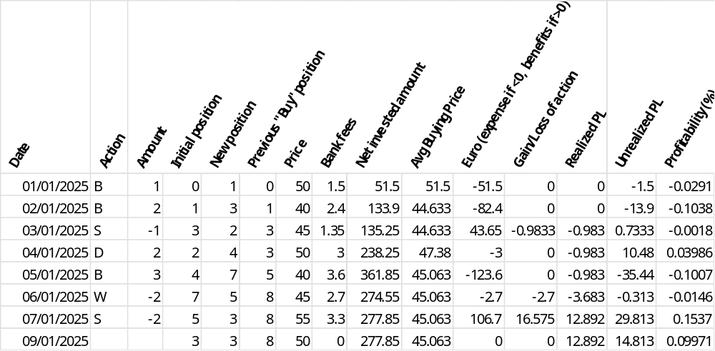

This information is stored at position level and updated at each operation. When a position is displayed to the customer, a new value of the unrealized PL can be computed considering the current price and then compute the percentage of profitability. When the position gets back to zero, i.e. when the customer sells all the assets, the average price and the net invested amount are also reset, considering the customer realizes his/her benefits (or loss). The next investment will trigger the following computations as it was the first investment.
This approach to compute PL and profitability can be personalized thanks to an EXIT point.
  - Persona
Currently the solution identifies the following persona:
- The customer of the bank (role: CUSTOMER, cf. § 4.4.2.b), who opens a digital asset account and triggers operations via the web application provided by the bank.
- The compliance officer (role: COMPLIANCE_OFFICER), who is a bank user, who monitors the suspicious operations and takes decision, via a web application dedicated to bank user.
- The customer advisor (role: CUSTOMER_SUPPORT), who is a bank user, who has a portfolio of customers under his/her responsibility and provide them with some advice and support, via a web application dedicated to bank user.
- The product manager (role: PRODUCT_MANAGER), who is a bank user, who maintains and configures the solution.
- The operation manager (role: OPERATION_MANAGER), who is a bank user, who monitors the solution activities and has access to the financial dashboards.
  - Event & Statistics management
The objective of the event management feature is to be able to feed the banking system with events that will impact its general ledger. Based on the event stored in the SCS table, the SCS is producing event reports which are available for consumption by the banking system.
Currently the SCS solution stores the following event types:
- Account creation, update and closure
- Deposit execution
- Withdrawal execution
- Order (buy and sell) execution
Each event contains the details on (non-exhaustive list):
- The customer
- The account
- The operation
- The fees
While storing events, the related information is used to compute statistics. There are two sets of statistics: one related to accounts, one related to operations.
For account related statistics, the following information is stored for each day:
- Number of active accounts
- Number of opened accounts
- Number of closed accounts
- Sum of all customer assets, per digital asset
For operation related, the following information is stored for each day and for each digital asset:
- Number of deposit transactions
- Number of withdrawal transactions
- Number of buy orders
- Number of sell orders
- Total of new assets due to deposit transactions
- Total of new assets due to withdrawal transactions
- Total of new assets due to buy orders
- Total of new assets due to sell orders
- Total of network fees (possibly in different currency / assets)
- Total of exchange fees (possibly in different currency / assets)
- Total of order margins (in asset)
- Total of bank fees.
- Number of rejected operations (for technical reasons)
- Number of KYT refused operations
- Number of eligibility refused operations (as limit, funds availability)
- Number of resolved operations (i.e. operation that were pending, for KYT for example, and finally accepted).
These statistics can be used by the bank to build dashboards (cf. § 3.28).

  - FIX connection
The interaction with the OMS (Wyden) relies on the FIX protocol (cf. for example: https://www.fixtrading.org/what-is-fix/) for the following actions:
- Trade initiation, notification and cancellation
- Price management
The list of FIX messages which is implemented is described in the integration guide. The FIX connection relies on a FIX engine, which deployment is described in the installation guide.
The capture of message issued from Wyden on the FIX session is done through a background process that monitors the FIX session.
The responsibilities of this process are:
- Ensure the FIX session is up and running. Automatically setting it up if it goes down
- Capture the received message and triggers the adequate SCS services, depending on the message type.
- Submit the message generated by SCS services and manage (a limited number of) retries in case of issues.
- Ensure message are all processed and only once. This is realized by storing the message in a cache with a status, updating the status once the SCS service has been executed.
  - Limit management
The solution implements the management of limits on customer operations and positions, and global limits on all customer positions. The objective is to limit risks:
- Operational risk, by avoiding the creation of operation with too high amounts, in case the account would have been hacked or in case the user would make some errors
- Exposure risk, by avoiding a customer having a too high amount of digital assets in his/her account, and by avoiding the bank having a too high amount of digital assets on all customer positions.
The operation limits are managed at account level and defined in base fiat currency. There are two sets of operation limits: one for trading activities (buy/sell/convert) and one for withdrawal. Each set of limit includes three limits: daily, weekly and monthly. The consumption of the daily one is reset every new day, the consumption of the weekly one is reset every new week (starting on Monday), the consumption of the monthly one is reset every new month (on the 1st day of the month). To control the operation limit, the amount of the operation must be converted in fiat currency (using average rate).
The customer position limits are managed at customer position level and defined in digital asset. There is one limit per position. The consumption of the limit is managed independently of the balance of the position, as it’s updated at the time of the acceptation of the request (while the balance is updated at the time of the execution of the operation).
The global position limits are managed centrally and defined in each digital asset. There is one limit par digital asset. The consumption of the global position limit is managed in parallel with the customer position limits: their control and consumption are managed the same manner and at the same time.
Depending on the nature of the request, the limits are controlled differently:
- Buying order
The trading operation limits and the position limit (for the base asset of the trading pair) are checked. If one limit is exceeded, the request is rejected. Otherwise the request is accepted and the limit consumptions are updated. If it’s an order with a target price and that the order is eventually cancelled or expired, the limit consumptions are reversed (but, for trading operational limits, not if the initial period of consumption is outdated).
- Withdrawal
The withdrawal operation limits are checked. If one limit is exceeded, the request is rejected. Otherwise the request is accepted and the limit (at withdrawal operation and position level) consumptions are updated. If the withdrawal is rejected later on (for example for AML reason), the limit consumptions are reversed (but, for withdrawal operational limits, not if the initial period of consumption is outdated).
- Selling order
The trading operation limits are checked. If the quote asset of the trading set is not a fiat one, the position limit of the quote asset is also checked. If one limit is exceeded, a warning is shown to the customer, but the request is not reject: we want to warn the customer in case he/she would have made a mistake, but we don’t want to reject the request if for example he/she decided to sell all his/her position in case the asset is tumbling and wants to limit his/her lost. Trading operation limit consumptions are not updated, but position limit (if the quote asset is not fiat) consumption is. As for a buying order, the order could be rejected or expired, and in that case the position limit consumption is reversed (if it has been updated).
- Deposit
The position limit is checked when SCS is notified of the deposit, but this is not blocking. We consider that the bank would not refuse some deposits. Nevertheless, the position limit consumption is updated, to take the deposit into account, and a notification is sent to bank users in case a limit is exceeded.
- Convert order
A convert order is managed as a selling order. To compute the impact on the operation limit there is a need to do a conversion into the fiat reference currency. If the convert order is an order at limit price, it’s not possible to have an estimation of the price in fiat reference currency, while in case of a selling order, the limit price can be used (as it’s expressed in fiat reference currency). In that case, the current price is used.
The values of the customer limits are set by default when opening the account. They can be changed later on by a bank employee based on a request from the customer (cf. § 3.15). For now all accounts have the same limits at opening time, but this could evolve if a concept of digital asset account product is implemented, with different default limits by product.
The values of the global limits are set in the solution configuration.
Rem: to check if storing the customer limits in the account and position table is the right approach. Alternative is to store them in a dedicated table. Issue with having position limit at position level, is that the limit consumption must be store while accepting the request, while position is usually updated (or created the first time) while executing the operation. As for global limit, we need a distinct table, maybe this table can also be used for the customer position limit, that would be easier.
  - Order and Transaction statuses
This paragraph makes a focus on the statuses related to buying / selling order, withdrawal and deposits. There are 3 statuses:
- Status of the request (i.e. the customer action)
- Status of the operation (i.e. the execution of the request), as managed by the back-end services.
- Status of the operation as perceived by the customer in the UI.
In the following diagrams there are three columns related to the evolution of these 3 statuses. There is a correlation between the customer status (last column) and the request/operation status which is highlighted through the color code: the statuses in one color in the two first columns is equivalent to the status in that color in the last column. Actually, it’s up to the UI layer to interpret the status provided by the back-end to display the adequate status to the customer. The here under proposition could be reviewed in case of a specific implementation of the UI layer.
    - Buy/Sell order
Figure 33 - Buy/Sell order statuses
    - Withdrawal
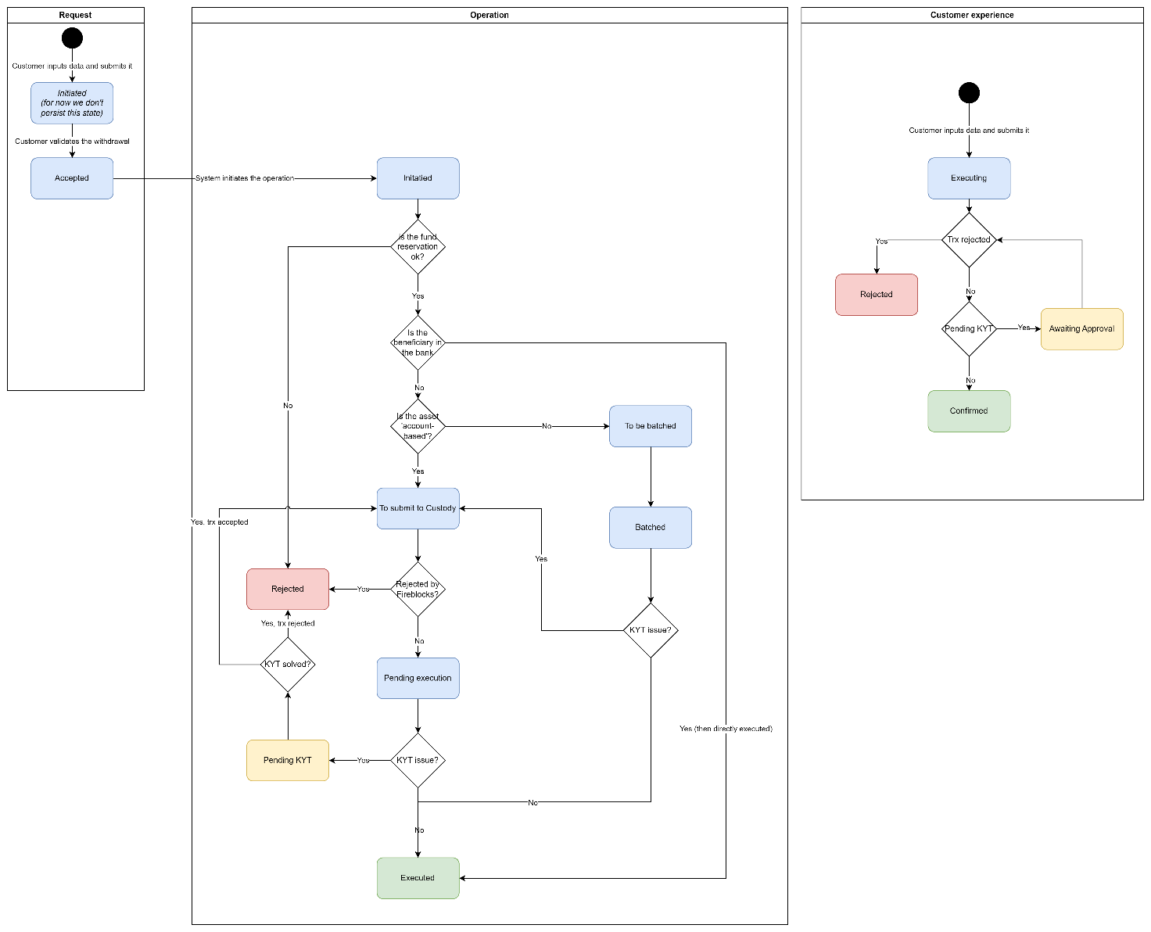
Figure 34 - Withdrawal statuses
    - Deposit

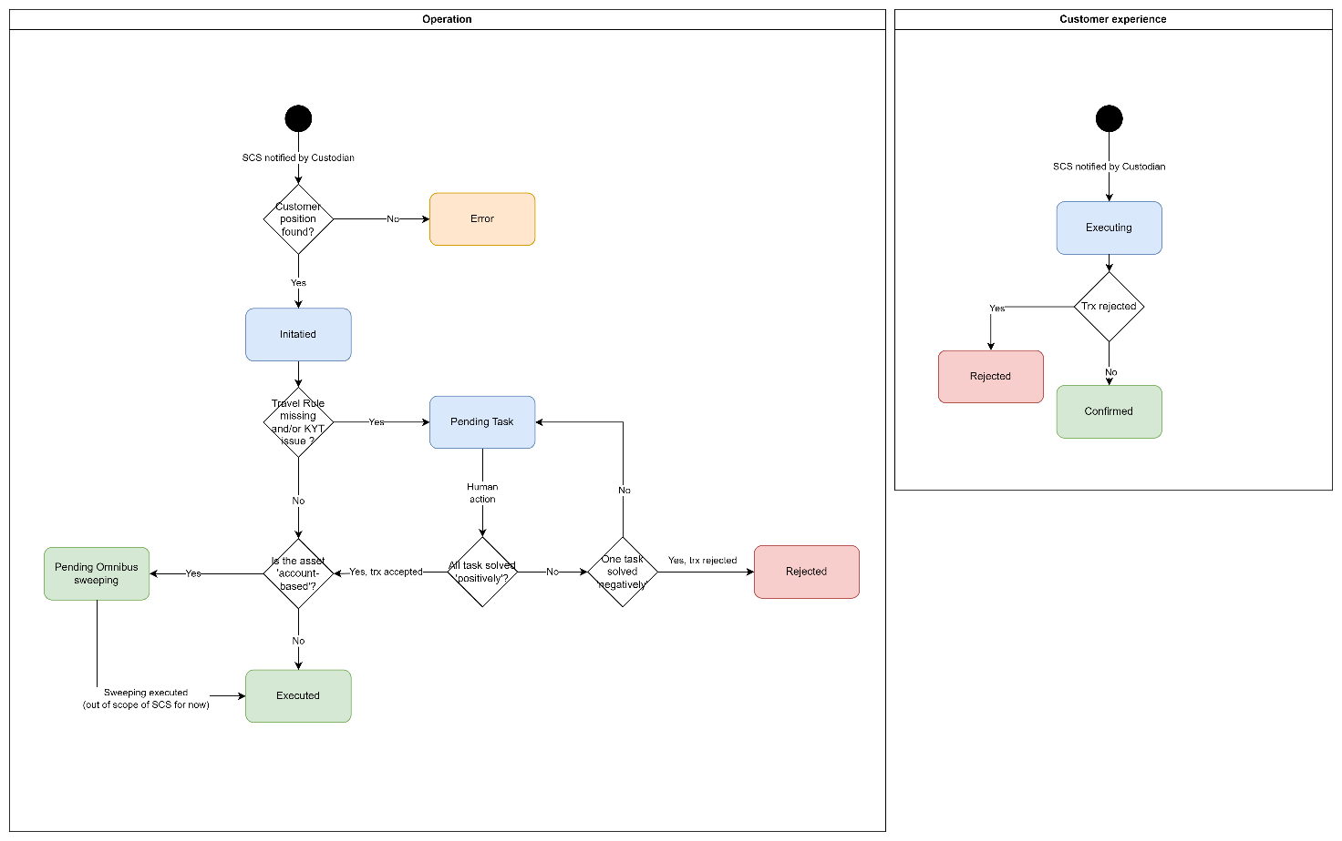
Figure 35 - Deposit statuses
  - Task management
To manage manual action, for example when a customer must complete Travel Rule information on a deposit, the SCS manages a generic concept of task, which identifies a manual action which is expected from a user. The user can be a customer or a bank user. A task is automatically created by the SCS based on an event that occurs on a object; the event being the trigger for the manual action.
For now, the following events are triggering the creation of a task:
- When a deposit or withdrawal is suspicious regarding KYT controls. A task is created and assigned to a back-office user (a compliance officer) who has to take a decision.
- When a compliance officer requests the customer to provide documents to justify a transaction pending KYT controls. A task is created and assigned to the customer who has to provide the document.
- When a deposit is received and lacks Travel Rule information. A task is created and assigned to the customer who received the deposit who has to complete the information.
- When a deposit is received and we need to know its value in order to compute gain, for tax report. A task is created and assigned to the customer who received the deposit who has to complete the information.
- When the customer requests an update of his/her limits. A task is created and assigned to a back-office user who has to validate the request.
- When a KYT alert is created based on continuous monitoring. A task is created and assigned to a back-office user (a compliance officer) who has to analyze the situation. This is not the same type of task as for KYT when a withdrawal or deposit is executed, as there is no more possibility to refuse the operation.
From an information modeling perspective, we distinct the object, the event and the task. The task object contains generic information like a type, a status, an assignee, etc. The object (on which the event occurred) and the event contain the information which is specific to the type of task. Depending on the type of task, the event information can be stored within the related object.
On one object we can have several events and pending tasks. Some dependencies may exist between tasks (as for example between the KYT resolution and the document request). The service managing the status of the related object must deal with these dependencies.
The status of a task is simple: a task is open, then closed when realized (whatever the result of the task) or cancelled if the task is not relevant anymore (e.g. a travel rule task could become not relevant if there is a KYT decision to refuse the operation).
Form an API point of view, we have the following behavior:
- The GET /tasks endpoint retrieves the information on a (list of) task including the event data (the specific part). It’s a public endpoint (i.e. accessible by the UI)
- The PATCH /tasks/{taskId} endpoint updates the information on a task and/or on the event. It’s a public endpoint. This one triggers the update of the event (or object) if needed.
- The DELETE/tasks/{taskId} endpoint cancels a task.
Next to these public endpoints, there are internal endpoints that allow updating the event (or objects) which are triggered by the PATCH /tasks endpoint. The next paragraph details the behavior of the different types of tasks.
    - Operation pending KYT
Process: a deposit or withdrawal is screened by Chainalysis and Chainalysis returns an alert. A bank user must decide to accept or reject the operation.
Object: the operation
Event: the Chainalysis screening, and its related data. Data are the Chainalysis ones (e.g. severity, etc) but also some SCS one (e.g. user decision, comments, etc).
Practically the screening data (event) can be stored with the operation (object).
The endpoint GET /tasks, with filter taskType and userId allows to list all the KYT actions a user must do.
The endpoint PATCH /tasks/{taskId} allows to update the task, either to:
- Complete event information, as user comments, or customer messages.
This simply updates the event information, through the internal API PATCH /operations/{operationId}/trx-screenings
- Request the customer to provide documents.
This requests to capture the request (including document type) through the PATCH /tasks endpoint.
The task service has to create a new task, assigned to the customer, so it can provide the document.
The current task is kept open, so the bank user can continue to update it.
- Accept or refuse the operation.
This updates the operation status and triggers its execution or cancellation. The task is set to close.
The endpoint DELETE /tasks/{taskId} allows to cancel the task. For example, if the operation is cancelled, the operation service should check if a task exists and cancel it.
Cf. also § 3.12 for an illustration of this use case.
    - Document request
Process: A task on KYT exist, the bank user requests the customer to provide proof.
Object: the operation
Event: the document request, which complete the screening information (cf. previous case).
Practically a document type and reference is stored in complement to the screening data. The document itself should be stored in a ECM (Enterprise Content Management system), which provides the document reference. This ECM should be provided by the bank IT system, accessible through a CBS endpoint.
The endpoint GET /tasks, with filter taskType and userId allows to list all the document a customer is expected to provide.
The endpoint PATCH /tasks/{taskId} allows to update the task, either to:
- Provide the document.
This update the event information, through the internal API PATCH /operations/{operationId}/documents. And close the task.

The endpoint DELETE /tasks/{taskId} allows to cancel the task. For example, if the operation is cancelled, the operation service should check if a task exists and cancel it.
Cf. also § 3.19 for an illustration of this use case.
    - Travel Rule
Process: a deposit or withdrawal is missing Travel Rule information. A customer must complete it.
Object: the operation
Event: the Travel Rule data, which can be empty or partially filled in at the time of the creation of task.
Practically the Travel Rule data (event) can be stored with the operation (object), or into an annex to the operation.
The endpoint GET /tasks, with filter taskType and userId allows to list all the TR data a customer must complete.
The endpoint PATCH /tasks/{taskId} allows to update the task, either to:
- Complete TR information.
This updates the event information, through the internal API PATCH /operations/{operationId}/travel-rules
The API should return a flag to inform if information is now complete. If yes, the task can be closed. Otherwise it stays open, and the user must be warned he needs to provide more information.

The endpoint DELETE /tasks/{taskId} allows to cancel the task. For example, if the operation is cancelled, the operation service should check if a task exists and cancel it.
Cf. also § 3.11 for an illustration of this use case.
    - Limit update
Process: a customer requests a limit update. A bank user must accept it.
Object: the account limits
Event: the request to update the limits, with new values.
Practically limit update request (event) should be stored next to the account, in order to trace the history of request.
The endpoint GET /tasks, with filter taskType and userId allows to list all the limit update request a bank user must complete.
The endpoint PATCH /tasks/{taskId} allows to update the task, either to:
- Update event information, as modify the limit request to give them an acceptable value.
This simply update the event information, through the internal API PATCH /subledger/accounts/{accountId}/limit-updates
- Accept or refuse the operation.
This updates the account limits (via API PATCH /subledger/accounts/{accountId}/limits. The task is set to close.
The endpoint DELETE /tasks/{taskId} allows to cancel the task. For example, if the account is closed, the subledger service should check if a task exists and cancel it.
Cf. also § 3.15 for an illustration of this use case.
    - Deposit value
Process: a deposit is missing deposit value. A customer must complete it in order to allow gain computation (for tax report)
Object: the operation
Event: the deposit value (which can be 0 in case of gift).
Practically the deposit value data (event) can be stored with the operation (object).
The endpoint GET /tasks, with filter taskType and userId allows to list all the deposits a customer must complete.
The endpoint PATCH /tasks/{taskId} allows to update the task, either to:
- Complete deposit value information.
This updates the event information, through the internal API PATCH /operations/{operationId} – no sub-resource in this case, as it’s just an amount.
The endpoint DELETE /tasks/{taskId} allows to cancel the task. For example, if the operation is cancelled, the operation service should check if a task exists and cancel it.
    - KYT – Continuous monitoring
Process: An alert is raised by the KYT tool (e.g. Chainalysis) about a past transaction, in the context of continuous monitoring. A compliance offer should analyze the alert and decide if a manual action (e.g. close the account) is required.
Object: the operation
Event: the alert raised by the KYT tool.
Practically the management of the task is manual. Once done, the compliance user should manually close the task.
The endpoint GET /tasks, with filter taskType and userId allows to list all the continuous monitoring alerts.
The endpoint PATCH /tasks/{taskId} allows to update the task, either to:
- Change its status to ‘close’.
This updates the status of the task and updates the alerts in KYT tool
The endpoint DELETE /tasks/{taskId} allows to cancel the task.
Cf. also § 3.12 for an illustration of this use case.
  - Regulatory Compliance
This section addresses regulatory standards, including MICA, TFR, DAC8 / CARF, GDPR and DORA. It looks mainly at the functional impacts. The technical impacts are discussed in the technical architecture section (cf. § 4).
    - MICA
In Europe, MiCA – Markets in Crypto-Assets regulation, (EU 2023/1114) is the main regulation which must be taken into account in the context of crypto-asset management. It’s been published on the 31/05/23 and applicable since 30/12/24.
The objective is not to provide an exhaustive analysis of MiCA but rather to highlight some practical impacts in the context of this solution.

Order execution
In the proposed configuration when the bank executes an order on request of a customer it actually executes the order in its name, with its funds, not in customer name. This corresponds to the situation covered by article 77 of MiCA. In this context, the article 77.3 requires that the price which is communicated to the customer when he/she validates the order is a firm price, even if the customer makes an order “at market price”. Consequently, once the order is executed, even with a different price (as the price may evolve between the validation of the order and its execution), that the agreed price which is used to impact the customer position.
To meet properly this requirement, we should manage a quote mechanism, where first a proposition of price is made to the customer. If he/she accepts this proposition, the bank has to provide the required asset at this agreed price (at worst). Practically the price at which the order is executed will be different from the agreed price: if the execution price is better than the agreed price, the bank must provide the required asset at the execution price, while if the execution price is worse than the agreed price, the bank must provide the required asset at the agreed price. In this last case, the difference is impacting negatively the bank margin.

For the moment this quote mechanism is not in place. Customer position is impacted taking into account the real execution price (except some cases which are explained in the detailed scenarios). This is an approach which is currently proposed by some exchanges. It requires at least a clear communication from the bank to the customer to explain that the price (and fees) which is shown at the time of the confirmation of the order is indicative.

Transparency on fees
Article 66, and more specially the paragraph 6, requires transparency on pricing. There are different fees that can be taken by the bank (cf. § 3.11) and this must be clearly documented to customers. For example the fact that the bank takes a margin on the price must be clearly communicated to customers. This communication is out of the scope of the solution; i.e. the margin is not explicitly communicated for each order, we take the hypothesis that the bank includes this information in the global communication on the crypto-asset offering.
    - TFR
The TFR - Transfer of Funds Regulation (EU 2023/1113) is another important regulation in Europ. It’s been published on the 31/05/23 and applicable since 30/12/24. It’s the EU translation of the Travel Rule constraint, initiated by the FATF (Financial Action Task Force) in order to fight against fraudulent activities such as money laundering. The FATF defines Travel Rule as
The obligation to obtain, hold, and submit required originator and beneficiary information associated with VA (virtual assets) transfers in order to identify and report suspicious transactions, take freezing actions, and prohibit transactions with designated persons and entities
This regulation is completed with EBA guidelines (EBA/GL/2024/11) which provide more detail on how to manage Travel Rule information.
The regulation makes mandatory the capture of information on the originator and the beneficiary of digital asset transfer:
- On the originator side: name and payment account number, completed by postal address or official personal document number or customer identification number, or date and place of birth. If the originator is a legal entity, the name must be the registered one (or commercial name), the identifier must be the one of the legal entity.
- On the beneficiary side: name and payment account number
The payment account number has to be understood in a very broad way, as any account identifier: it can be a portfolio id, a wallet id, a blockchain address, etc.
Let’s remark that in the case of transfer to a ‘self-hosted wallet’, i.e. a wallet not managed through a VASP – Virtual Asset Service Provider, as for example a Ledger wallet, there is a specific obligation to prove that the self-hosted wallet really belongs to the beneficiary when the transfer exceeds 1000 €. There is currently no standardized way to identify that the beneficiary is a ‘self-hosted wallet’, neither to get this kind of possession proof.
In the current SCS implementation, we only manage the capture and the storage of the information, but not its transfer. We don’t implement specific logic to identify ‘self-hosted wallet’ and we consequently don’t require specific information in this case.
The impact of Travel Rule management is illustrated in the different use cases. The logic is the following:
- For withdrawal, the travel rule information managed in two steps. The information on the ordering side is automatically fed based on information available in the CBS (retrieved via a consumed API endpoint). The information on beneficiary side is captured when creating the whitelisted address. Consequently the customer doesn’t have to provide travel rule information at the time of the withdrawal. When capturing the information on the beneficiary side, there is no specific control on the information (except the KYT controls done through Chainalysis). When working with Fireblocks, the Travel Rule information is provided in the Fireblocks endpoint that triggers the withdrawal; if the bank configures Fireblocks to be integrated with Notabene (one of main provider for Travel Rule management, including transfer of information between VASP, for which Fireblocks proposes a standard integration), the information should be transferred to the beneficiary VASP.
- For deposit, as we don’t manage the possibility to receive the information from the originating VASP, we have to suspend all deposits to ask the beneficiary to provide the Travel Rule information. The funds are frozen until the customer completes the information via a dedicated UI, relying on API endpoint PATCH /tasks/{taskId} (cf. § on task management). When the information is provided (without specific controls, except the ones done through Chainalysis), it’s stored in SCS database and the funds are made available to the customer.
    - DAC8 / CARF
DAC8 is EU directive (8th Directive on Administrative Cooperation, EU 2023/2226) which has been adopted on the 17th of October 2023, which is the translation of the Crypto-Asset Regulation Framework (CARF) as defined by the Organization for Economic Co-Operation and Development (OECD). It makes mandatory for CASP to report transaction data on crypto-assets to regulators, in order to achieve tax transparency across jurisdictions. This directive enters into force on the 1st January of 2026 for a first reporting beginning of 2027. In France, it has been transposed through the 2025 “Loi des finances” (article 54).
The reporting follows an XML structure defined by the OECD (XML schema). Based on the operational data stored in SCS, the solution is able to produce the XML structure, with the constrain of storing some detailed information on customer, as their addresses and fiscal identifier.
    - GDPR
GDPR (General Data Protection Regulations) has the following objectives:
- Protect individuals' personal data and privacy across the EU,
- Harmonize data protection laws across EU member states.
- Ensure transparency and accountability in data processing activities.
GDPR creates requirements on data minimization and classification, on data subject rights, on consent management and on breach notification.

The SCS doesn’t store information related to customer except for Travel Rule. But as Travel rule is a legal requirement, there is no need of specific customer consent. Nevertheless the information must remain confidential, which implies it must be encrypted during transport and storage (cf. paragraphs on data security § 4.4.4). Moreover the bank GDPR documentation should be completed to refer to this SCS process.
All interactions with partners are done without providing customer information (except for Travel Rule information). For example no customer id are propagated, only the internal digital asset account id.
The SCS documentation includes a Data Registry that list all processes and data usage, which can be used to complete Bank’s GDPR documentation.

    - DORA
DORA (Digital Operation Resilience Act) has the following objectives:
- Standardise digital operational resilience requirements throughout the EU financial sector.
- Target cybersecurity risks that are not addressed by capital buffers.
- Maintain the continuity of essential financial services during ICT disruptions.
DORA creates requirements on ICT risk management (e.g. setup a ICT risk management framework), on ICT incident reporting, on digital operational resilience testing, on third-party risk management, on information sharing.

Most responsibilities regarding DORA are at bank or integration project level, to include the SCS processes and its ecosystem in the bank DORA governance. At SCS level we ensure that:
- The solution is qualified from a function point of view through automated and manual testing
- The solution is qualified from a security point of view through security audits (realized by the cyber security department from Sopra Steria, in complete independence from the SCS team).
- The solution provides audit trail and logging features in order to report any incidents

Moreover the contract between Sopra Steria Group and the bank must be compliant with DORA, considering that the services provided by the SCS can be classified as ‘critical’ in regards to the potential impacts on customer assets in case of incidents.

  - Operational dashboards
Several optional dashboards targeting the bank users are foreseen:
- Portfolio insights, that gives information on:
  - Graph with revenue evolution, showing the P&L, in fiat and an in crypto. This part can be built by calling the REST API GET /banks/revenues
  - Margin evolution, which can be computed with the result of the REST API GET /banks/revenues
  - Statistics on account and customers, which can be computed by calling the REST API GET /accounts/statistics
  - Graph on operation volumes, which can be built by calling the REST API GET /operations/statistics
  - Information on assets on exchange / broker / custody and expositions by assets, which can be retrieved by calling the REST API GET /banks/positions
  - Graph on evolution of the asset under management, which can be built by calling the REST API GET /operations/statistics and GET /accounts/statistics and merging both information.
  - Table with the list of assets and their evolutions per month, which can be built by calling the REST API GET /banks/positions/{positionId} (one call per position).
- Activity dashboards, that gives information about:
  - Graph on evolution of the number of transactions, which can be built by calling the REST API GET /operations/statistics
  - Other statistics that can be retrieved via the same endpoint.
  - Operations for a given account, with possibility to drill down to the bank position entries for one operation. This part is built based on the GET /operations/{accountId} and GET /banks/entries endpoints.
- Liquidity and settlement dashboard, that gives information:
  - On the situation on each ‘bucket’ with potential alerts. This one can be built by calling the REST API GET /bank/positions. It’s possible to drill down from the global position (in reference fiat currency) to the details per positions and then to the details of each entry for a given position (via the GET /banks/positions/entries endpoint).

The following paragraphs provide more detail on the behaviour of these endpoints.
    - Bank revenues
The REST API endpoint GET /banks/revenues returns a table with P&L information. Its detailed documentation is available in the integration guide.
Its usage is restricted to bank user with adequate role.
It accesses the subledger bank positions, filtering by the position type related to P&L and compute the information to fill in the table.
    - Account statistics
The REST API endpoint GET /accounts/statistics returns a table with statistics on account activity. Its detailed documentation is available in the integration guide.
Its usage is restricted to bank user with adequate role.
To optimise the answer to this request, the subledger service maintains a table that stores the statistics per day, with the number of active accounts, opening and closing. This table is updated each time there is an event of such type on accounts, cf. § 3.22. If for one day there is no such event, there will be no record on the table for that date; in that case the information from the previous day can be used.
To return the total of assets for the day, the table used for operation statistics can be used, cf. next paragraph.
    - Operation statistics
The REST API endpoint GET /operations/statistics returns a table with statistics on operations. Its detailed documentation is available in the integration guide.
Its usage is restricted to bank user with adequate role.
To optimise the answer to this request, the operation service maintains a table that stores these statistics on operation per day. This table is updated each time there is an event related to operation, cf. § 3.22. If for one day there is no such event, there will be no record on the table for that date; in that case the information from the previous day can be used.
    - Bank positions
The REST API endpoint GET /banks/positions returns a table with bank positions with their value at current time. While GET /banks/positions/{positionId} returns one bank position with the possibility to get the evolution of its value on a period of time. Their detailed documentation is available in the integration guide.
Their usage is restricted to bank user with adequate role.
Their accesses the bank positions in the SCS and aggregates information by period of time (for the second one). For the first one, the number of alerts is computed based on alert data, cf. next paragraph.
For the first one, if the position is related to custody, it accesses the custodian to get the positions at that level (cf. field ‘positionExternalValue’ in the API endpoint), which should be identical to the SCS ones. This is done by calling the Fireblocks API endpoint GET vault/accounts/{vaultAccountId} (cf. https://developers.fireblocks.com/reference/getvaultaccount), where the wallet id is used as vaultAccountId. This API endpoints returns a list with all assets in the wallet and their positions. If the position is related to broker or exchange, it accesses the broker or exchange to get the position at that level (same field ‘positionExternalValue’). This access is done through the order integration module, which exposes an internal API endpoint to retrieve this information (cf. § 3.14).
  - Alert management
This feature relies on a background process that monitors the customer and bank positions in order to detect abnormal situation and generates alert to warn bank users.
The configuration of alerts is based on a list of predefined KPI to which it’s possible to define:
- A condition (e.g. greater than, lower than)
- A threshold (either an amount in the currency of the KPI, a number or a percentage depending on the KPI)
- A severity level (low, medium, high)
These rules are scanned and if a KPI matches a rule (i.e. if the condition and the related threshold are applicable), an alert is generated, with the related severity. In case several alerts are generated for the same KPI, only the one with the higher severity is kept. An alert has a type which is based on the KPI which generates it.
The available KPI are the following:
- Bank position at exchange / broker / custody
Each position has its own KPI; i.e. one position per bucket and per digital asset. It’s the balance of the position at the time the monitoring process is executed.
- Bank P&L at exchange / broker / custody
Each position has its own KPI; i.e. on position per type and per digital asset. It’s the balance of the position at the time the monitoring process is executed.
- Bank average price margin
The average price margin, as a percentage of the bank price, for the day at which the monitoring process is executed. There is one KPI aggregating the percentage for all digital asset, and each digital asset has also its own KPI.
- Bank revenue evolution
The difference between the total revenue (profit based on margin and bank fees) of the day and the previous day, expressed as percentage (positive in case of increase, negative in case of decrease). There is one KPI aggregating the percentage for all digital asset, and each digital asset has also its own KPI.
- Withdrawn amount
The total amount withdrawn that day. There is one KPI aggregating all the amount, converted in fiat currency with the average rate at the time the monitoring process is executed, and each digital asset has also its own KPI.
- Deposit amount
Each deposit amount is a KPI on which a rule can be configured to alert on deposit amount which are too high. There is one global KPI, expressed in reference fiat currency, and each digital asset is converted to it to apply the rule. And each digital asset has its own KPI. Let’s notice that this rule is in overlap with the limit management and should be configured accordingly.
The two first KPI allows to monitor bank liquidity, to ensure the right level of liquidity is available at exchanges / broker and custody to process orders and transactions. The related alerts are the ones which are included in the bank positions API (cf. § 3.28.4)

The generated alerts are stored in a table and triggers the generation of a notification via the CBS API endpoint POST /core-banking/user-notifications.
Its content is accessible through the REST API endpoint GET /alerts. Cf. the integration guid for more details on its structure.
This API endpoint is only accessible to bank user with the adequate role. If the alerts is related to bank positions, the details on the bank position (its type, bucket, value) are also provided.
An alert has a lifecycle: it’s first created in a status ‘OPEN’, then can move to a status ‘PENDING’, and then to a status ‘CLOSED’. The status update is a manual process under the responsibility a bank user. A REST API endpoint PATCH /alerts/{alertId} allows to update the status or add a comment.
  - Unrealized P&L
Will be completed in future versions
  - Bank fee computation
Bank fees are supposed to be computed by the bank CBS and the SCS is expecting to call an API endpoint POST /core-banking/customer-billable-operation as defined in the integration guide. But SCS is also proposing an implementation of this endpoint in order to limit the integration with the CBS. In this case the bank fee must be configured in the SCS. This chapter details the behaviour of this implementation.
SCS Bank fees are computed as a percentage of the operation value, in a currency which depends on the type of operation. This currency is the fiat currency for Buy and Sell, the quote currency for Convert and the digital asset for Withdrawal. The result can be limited based on a minimum amount or maximum amount as defined in the configuration.
The configuration of the bank fees is done through bank-user UI. A dedicated set of API endpoints is available to manage the configuration, cf. the integration guide and the endpoints managing the bank-fee-configurations resource.
The configuration is made of a list of configuration items that link a set of criteria and a computation rule. The set of criteria defines when the computation rule must be applied. The available criteria are, by order of importance (the first one being the most important):
- Product type: which is an attribute of the account and is fully configurable.
- Operation type: which allows to identify if the operation is a buying order, a sell order, a convert order, a withdrawal or a staking.
- Digital asset: which is the quote digital asset in case of order, or the digital asset in a withdrawal or a staking.
Criteria are not mandatory to define a configuration item. If no criteria are declared, the computation rule is generic and applicable in any case. Except if there is a more precise one: it’s always the more precise set of criteria which is selected, taking into account the priority of criteria (i.e. the engine first searches for configuration items where the criteria product type matches the product type of the operation, then if it finds some, it filters them based on the operation type, and then based on the digital asset; if no configuration items is find when searching at the product type, it then searches for configuration items when the criteria product type is empty but where the operation type matches the operation type of the operation, etc.). Let’s notice that several values of a criteria can be declared for one configuration item (e.g.: this computation rule is applicable for product X or Y).
The computation rule is made of the percentage, the minimum amount (defined in reference fiat currency) and the maximum amount (defined in reference fiat currency). Minimum and maximum amount can be set to 0 if they are not applicable. If the currency used to compute the bank fees is not the reference fiat currency, the minimum and maximum amount will be converted considering the current average price.
  - Digital asset configuration
Digital assets and digital asset pairs can be configured through UI and API endpoints available to product managers. This configuration must be aligned with the configuration of the rest of the ecosystem. Cf. the integration guide (chapter 4.1.1) for the list of configuration items that must be specified at the level of each digital asset and digital asset pairs. These configuration items are checked when accepting and order or a transaction request.
There are two set of API endpoints on the resource /digital-assets/configurations and /digital-asset-pairs/configurations. Cf. the documentation of these endpoints for more details.

- Technical architecture
This section describes the technical architecture based on the current development of the SCS Core component by the Sopra Steria Group team. Obviously, the target technical architecture of a given bank will highly depend on the existing bank infrastructure and requirements. The here under proposed architecture must be tailored by the integration project to cope with bank expectations.
  - Architecture Principles

Our architectural strategy is grounded in a set of principles that ensure scalability, agility, maintainability, security, and observability across our software systems. These principles guide the design, development, and deployment of all applications and services.
- Embracing Microservices architecture promotes modular, decoupled services with clear business responsibility, enabling fault isolation and independent scalability.
- Security is incorporated from the outset through a "Security by Design" approach, ensuring least privilege access, authentication and authorization controls, and proactive security testing.
- An API-first philosophy encourages the use of OpenAPI specifications and well-defined API contracts, fostering parallel development and agility.
- Continuous Integration and Continuous Deployment (CI/CD) streamline delivery with automated builds, tests, and deployments.
- Logging and monitoring provide insight into system behavior and user actions, ensuring operational health and accountability.
- Code quality is maintained with rigorous standards like automated unit testing, code coverage targets, and static analysis tools such as SonarQube.
- Finally, comprehensive documentation spans functional, technical, architectural, and operational domains, ensuring transparency, maintainability, and ease of onboarding.
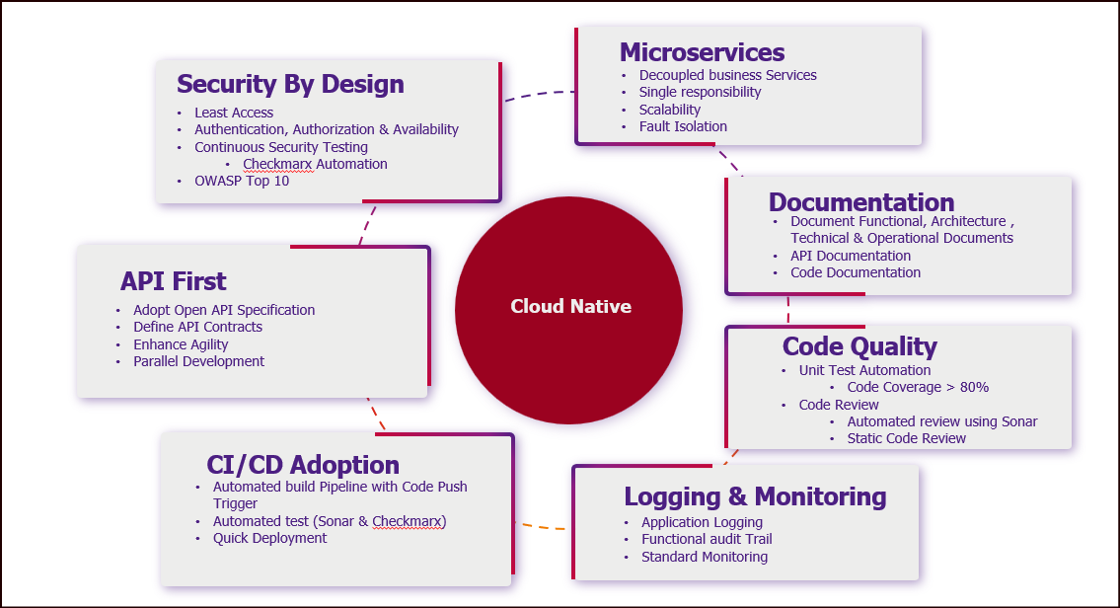
Figure 36 - Architecture principles
    - Microservices
Microservices architecture promotes the decomposition of applications into loosely coupled, independently deployable services, each representing a specific business capability. Each service adheres to the single responsibility principle, ensuring it is focused on a specific business function. This allows for scalability both at the system and component level and enhances fault isolation—issues in one service do not bring down the entire system. Microservices also enable polyglot development, technology independence, and foster rapid innovation cycles.
    - Security by design
Security is integrated from the earliest stages of system design, not as an afterthought. This includes enforcing least privilege access principles, robust authentication and authorization mechanisms (e.g., OAuth2, JWT), and ensuring system availability through DDoS protection and disaster recovery strategies. Regular security testing using tools like Checkmarx and maintaining compliance with OWASP Top 10 vulnerabilities help reduce risk. Security gates must be embedded into the CI/CD pipeline for continuous assurance.
    - API-First
An API-First approach mandates designing and documenting APIs before implementation. By adhering to OpenAPI specifications, teams can define clear, machine-readable API contracts that foster alignment and reduce rework. This enables parallel development across teams and promotes third-party and internal integration agility. Versioning, mocking, and simulation tools enhance testability and reusability, ensuring that APIs become foundational components rather than byproducts of implementation
    - CI-CD Adoption
Continuous Integration and Continuous Deployment (CI/CD) streamline the software development lifecycle through automated build, test, and deployment pipelines. This ensures rapid and reliable releases while maintaining high quality. Every code commit triggers automated builds and tests, facilitating early bug detection and quicker feedback loops. Deployment pipelines can support canary releases, blue-green deployments, and rollback mechanisms for resilient delivery.
    - Logging and Monitoring
Observability is vital for maintaining system health and operational excellence. Application logs capture structured data and contextual metadata, while functional audit trails must be maintained for compliance and traceability. Integration with standard monitoring tools (e.g., Prometheus, Grafana, ELK stack) ensures proactive alerting, trend analysis, and system diagnostics. Centralized logging supports faster root-cause analysis and continuous improvement.
    - Code quality
Ensuring high code quality involves enforcing automated unit testing with a target coverage above 80%, implementing static code analysis through tools like SonarQube, and promoting peer code reviews. Automated code quality gates in CI pipelines help detect code smells, vulnerabilities, and maintainability issues early. Following clean code principles and secure coding practices ensures the longevity and reliability of the system.
    - Documentation
Comprehensive documentation supports understanding, onboarding, and governance. This includes functional specifications, architecture diagrams, technical implementation guides, operational runbooks, API documentation (e.g., Swagger), and inline code documentation. Documentation is treated as a living artifact, continuously updated in sync with code and architecture changes. Well-documented systems reduce knowledge silos and support scalability across teams.

  - Technical Stack & Logical Architecture
The technical stack and logical architecture are designed to deliver a robust, secure, and scalable platform by leveraging cloud-native technologies and industry best practices. The system currently uses AWS for infrastructure, embraces container-based deployments, adopts a microservices architecture using Java Spring Boot, integrates with external services via secure APIs, and provides a responsive UI built with Angular. The architecture ensures scalability, observability, and security at all layers.
There is no strict dependency towards AWS tools, the deployment on other cloud providers or local infrastructure is also possible considering that similar tools can be provided.

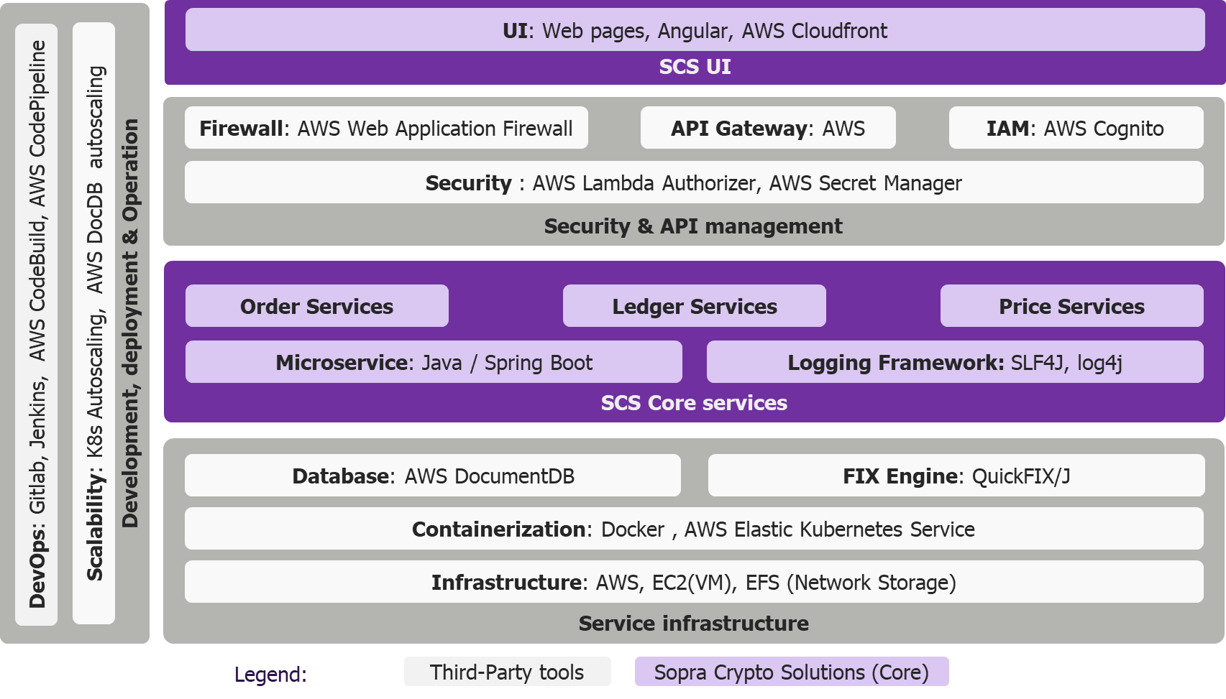
Figure 37 - Technology stack
    - Third-Party Tools
This layer encapsulates core third-party services and infrastructure essential to system operation. AWS provides the backbone of the infrastructure, while various tools enhance scalability, security, and runtime agility.
The application is architected on a highly available and scalable AWS cloud infrastructure, leveraging AWS EC2 instances to handle compute-intensive workloads. These instances are integrated with AWS Elastic File System (EFS), which provides a distributed, POSIX-compliant, shared file system that scales automatically to accommodate growing storage demands. This setup ensures fault tolerance and high throughput for concurrent access across multiple availability zones.
The application follows a microservices architecture, with each service containerized using Docker to ensure environment consistency and portability. These containers are orchestrated using AWS Elastic Kubernetes Service (EKS), which provides a managed Kubernetes control plane for automated deployment, scaling, and lifecycle management of containerized workloads. EKS integrates with AWS-native services for observability, security, and networking, enabling seamless CI/CD pipelines and blue-green deployments.
For data persistence, the system utilizes AWS DocumentDB (with MongoDB compatibility), a fully managed NoSQL document database that supports horizontal scaling, automatic failover, and multi-AZ replication. This ensures low-latency access and high availability for semi-structured data.
Financial messaging through FIX protocol is handled using QuickFIX/J, a Java-based FIX protocol engine that supports session-level and application-level message parsing, validation, and routing. It enables low-latency, stateful communication with external trading systems, supporting FIX 4.x and 5.x versions with customizable message dictionaries and session configurations.
API management is centralized through AWS API Gateway, which provides RESTful and WebSocket API support with built-in request throttling, caching, versioning, and monitoring via AWS CloudWatch. Custom authentication and authorization logic is enforced using AWS Lambda Authorizers, which allow for token introspection, role-based access control (RBAC), and integration with identity providers.
Sensitive configuration data, such as API keys and database credentials, are securely stored and rotated using AWS Secrets Manager. It provides fine-grained IAM policies, automatic secret rotation, and audit logging via AWS CloudTrail. Access control across AWS resources is governed by IAM roles and policies, while user authentication and authorization for client-facing applications are managed through Amazon Cognito. Cognito supports OAuth2, SAML, and OpenID Connect, along with multi-factor authentication (MFA) and user pool federation.
To protect against Layer 7 threats, AWS Web Application Firewall (WAF) is deployed in front of API Gateway and load balancers. It uses rule-based filtering to block common attack vectors such as SQL injection, cross-site scripting (XSS), and bot traffic, enhancing the application’s security posture.

    - SCS Core services
The application follows a microservices architecture, where each business domain, such as Order Services, Subledger Services, and Price Services, is encapsulated as an independent Spring Boot service. Each of these services is designed to handle specific business logic and operations related to its domain, ensuring a clear separation of concerns. These microservices communicate with each other over RESTful APIs, which allows for loosely coupled interactions and promotes scalability and flexibility in the system architecture.
In addition, each microservice operates independently and does not share direct access to databases. Instead, they interact with their respective data stores, which allows for more effective data management and isolation of concerns. This design pattern also improves the system's resilience, as failures in one microservice do not directly impact the others.
Logging across these services is consistently implemented using SLF4J (Simple Logging Facade for Java) and Log4j (a reliable logging framework). This consistency ensures that all log messages generated by the different microservices follow a unified format, which simplifies log analysis and troubleshooting. The centralized log management system can aggregate these logs, providing a comprehensive view of the application's behavior and facilitating efficient monitoring and debugging processes.
This robust logging mechanism also contributes to the overall observability of the system, enabling teams to track and analyze application performance, detect anomalies, and respond to incidents promptly. By maintaining detailed logs, the development and operations teams can ensure the application's reliability and optimize its performance over time.

    - SCS Core UI Layer
The web UI layer is built using Angular, a powerful and flexible front-end framework. This choice allows for the creation of dynamic, highly interactive, and responsive user interfaces that enhance the overall user experience. Angular’s component-based architecture facilitates efficient development and maintenance, ensuring that the UI remains modular and scalable.
To further optimize performance and deliver content swiftly to users across the globe, AWS CloudFront is employed as the content delivery network (CDN). By caching UI assets at edge locations around the world, AWS CloudFront significantly reduces latency, providing faster load times and a smoother user experience. This global distribution network ensures that users, regardless of their geographic location, can access the application’s interface quickly and reliably.
  - Infrastructure Architecture
SCS Core is based on AWS infrastructure architecture and is designed to deliver scalable, secure, and resilient cloud-native solutions by leveraging Amazon Web Services' extensive ecosystem. At its core, the architecture typically includes a multi-account setup governed by hosting AWS Organizations, enabling isolation, centralized governance, and cost tracking across environments. This architecture aligns with the AWS Well-Architected Framework, emphasizing operational excellence, security, reliability, performance efficiency, cost optimization, and sustainability
    - Existing Architecture
The current architecture outlines a cloud-native financial trading application deployed on Amazon Web Services (AWS), purpose-built for high availability, scalability, and security. It leverages a suite of AWS services to support various operational layers, including frontend delivery, API management, container orchestration, persistent storage, CI/CD automation, and compliance enforcement. This modular and resilient design ensures the platform can handle dynamic workloads and evolving business requirements while maintaining robust security and performance standards.
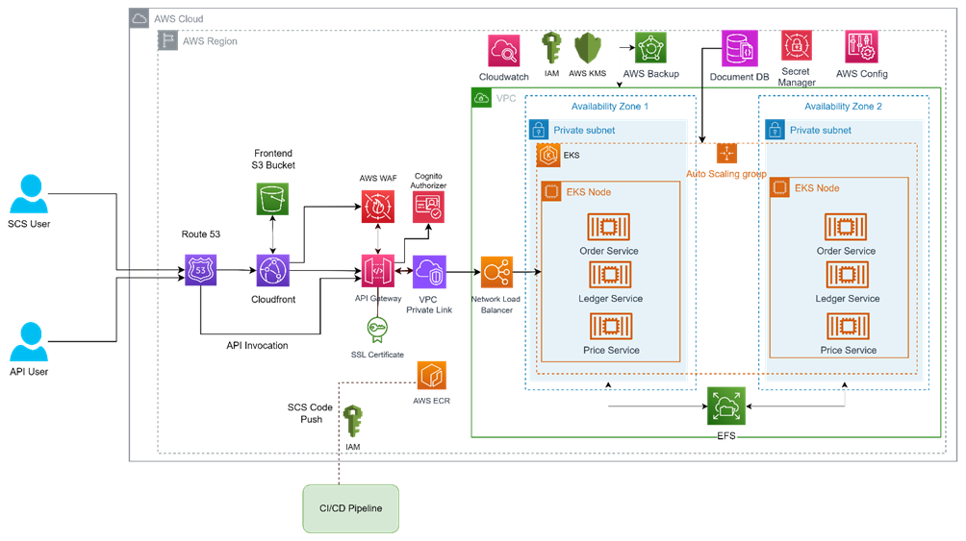
Figure 38 - Current infrastructure
User access to the system is facilitated through AWS Route 53, which provides DNS-based traffic routing and automated failover. This ensures that external clients—including SCS users and API consumers—are directed to the most responsive and healthy endpoints, thereby enhancing reliability and minimizing service interruptions.
For frontend delivery, static assets such as HTML, CSS, and JavaScript files are hosted on AWS S3, a highly durable and scalable object storage service. These assets are distributed globally via AWS CloudFront, a content delivery network (CDN) that caches content at edge locations. This setup significantly reduces latency and ensures a fast, consistent user experience regardless of geographic location.
API traffic is managed through AWS API Gateway, which offers advanced features such as request throttling, monitoring, and versioning. To protect against common web vulnerabilities like SQL injection and cross-site scripting (XSS), AWS WAF (Web Application Firewall) is integrated into the architecture. Secure communication is enforced using SSL certificates, while AWS Cognito handles user authentication and authorization through JWT tokens. Internal services communicate securely using AWS VPC PrivateLink, which enables private connectivity within the AWS environment without exposing services to the public internet.
The backend is powered by AWS EKS (Elastic Kubernetes Service), with containerized microservices such as Order Service, Subledger Service, and Price Service deployed across multiple Availability Zones. These services are hosted in private subnets within a Virtual Private Cloud (VPC), ensuring network isolation and enhanced security. Incoming requests are routed through a Network Load Balancer (NLB), which distributes traffic efficiently across AWS EKS nodes to maintain high availability and fault tolerance.
For data storage, AWS EFS (Elastic File System) provides scalable, shared file storage accessible by EKS nodes. This is complemented by AWS DocumentDB, a MongoDB-compatible NoSQL database that supports high availability, automatic scaling, and multi-AZ replication. This combination ensures both structured and unstructured data are handled efficiently and reliably.
The CI/CD pipeline is initiated by SCS Core Code Push, which triggers automated build and deployment workflows. AWS IAM (Identity and Access Management) governs access control, ensuring that only authorized users and services can interact with infrastructure components. Docker images used in deployments are stored in AWS ECR (Elastic Container Registry), enabling seamless integration with AWS EKS for container orchestration.
Monitoring, security, and compliance are integral to the architecture. AWS CloudWatch collects logs and metrics to provide observability into system performance and health. AWS KMS (Key Management Service) manages encryption keys to protect sensitive data, while AWS Backup ensures data durability and recovery in case of failures. AWS Secrets Manager securely stores configuration secrets such as API keys and database credentials. Finally, AWS Config continuously monitors and records configuration changes across AWS resources, helping enforce compliance with internal and regulatory policies.

    - Target Architecture
Target architecture will be in addition to above Infrastructure Architecture which contains additional security network components as per Bank hosting environment. The diagram presents a comprehensive view of an AWS-based network security architecture, showcasing how various security services are integrated to safeguard cloud infrastructure. At the forefront is the AWS Network Firewall, which acts as the initial line of defence, filtering traffic before it enters the internal network. This traffic is then routed into an AWS Inspection VPC, a dedicated virtual private cloud designed for deep packet inspection and threat analysis. Within this VPC resides the AWS Firewall Endpoint, which serves as the enforcement point for traffic inspection policies.
From the Inspection VPC, traffic is forwarded to the AWS Transit Gateway, a central hub that interconnects multiple VPCs and on-premises networks, enabling scalable and secure routing. The AWS Transit Gateway then distributes traffic to additional security services. One such service is AWS Shield, which provides protection against Distributed Denial of Service (DDoS) attacks, ensuring availability and resilience. Another is AWS Session Manager, which facilitates secure and auditable administrative access to AWS resources without the need to open inbound ports or manage SSH keys.
The architecture also incorporates AWS Direct Connect, which establishes a dedicated network connection from on-premises environments to AWS, enhancing bandwidth and reducing latency. This connection feeds into the AWS Transit Gateway, allowing secure and efficient integration of external network security components. These components, represented collectively, may include third-party appliances or additional AWS-native services that further enhance the security posture.
AWS GuardDuty provides intelligent threat detection and continuous monitoring to protect EKS-based infrastructure from potential security threats. By analysing VPC Flow Logs, Kubernetes audit logs, DNS logs, and AWS CloudTrail events, AWS GuardDuty helps detect malicious activity such as unauthorized API access, container compromise attempts, or anomalous network behaviour within the Kubernetes cluster. With EKS audit log integration, it monitors control plane activity for suspicious actions like privilege escalation or lateral movement. AWS GuardDuty operates in a fully managed, serverless manner and delivers real-time alerts with actionable insights, enabling security teams to respond quickly to threats without managing infrastructure or agents manually. This significantly enhances the security posture of containerized workloads running on AWS EKS.
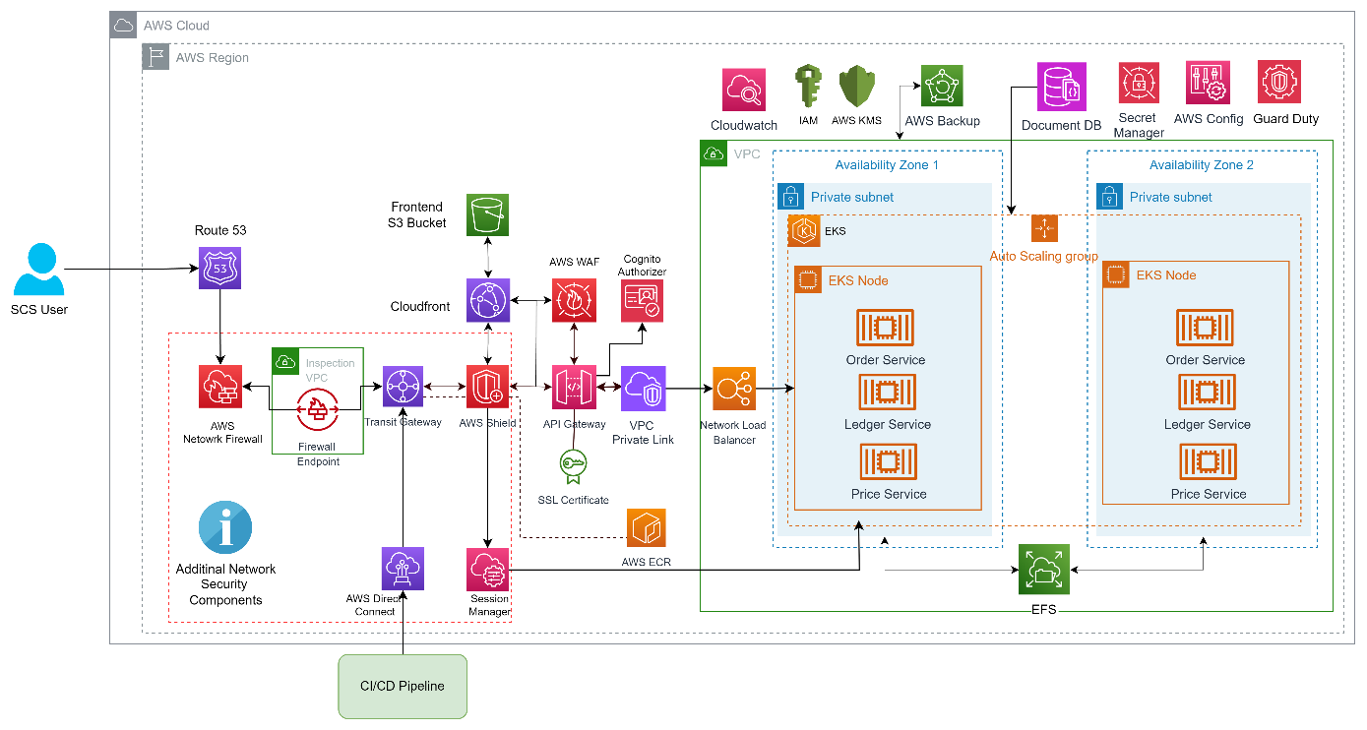

Figure 39 - Target infrastructure
    - Infrastructure Scaling
Infrastructure scaling in AWS Elastic Kubernetes Service (EKS) is a critical capability for managing dynamic workloads in cloud-native environments. In SCS Core, scaling is done using Cluster Autoscaler & Horizontal Pod Autoscaler (HPA).
      - EKS Scaling: Cluster Autoscaler
The Cluster Autoscaler is a dynamic component within Kubernetes—integrated seamlessly with AWS EKS—that automatically adjusts the number of nodes in a cluster based on real-time workload demands. It continuously monitors the cluster for un-schedulable pods, which are typically pending due to insufficient CPU, memory, or other resource constraints. When such pods are detected, the Cluster Autoscaler triggers a scale-up event, provisioning additional nodes to accommodate the workload. This ensures that applications remain responsive and scalable under fluctuating demand.
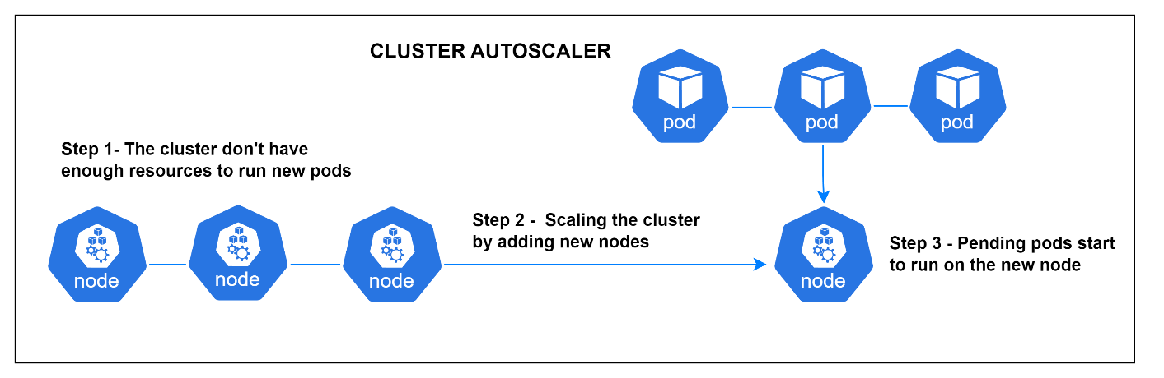

Figure 40 - Cluster Autoscaler
In the first stage, the cluster is fully utilized, and new pods remain in a pending state due to a lack of available resources. In the second stage, the Cluster Autoscaler responds by initiating the addition of a new node to the cluster. Finally, in the third stage, the previously pending pods are scheduled and begin running on the newly added node, restoring balance and performance to the system.
Beyond scaling up, the Cluster Autoscaler also identifies underutilized nodes and removes them when they are no longer needed, thereby optimizing resource usage and reducing operational costs. This dual capability of scaling both up and down makes it an essential tool for maintaining efficient, cost-effective, and resilient infrastructure in cloud-native environments like EKS.
      - EKS Scaling: Horizontal Pod Autoscaler
The Horizontal Pod Autoscaler (HPA) is a key component in Kubernetes that dynamically adjusts the number of pod replicas in a deployment based on real-time resource utilization metrics such as CPU or memory usage. This ensures that applications can automatically scale out during periods of high demand and scale in when demand subsides, optimizing both performance and cost-efficiency.
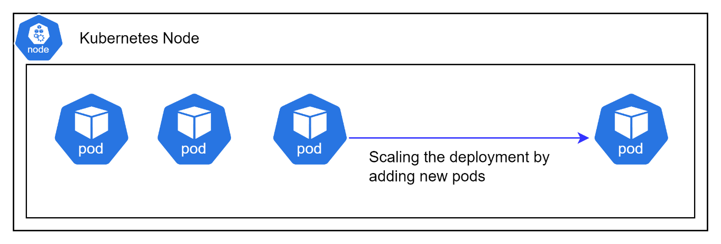
Figure 41 - Horizontal Pod Autoscaler
  - Security
    - Infrastructure & Network Security
The AWS infrastructure security architecture represents a comprehensive, multi-layered approach to securing a cloud-native application environment. It emphasizes the use of private subnets, VPC peering, and routing controls to isolate workloads. Security Groups, Network ACLs, and AWS Network Firewall are recommended for traffic filtering and access control. Kubernetes Network Policies and service meshes like Istio are used to manage pod-level communication and encryption.
      - VPC Design & Subnet Isolation
Deploying services within private subnets can create isolated environments and restrict exposure to the public internet, thereby potentially reducing the attack surface. SCS Core architecture uses AWS VPC with private subnets to host AWS EKS workloads, ensuring isolation from public access. Inter-VPC communication may be established through AWS VPC peering or AWS Transit Gateway solutions, with NAT gateways and routing policies managed to control traffic flow and address unauthorized access concerns. Multiple Availability Zones are leveraged for high availability and fault tolerance.
      - Security Groups, NACL & Network Firewall
Security Groups and Network Access Control Lists (NACLs) must be meticulously configured to uphold the principle of least privilege. Only essential ports and CIDRs should be permitted, with deny-all default rules supplemented by explicit allowlists. Additionally, deploying AWS Network Firewall enables deep packet inspection and stateful traffic filtering at the VPC level, thereby strengthening the overall network security posture.
      - Ingress & Egress Control for EKS
Kubernetes Network Policies are recommended for managing pod-to-pod and namespace-level communication within AWS EKS clusters. Additionally, implementing service meshes such as Istio enables enforcement of mutual TLS (mTLS) and facilitates granular traffic control, thereby promoting secure service-to-service interactions and ensuring the encryption of data in transit.

    - Identity, Access Management and Service Security
The implementation of least privilege access relies on IAM roles and policies. Security at back-end service level is ensuring that the service execution is authorized. We can identify following types of controls:
- Authentication
- Role based access control (RBAC)
- Asset-link based access control
- Functional eligibility
      - Authentication
User authentication should be secured using Multi-Factor Authentication (MFA) and OAuth2-based access mechanisms. AWS Cognito is used to manage user identities, and integration with enterprise Single Sign-On (SSO) solutions ensures centralized and secure authentication across services. Authentication & SSO will be integrated as per Bank choice.
      - Role based access control
Every service controls that the role of the user who triggered the service is relevant to execute its logic.
The user role is made available via the JWT token which is provided during the API call that triggers the service.
This is a simple control: the service must test that the role provided in the token matches the list of roles (or persona) the service is accepting. The name of the roles can be changes via a configuration file (but the granularity and related access can’t be changed for now).
Cf. § 3.23 for the list of roles.
      - Asset-link based access control
Every service controls that the user who triggered the service has some relevant links with the asset(s) which is(are) handled by the service.
If the user is a bank customer, currently the service checks that this customer is the holder of the crypto-account on which the service is operating. If it’s not the case, the action must be refused. In the future this logic could be extended to manage more complex situations with crypto-accounts held by several holders or where mandates are granted on cyrpto-accounts.
The control is based on the customer identifier which is provided in the JWT, which ensures it can’t be intercept-ed and modified during the call.
In the current implementation of the solution, this approach is partially implemented. For development purpose, AWS Cognito is used to manage user and login. A JWT is created at login but it doesn’t contain a customer id. In-stead we use the user email as customer identification (instead of the one that should be provided from the bank customer database). This one is then stored at account level as customer id. This way of working doesn’t allow to completely secure the controls related to the link between user and the customer on the behalf of whom the user is acting. A production ready implementation must review this implementation, relying on more advanced user management and authentication mechanism that will create a JWT token with the adequate customer id.
In case of a ‘bank user’ role, the control that the bank user can access a given customer (and his/her assets) is delegated to the Core Banking System, via a call to an API endpoint POST /bank-user-access-controls, with the user id and customer id in the body. A simple ‘true/false’ is expected as answer: if the answer is true, it means that the bank user can access this customer (and if false, the access must be refused). Implementing the logic to manage links between bank user and the customer they can access is not the responsibility of the SCS Core. Let’s notice that an alternative would be that the JWT includes a list of customers the user can access, but as the list could be huge, it’s not applicable. This control must be implemented in all services which access customer information and that can be called by a ‘bank user’ role.
Such control doesn’t exist if the accessed resource has no link with customer or account, as for example the endpoint that allows retrieving information on digital asset price or configuration.
      - Functional eligibility
Functional eligibility relates to the business logic of each service. For example it’s about controlling that the customer is not already holder of a crypto-account, as for now we only accept one account per customer. Or it can be controls on limits, etc. The use cases described in chapter 3 are detailing these controls.
    - Application Security
Application security encompasses UI security, API protection and AWS Web Application Firewall (WAF).
      - UI Security
The UI layer is responsible to identify and authenticate users, relying on some login mechanism. In our default implementation, this responsibility is delegated to AWS Cognito. During the integration of the solution in the bank IT landscape, this can be replaced by the bank selected mechanism.
If the user is a customer of the bank, it’s also up to the login mechanism to identity the customer on behalf of whom the user is acting. This information must be communicated to the back-end via the API call.
Based on this authentication, the UI layer must build a JWT (Json Web Token) as expected by the API (cf. next paragraph)
The UI layer is also responsible to check the access to the UI page, by implementing Role Based Access Control (RBAC). During end user setup respective roles (cf. § 3.23) will be assigned to respective users.
These roles will be integrated into the user profile within the Authentication Provider (in this case, Cognito). Upon login, the application UI will retrieve the JWT token and access the user profile, including the assigned role. Users will then be directed to the appropriate page based on their designated role.
The UI layer is also responsible for the implementation of ‘signature’ of sensitive actions. A ‘signature’ is a mechanism usually based on authentication that requests a confirmation from the user and allows the system to ensure the user is well at the origin of the action. Such signature can be based on multi-factor authentication mechanisms. In the default implementation, there is no such signature implemented, but it can be implemented during the integration project. As described in § 4.5.3, the API allows to capture a proof of signature which can be used for non-repudiation purposes.
      - API Security
There are multiple aspects related to API security to take into account
• Security at transport level, related to the network and the communication between the caller and the called application, relying on TLS.
• Security related to the identification, authentication and authorization of the calling application, to control the calling application is entitled to call the service.
• Security related to the identification, authentication and authorization of the user behind the API call, to control the user is who it claims to be and is entitled to call the service.
• Security related to the functional context, to control that the service can indeed be realized for this account or operation (the functional context). This part is under the responsibility of each service as it depends on the functional scope of the service. Cf. § 4.4.4.
• Rate Limit & Throttling to protect against abuse, brute-force attacks, and denial of service (DoS).
• CORS policies to restrict cross-origin requests to known domains.
• Logging & Monitoring to monitor anomalous API behaviour.
• Error Handling and Information Disclosure to provide generic error code and to avoid send detail stack trace
• Input Validation & Data Sanitization to validate all incoming data

Transport level
On the transport level all requests to the SCS Core, as well as all requests sent by the SCS Core, must be encrypted using TLS and be made over HTTPS. TLS 1.3 must be used. The TLS authentication method used is one-way, that means in requests to SCS the caller server authenticates itself with its certificate and in case of requests from SCS Core to external parties, the latter authenticates itself with its certificate.
Any connection without TLS encryption, such as plain http will be refused.
When an application uses AWS Cognito for managing user authentication and authorization, it is critical to ensure that all communication between the application and AWS Cognito is secure. This is achieved through the use of SSL (Secure Sockets Layer), which encrypts data in transit. All communication between the frontend/backend and AWS Cognito is conducted over HTTPS, which uses SSL/TLS protocols.
Application control
For calls to the internal API endpoints, the ones published by the subledger services and only called by the request & operation services, we take the hypothesis that both set of services are always deployed in the same container (or pod). Consequently there is no need to setup specific security features, as these calls will always be made inside a container (or pod) sub-network, which is private and not accessible from outside the container (or pod).
User control
The back-end service has also to control the consistency between the user, the customer and the related assets (account or operation) to ensure no “man in the middle” corrupted the information.
These controls rely on the usage of a JWT (Json Web Token) which is required for any API call. The UI (more precisely the login mechanism) has to create this JWT and encrypt it and communicate it with the API call in an ‘Authorization’ header. This JWT must contain the following attributes:
- ‘sub’: identifier of the user
- ‘iat’: time at which the token is issued
- ‘exp’: time at which the token expires
- ‘client’: identifier of the app that consumes the API
- ‘customer’: identifier of the customer on behalf of whom the user is acting
- ‘role’: role of the user, which matches the identified persona, cf §3.23.
The service behind the API must control the JWT validity to ensure it’s not corrupted. The functional part of these controls is described in § 4.4.4 which are related to service security.

Rate Limit & Throttling
Rate limiting and throttling are essential for protecting APIs from abuse, denial-of-service (DoS) attacks, or sudden traffic spikes. AWS API Gateway natively supports throttling settings at both API stage and method levels, allowing architects to define request quotas per user, per second, and burst capacity. This ensures fair usage and protects backend services from being overwhelmed. Additionally, AWS WAF can enforce rate-based rules at the edge to block IP addresses making excessive requests, adding a perimeter defence layer before traffic reaches the AWS API Gateway. Throttling also helps preserve service quality and enables predictable scaling, particularly for backend microservices with constrained resources.

CORS Policies (Cross-Origin Resource Sharing in API Gateway)
Cross-Origin Resource Sharing (CORS) is crucial for controlling how frontend applications access APIs hosted on different domains. In AWS API Gateway, CORS headers (e.g., Access-Control-Allow-Origin, Access-Control-Allow-Methods) can be configured directly in the method response settings.

Logging & Monitoring
Robust logging and monitoring are essential for detecting anomalies, auditing access, and investigating incidents. In AWS, CloudWatch is used to log API Gateway requests, response status codes, latencies, and usage metrics. Custom metrics and filters can be created to trigger alerts for suspicious behaviour, such as spikes in 4xx/5xx errors.
AWS X-Ray can be integrated with AWS API Gateway and Lambda to trace end-to-end API calls across services, enabling architects to visualize bottlenecks and performance issues. For security monitoring, AWS WAF logs and AWS GuardDuty findings can be centrally analysed to identify API misuse or reconnaissance attempts.

Error Handling & Information Disclosure
To maintain a secure interface, error messages should be sanitized and standardized. AWS API Gateway supports custom error responses, allowing to intercept and mask backend error details (e.g., stack traces, DB errors). Only essential HTTP status codes and generic messages (e.g., 400 Bad Request, 403 Forbidden) should be exposed to clients. Internally, detailed logs should be sent to CloudWatch for debugging and operational analysis. Masking sensitive error content reduces the attack surface and prevents information leakage that could aid attackers.

Input Validation & Data Sanitization
Input validation is critical to prevent injection attacks (e.g., SQL, script injection) and ensure data integrity. In AWS, API Gateway models (based on OpenAPI/Swagger schemas) can be used to validate request payloads against defined types and constraints before the request reaches the backend.
For deeper validation, backend Lambda functions or microservices should enforce strict checks on inputs and sanitize any user-provided data. Combined with AWS WAF rules that block common patterns (e.g., XSS, SQLi), this ensures a defence-in-depth approach to handling untrusted input.
      - Web Application Firewall (WAF)
AWS WAF ought to be configured with managed rule sets to safeguard web applications against prevalent threats, including SQL injection and cross-site scripting (XSS). Implementing rate-based rules further assists in mitigating Distributed Denial of Service (DDoS) attacks and bot traffic, thereby supporting continued application availability and optimal performance.
    - Data Protection & Encryption
This section underscores the criticality of encrypting data both at rest and in transit by utilising AWS Key Management Service (KMS) and Transport Layer Security (TLS). It further advises implementing robust secrets management practices with AWS Secrets Manager, as well as enforcing stringent access control and classification measures for sensitive information.
      - Encryption at Rest & In Transit
Data at rest must be encrypted utilizing AWS Key Management Service (KMS) across services including EBS, S3, EFS, and DocumentDB. For data in transit, encryption should be implemented using TLS version 1.2 or higher, enforced via Application Load Balancers (ALBs) and Kubernetes Ingress controllers.
      - Secrets Management
Sensitive configuration data, including credentials and tokens, must be securely managed using AWS Secrets Manager or Systems Manager Parameter Store. Whenever feasible, employ short-lived tokens, and ensure that secrets are never hardcoded under any circumstances. SCS Core utilises AWS Secrets Manager to store API keys for multiple integration providers. These keys are retrieved securely by the SCS Core application within the AWS network.
      - Data Classification & Access Control
By default, public access to S3 buckets should be restricted, with bucket policies enforced to ensure robust access control. Additionally, implementing data classification and tagging policies is essential for tracking data sensitivity and meeting compliance requirements across cloud resources.
    - DevSecOps
This section advocates for embedding security within CI/CD pipelines by leveraging static and dynamic analysis tools. It encompasses the scanning of container images and infrastructure-as-code templates to identify vulnerabilities, as well as automating remediation processes with solutions such as AWS Inspector. It leverages automation to apply security controls in code repositories, build processes, and deployments, thereby reducing manual intervention and human error.
      - CI/CD Pipeline Security
Security can be incorporated into CI/CD pipelines by utilising Static Application Security Testing (SAST) and Dynamic Application Security Testing (DAST) tools, including SonarQube and Checkmarx. Tools such as AWS Inspector and managed node groups in AWS EKS are available for automating patching processes and supporting compliance.
      - Container & IaC Security
Docker images can be scanned for vulnerabilities with tools such as Trivy, Clair, or Aqua before deployment. The use of image signing and trusted registries may also be implemented. Infrastructure as Code (IaC) templates, including Terraform, Helm charts, and CloudFormation, can be analysed for potential misconfigurations.

  - Observability & Monitoring
This section highlights the implementation of centralized logging and monitoring through solutions such as AWS CloudWatch, Prometheus, and the ELK stack. It also addresses threat detection using AWS GuardDuty and Security Hub, as well as auto-mated remediation facilitated by AWS Config and Lambda functions.
    - Threat Detection & Logging
To ensure a secure and resilient architecture, AWS GuardDuty and Security Hub should be enabled to provide continuous threat detection and centralized visibility across the cloud environment. AWS GuardDuty monitors network traffic, API activity, and Kubernetes logs to detect anomalies, while AWS Security Hub aggregates findings from multiple security tools to streamline compliance and incident management. AWS CloudTrail must log all API activity for governance and audit purposes, and Kubernetes audit logs in AWS EKS should be enabled to track control plane interactions. These services form the foundation for real-time observability, fast incident response, and continuous security assurance in AWS-based architectures.
Application logging can be activated at different levels:
- Debug: which provides an exhaustive trace of application processing, with details on internal behavior of each method and key values
- Info: which provides a less detailed trace of application processing, allowing to identify the methods which are used with their status.
- Warn: which provides trace of potential issues (non-blocking ones)
- Error: which only provides trace of errors (blocking issues)
Debug mode should only be used in development and testing environments (but can be used in production too if really required).
In order to respect privacy constrains, logs only contain technical id (as for example account id). Except in Info messages, where no id is provided.
    - Centralized Monitoring
To ensure comprehensive visibility and actionable insights across distributed microservices and containerized workloads, monitoring should be architected as a centralized and scalable solution. Use AWS CloudWatch for collecting metrics and logs from AWS-native services, and Prometheus for capturing time-series metrics from Kubernetes workloads. For log aggregation at the container level, integrate Fluentd or Fluent Bit to stream logs into centralized platforms like the ELK stack (Elasticsearch, Logstash, Kibana) or AWS CloudWatch Logs.

This centralized architecture enables correlation across infrastructure, application, and security layers, supporting proactive detection of performance degradation, errors, and anomalous behavior. In parallel, AWS GuardDuty for EKS should be enabled to continuously monitor Kubernetes audit logs and network activity for security anomalies such as unauthorized access attempts, privilege escalation, or lateral movement within the cluster.
    - Automated Remediation
AWS Config rules and Lambda functions can be utilized to automatically address security issues, such as open ports or unencrypted storage buckets. This approach helps maintain compliance and minimizes the need for manual intervention.

  - API
    - Design
      - Resource
Objective of the design of API is to make them as developer friendly as possible, especially for external API which are the visible part of the iceberg. The name of resources is thus simplified: the concept of ‘request’ which exists in the model is hidden. For example the creation of an account opening request is made via a simple POST /accounts, and not a POST /account-requests while actually this would be more correct regarding the objective of the endpoint.
All resource and field names follow a lower-camel case convention. The only exception is in the openAPI file, in the schema description to reference complex object (made of several unitary fields).
      - Message structure
The returned message by an API endpoint call follows always the same structure:
- A ‘message’ field that provides a description in plain English of the result of the call. It’s mainly useful for developer to have simple and rapid feedback. But it could also be used at UI level to provide a message to the user, as result of his/her action.
- A ‘payload’ structure that contains the returned data. The payload contains the resource(s) in the scope of the API endpoint.
      - Simulation mode
All the API provided by the solution which allows to update information (as POST, PUT, etc) are providing a simulation mode.
The objective of the simulation mode is to let the consumer check that the provided information is correct. In a simulation mode, the service behind the API will realize all its business logic but without updating any information in DB or creating information in other systems (by calling other services, except if they also provide a simulation mode).
The benefit of the simulation mode is mainly for the UI layer: it allows managing a user workflow where there is a confirmation step. Practically it means that the user is first keying all the required information in the screen, then push on a first ‘validate’ button, that calls the API in simulation mode to check that the provided information is correct. Then if no error is received from this call, a second button can be shown to the user with a ‘confirm’ label that this time calls the API without the simulation mode, then will then execute the request. In between, the UI could display a message like ‘Are you sure?’. This is of course optional and depends on the way the UI layer is designed.
Practically the simulation mode is implemented use a query parameter simulationIndicator which must be set to true to be activated. If this query parameter is not provided, it’s considered as set to false. When the simulation mode is activated, the service must control the provided data, do all the business logic that doesn’t lead to a DB update (e.g. call another service to evaluate the fees of a transaction), but not apply any DB update or do calls to other services that would do a DB update (except if this service is also implementing a simulation mode, that could then be used).
      - Pagination
For now there is no management of pagination at API endpoint level. But for the GET endpoints that may retrieve a large number of lines, there is a hard-coded limit of lines that can be retrieved. If this limit is reached, only this limited number of lines will be returned with a return code 206 to warn the consumer. Up to the consumer to use provided query parameters to make a request that will return a lower number of lines.
      - Amount
Fields containing amount are grouped with the related currency or digital asset to avoid any confusion. There may be some exceptions when the related currency (or digital asset) is obvious.
The number of digits after the decimal separator follows the same rules as for their display in UI (cf. § 5.1.1). There may be some exceptions when the consumer may need to use this amount to do some computations, as for example when retrieving a price expressed in Euro: having more than 2 significant decimals allows to compute equivalent amount more precisely.
      - Extension (x-)
We use the following extensions to document the REST API endpoints via the openAPI specification:
- x-role: list the user roles which are required to use the endpoint,
- x-availability: indicates in which version of SCS the endpoint is available.
    - API Versioning
Versioning ensures backward compatibility and smooth evolution of APIs.
AWS API Gateway allows versioning through:
- Stage-based versioning (e.g., /v1/, /v2/ in the URL path),
- Custom domain mappings
SCS Core is versioned & enabled with above both methods. API deployment stages can also be configured to include environment segregation like dev,uat,prd.
      - REST API versioning policies
The main principle is that a change in an REST API endpoint that break the backward compatibility must imply a major version of this API. While a change in an API endpoint that preserves backward compatibility must imply a minor version of this API.
A major version of API must be managed in the URL of the API endpoint. Minor version of API must be managed in API documentation (i.e. in the OpenAPI file, through the info version attribute). API versioning is managed at API level, i.e. at the level of a group of an API endpoints; all the endpoints are sharing the same version.
Here is a non-exaustive list of changes which are breaking and must lead to a major version:
- Removal of an endpoint
- Change in URL/URI
- Add new mandatory request / query parameter or field in an endpoint payload input
- Change name or remove request / query parameters
- Remove or change a field in an endpoint payload output
- Remove or change the name of an item in an enum
Here is a non-exaustive list of changes which are not breaking and should lead to a minor version:
- Add a new endpoint
- Add new optional request parameter to an existing endpoint
- Add new values in an existing enum
- Add new field in an endpoint payload output
- Change the order of the fields in an endpoint payload.
Let’s remark that resource identifier can’t be changed, even with a major version: a resource identifier must continue to identify the same resource, even in case of major version.
On the other side, the API consumer must be tolerant about changes in minor versions. Here is a non-exaustive list of changes a consumer must be able to deal with:
- Receive unexpected / unknown attributes in an API answer and ignore them
- Receive unexpected / unknown HTTP header in an API answer and ignore them
- Receive attributes in a different order than previously
The service that exposes the API must manage backward compatibility, considering that at least the two last minor versions of the endpoint must be supported. That means that if current version of the API is vX.Y, the service must still accept calls using the vX.Y-2 contract. If Y is lower than 3, it means that the service must still accept calls using the vX-1 of the contract.
Let’s notice that the service has its own version, which is not identical to the API version: the service version may evolve for other reason than an API update. But an API update should impact the service version.

    - Non-repudiation
Each API endpoint that captures a customer request (as for example the creation of a buying order) accepts a ‘Authorization-Reference’ header which should be used to store a reference to the customer authorization (or signature). This customer signature (e.g. an authentication of the customer via a dedicated mechanism) has to be managed by the bank by its own security-related mechanisms. This reference to the customer signature is stored in the SCS Core database, in order to keep a link to the signature, for future justification. It’s up to the integration project to identify the reference to use: it could be token, an authentication session id, a hash, etc.
    - Error management in API
This chapter is related to the management of errors when calling API endpoints. This management is aligned on REST API error management best practices, especially on the usage of status code (cf. for example https://developer.mozilla.org/en-US/docs/Web/HTTP/Status); the focus here is on client errors and server errors.
It’s important to distinct these two types of errors:
- Client errors (status code 4xx) are triggers by the information provided by the client, which are not accepted by the service logic. There are also called ‘intended errors’ as these errors are explicitly managed by the service logic. An example is an error that would occur because a customer doesn’t exist, or has not the right status.
- Server errors (status code 5xx) are independent of the client information, they can happen even if the provided information is perfectly acceptable from a functional point of view. They are only related to the server context. They are usually more technical and less expected. An example is the unavailability of the data base, avoiding its update.

In both cases, the API endpoint must return details on the error. The SCS Core API will provide the following information (cf. also the documentation of API in openAPI format that details this information):
- traceId: if a trace id has been generated by the service, this one is provided
- returnCode: a “human readable” code which identifies univocally the error. The API documentation must list all the return code that can be provided by each endpoint. For example: “ACCOUNT_ALREADY_EXIST” if a customer is trying to create twice an account (this is a 4xx error). Or for example “CUSTODIAN_NOT_AVAILABLE” if an API call to Fireblocks is failing for technical reason (this is a 5xx error).
- label: a text detailing the error. For the same example: “This customer has already an account.
- type: to distinct business error, security error, technical error. 4xx errors are ‘BUS’ or ‘SEC’. 5xx error are ‘TEC’.
- origin: something that allows to identify where the error happened, as for example the name of a microservice, suffixed with name of a method.
- source: a reference to the resource attribute that triggers the error, if relevant (only for 4xx). For example ‘accountId’.
- parameters: a list of key-value that allows providing more details on the error. For the same example this could be [ { “code” : ”accountId”, ”value” : ”xxxxxx” } ] which would allow to provide details on the accountId.

    - Idempotency
An API endpoint is idempotent if a consumer can call it multiple times, with the same information (in other words making the same call) and always get the same result.

This is an important feature specially in the case of endpoints which create (or update) information. For example if the front-end calls an endpoint to create a buying order request, the order can be created by the back-end service, but the answer can be lost due to network issues. As it doesn’t receive an answer, the front-end will try to call again the endpoint with the same request: the back-end must identify that it’s the same call and not create again the buying order, but answer with the same answer as for the first call.

An idempotent API endpoint relies on a Idempotency-Key which must be provided by the consumer in the header. It’s up to the consumer to provide an Idempotency-Key which uniquely identifies a call (from a functional point of view). This header attribute must be provided to subsequent API call (for example to internal API call), in order to control the idempotency in the full chain of calls.
That means that the Idempotency-Key is not sufficient to identify uniquely one call; consequently the API endpoint must also take into account the signature of the call, including the REST verb (e.g. POST, GET, etc), the resource path and the input payload. Each API endpoint, which supports idempotency, must create a hash with this set of information (i.e. the Idempotency-Key, the REST verb, the resource path and the input payload) which is used to identify a unique call. This hash must be saved in an idempotency cache next to the answer (full payload) which is provided by the service.
For each call, the API endpoint must check if a similar call has not been done yet, by hashing the different information and search in the idempotency cache. If some information is found, the business logic of the service can be by-passed, and the previous answer must be again provided.
The idempotency cache should be regularly cleaned-up as its content is only applicable for short periods of time, as for example max 24 hours.

Let’s remark that Fireblocks API to create transaction foresees the usage of an externalTxId attribute which should identify, from caller point of view (i.e. our solution), the transaction. Fireblocks will reject a second transaction using the same externalTxId. This externalTxId should be fed with our own operation id.
    - API consumption
Regarding consumed API, there is on one side the API provided by partners for which the SCS Core complies with their provided API, and on the other sides the API that should be provided by the Core Banking System (CBS) the solution should integrate with.
The list of consumed API is described in the integration guide.
For the CBS API, the SCS Core defines the endpoints and information it expects to be provided by the CBS. For testing purpose, a set of default implementations (mock) is provided. But the responsibility of the integration project is to map these SCS Core consumed API with the reality of the ones provided by the CBS.
The documentation of the consumed CBS API endpoints is available in a dedicated openAPI file.
Each API call from the SCS Core includes a retry mechanism to deal with temporary technical issues. But if the issue persists, the service at the initiative of the call will manage it as an error.
To facilitate secure integration with external services requiring signed API requests, such as those utilising HMAC or token-based authentication, the architecture is structured to uphold confidentiality, integrity, and operational resilience.
Operation Microservice is responsible for preparing and dispatching external API requests. Sensitive credentials, such as API keys and passphrases, are securely retrieved from AWS Secrets Manager or an equivalent secret management solution to ensure they are never hardcoded. Authentication with external service providers will be conducted using either token-based authentication or HMAC, depending on the provider's requirements. The following options outline the available authentication methods for external APIs.

Token based authentication
The API key is obtained from AWS Secret Manager and included in requests as an Authorization header. Certain providers offer functionality to generate a JWT token using both the API key and secret key; this token is then placed in the API request header and validated by the external service provider.

Signed API Request
The request is cryptographically signed with the retrieved secret, typically using HMAC-SHA256. A prehash is created from the timestamp, method, request path, and body. The signature is then generated through HMAC-SHA256 using the prehash and the secret. The API is accessed using the API key, generated signature, timestamp, and passphrase.

- User interfaces
The list of available functions across the different types of screen of the Application Component, per personna, and a description of main screens and main controls performed in those screens.
  - UI general principles
    - Amount formatting
The basic rule for amount formatting is to only show two digits after the decimal separator. But in some cases, it’s not sufficient. Some digital assets have a EURO value which is very low (at the time of writing SHIB has a value of 0.00001 €, while being nevertheless in the top 30 of the most capitalized digital assets). In that case we need to be able to display more digits after the decimal separator, in order to not simply display 0. The rule in that case is to always display two significant digits after the decimal separators. Keeping the same example of SHIB, it should be 0.000010 €.
  - UI for customers
The solution includes an UI for customers, provided as a web interface. It has initially been developed for demo purposes. It can be a starting point for a bank implementation.
  - UI for bank users
The solution includes an UI for bank employees, provided as a web interface. These UI are part of the standard solution and can be used as such by bank employees.

- Glossary
This chapter provides a list of terms and acronyms commonly used in the context of this documentation. The provided definitions are applicable mainly in the scope of this documentation (i.e. other definitions may be applicable in other contexts).
- SCS – Sopra Crypto Solutions: the end-to-end solution which allows bank to deploy a crypto-account offering.
- SCS Core: the part of SCS which is developed by Sopra Steria, and which is the main scope of this documentation.
- Digital Asset: A digital asset is any item of value managed on a blockchain, including cryptocurrencies, tokens, and other blockchain-based assets. Terms like "crypto asset" and "cryptocurrency" are synonymous with digital assets
- Blockchain: A blockchain is a decentralized, distributed ledger that records transactions across multiple computers, ensuring security and transparency. It is the underlying technology for digital assets like cryptocurrencies, ensuring their integrity and preventing fraud
- Transaction: A deposit or a withdrawal of digital assets on (or from) a digital asset account
- Order: A purchase or a sell of digital assets, in exchange of fiat currency or another digital assets (in that case the term ‘convert’ or ‘swap’ is usually used instead of buy / sell).
- Fiat currency: A traditional currency, issued by central bank, as for example EUR or GBP
- Request: An instruction given by a user (either a customer or a bank user) which is processed by the SCS.
- Operation: The execution of a transaction or an order, as registered in the solution
- Subledger: A registry of customer accounts, with detailed positions (justified by entries), maintained by the bank based on customer activities.
- Custodian: An entity managing the interactions with blockchains, especially regarding security concerns. Reponsible to execute the transaction (deposit & withdrawal) request. Example of Custodian: Taurus, Fireblocks
- OMS – Order Management System: An entity managing the orders (buy and sell) by interacting with exchange venues. Example of OMS: Wyden
- Exchange venue: An entity which eventually executes orders (buy and sell) by connecting sellers and buyers. In Wyden terminology is also called ‘account’. Examples of exchange venue: Kraken, Coinbase
- KYT – Know Your Transaction: A process that checks a transaction regarding some rules to identify fraudulent transactions. Synonymous: Screening process
- KYA – Know Your Address: cf. Whitelisted address
- AML – Anti Money Laundering: A process that checks a transaction or a set of transaction regarding some rules to identify fraudulent activities. KYT is a subset of AML.
- Broker Desk: a configuration pattern at Wyden where the bank is acting as a broker for customer orders. Cf. https://doc.wyden.io/docs/Broker-Desk/
- (blockchain) Address: A unique identifier used to send and receive digital assets within the blockchain network
- Wallet: a placeholder to manage addresses, linked to one digital asset, managed by the Custodian.
- UTXO – Unspent Transaction Output: A discrete piece of digital asset that remains unspent after a transaction and can be used as input for future transactions. It represents the amount of digital asset that a user has available to spend. Some digital assets are UTXO-based (e.g. BTC) while other are account-based (e.g. ETH). A UTXO-based digital asset system tracks individual unspent transaction outputs, which can be combined and spent in future transactions, ensuring precise tracking of funds. In contrast, an account-based digital asset system manages balances at accounts, updating the balances directly with each transaction, similar to how a bank account operates.
- Account-based: cf. UTXO
- Transaction hash (Tx Hash): A transaction hash is a unique identifier generated by hashing the details of a transaction, used to uniquely identify and track the transaction on the blockchain
- Omnibus (address/account/wallet): A way to manage customer assets where they are centralized in one (or several) omnibus address hold by the bank. The subledger being the only registry where these assets are allocated to customers. By opposition to ‘segregated’, where the customer assets are maintained on distinct addresses.
- Segregated (address/account/wallet): cf. Omnibus
- Deposit address: an address dedicated to receive incoming funds (deposit), which is linked to a given customer, in able to identify the beneficiary of these incoming funds. Deposit address are created on customer request.
- Whitelisted address: an address used for withdrawal as beneficiary of the transaction, which has been controlled regarding KYT/AML (also known as KYA – Know You Address). In reality even if the address is whitelisted, the KYT/AML process should be applied for each withdrawal transaction.
- Solution: Generic term that identifies the solution which is the scope of this documentation, aka the SCS. Sometimes also used to identify the global solution from a bank of point of view, i.e. when the SCS is integrated with all other components in order to provide an end-to-end fully functional solution.
- Order Book: a set of prices for a given digital asset, depending on the quantity for which buy and sell order are placed. Practically an exchange venue is managing such order book, depending on its customer orders, with the objective to match the demand (buying orders) and the offer (selling orders). For example, if someone want to buy 0,1 BTC, maybe there is in front one who wants to sell 0,05 BTC at 55 000 € and another one that wants to sell 0,07 BTC at 55 100 €. The order book illustrates all these prices depending on the available quantity and type of order. Cf. for example https://www.coinbase.com/learn/advanced-trading/what-is-an-order-book

